|  |  |  |
| --- | --- | --- |
| Airds Announcer | |  |
| “A place to learn, lead and achieve your personal best”  Find us at: Airds High School, 2 Briar Road, Airds NSW 2560 | |
| airds-h.school@det.nsw.edu.au | | |
|  | | |
| Issue 3– Term 2 | May 2013 | |

**DIARY DATES**

Mon 27th-31st May Year 7 – 10 half yearly exams

Tues 4th June Year 10 Skills Day UWS

Wed 5th June Pacfic Islander Forum

Year 7 Values Day

Mon 10th June Public Holiday

Thurs 13th June Regional Cross Country-

Hurlstone Ag HS

Thurs 20th June Year 11 School Values Day

Wed 26th June Parent Teacher Night 4-6pm

Fri 28th June End of Term 2

Mon 15th July School Development Day Term 3

Tues 16th July Students return Term 3

Fri 19th July Formal Assemblies

Mon 22nd-26th July Year 12 trial HSC exams

Thurs 25th-26th July Zone Athletics Carnival

Thurs 1st August Regional SSW Athletics Carnival

Tues 6th August School Values Showcase

**NEXT P&C MEETING**

**WEDNESDAY 5th JUNE**

**AT 10:15 am**

**IN THE STAFF COMMON ROOM**

**WOULD LOVE TO SEE YOU THERE!**

**YEAR 12 REPORT**

Since the last Airds Announcer, Year 12 students have completed their half yearly examinations and are now half way through their final year at Airds High School. As soon as next term, students will start submitting HSC works and their exams will start early Term 4. It is imperative that Year 12 uses all available time to study and prepare for their HSC. Whilst I urge students to keep up their study I would also like to encourage Year 12 to participate in the variety of school events and activities coming up and enjoy their final year at school. It will become memories that they will keep for life.

The last day of Term One was a very successful fundraising day for Year 12 with the fundraising committee running a staff carwash and helper for a day. The fundraising committee washed and vacuumed 44 cars and the other Year 12 students assisted staff with duties they needed done around the school. The event raised over $750 with a majority of this money going towards the formal tickets of those students who helped out on the day. The fundraising committee will also be running this term a sausage sizzle at the Flag Ceremony, a Guessing competition week 6, at the Disco they will be selling food, drinks, ice blocks, neon paint and glow sticks and another carwash and helper for a day will run on the last day of Term 2. Well done Year 12 on your success so far.

The Fundraising/Formal Committee are hard at work preparing for the Year 12 Graduation in Term 3 and the Formal, which we are proud to announce, has been booked for Wednesday the 4th of December. The committee is in the process of choosing colour themes and invites for the events and these will be distributed soon. The Graduation this year will be held in the evening to help accommodate parents and family members who would like to attend the event and support the Year 12 cohort.

Early this term Year 12 students received their final portrait and cohort school photos. The students looked amazing and had a great time creating their muck up photo.

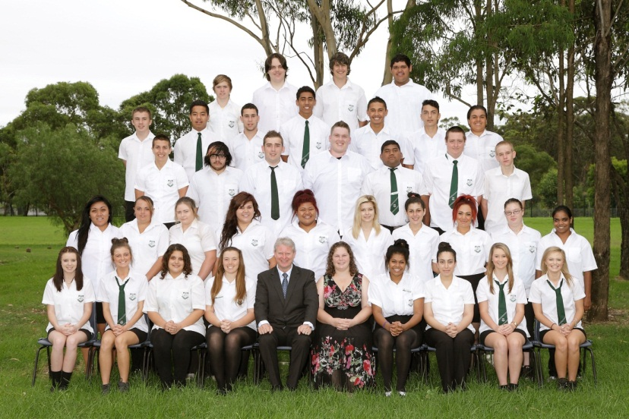

The Values Day for this term will be held on the 27th May with a guest presentation from the No Second Chance team followed by bowling, laser skirmish and arcade games. The No Second Chance team will discuss a variety of situations that senior students might become involved in and help identify how to remain safe in these situations. As our students are now developing into young adults it is important that they are aware of potential situations and educate them to make positive choices. The bowling, laser skirmish and arcade games will further develop cohesion and teamwork skills amongst the year group and become an event that they will remember for life.

Keep up the hard work Year 12 and remember to make the most of the time you have left in your last 6 months at Airds High School.

*“Success is to be measured not so much by the position that one has reached in life as by the obstacles which he has overcome.” -* [*Booker T. Washington*](http://www.brainyquote.com/quotes/authors/b/booker_t_washington.html)

Ms Green

Year 12 Adviser

**Donations for Biggest Morning Tea**

Airds High School extends thanks to the companies who donated goods or vouchers to our recent Biggest Morning Tea fundraiser

Foodworks – 2 boxes chocolates

St Helens Park Baker – 2 dozen scones

Bilita - Cake

Mekong Asian Cuisine - $30 voucher

Airds Country Meat – Meat Tray

Airds Pharmacy

Riverside Inn - $50 Bistro voucher

IGA Supermarket

C:\Program Files\Microsoft Office\Media\CntCD1\ClipArt5\j0281836.wmf**PICLO REPORT**

Kia Orana and greeting to all our families and friends of Airds

The month of May is for Mums, Happy Mother’s Day to all our Mums, hoping you were all spoilt on your one day of the year where you are acknowledged for the wonderful work you do in your families

Much has been happening with our Pacifica students especially those who participated in the Nesia fest 2013 and we very happy to announce that the students came first in the Maori and were placed third overall, even though they did not place for Samoan they did extremely well and looked absolutely stunning on stage. Thank you to all the parents who helped out in all sorts of ways too many to name and also the staff and students of AHS It has been an amazing journey after 3 months of practising it ended all too soon, but never mind there’s always next year.

We have been given a beautiful set of handcrafted Cook Island drums as a gift from the Mauri family if you have always wanted to learn how to beat the pate drum then come down to ABCentral Saturday mornings from 9am-1pm for lessons on Cook Island drumming and dancing.

Bring the Family to Uni is happening very soon and we are looking forward to going by bus to UWS Bankstown if you would like to come it’s on Wed 22 May meeting at 5pm outside AHS and returning after 9pm.

The Pacific Achievement Awards is coming up in August and nominations are closing on Fri 28th June if you would like to nominate someone nomination forms can be downloaded from the Pacific Achievement Awards website categories include Education, Performing Arts, Visual Arts, Sports, Volunteer, Community Services and Project/Business sector feel free to contact me for help with forms and yes a number of students will be included in the nominations this year.

Keep June 5th vacant for the Pacific Parents Forum, it will be a great day with fantastic speakers, performances by the Nesian fest winners and a buffet lunch.

Pacific Parents Forum 2013

Wednesday 5th June

**9.30am - 2.00pm

* *Guest speakers*
* *Pacific performances*
* *Pacific Buffet lunch*

Kia Manuia

Mrs M Varu

PICLO

**FROM THE PASTORAL CARERS DESK**

Term 2 is well underway, and it is going to be a busy term with so many positive things planned and happening. Last term was a busy time for all with many improvements throughout the school. The recent funding agreement achieved between the State and Federal Governments is such an important outcome for the continued investment in education and our school community. It’s also important to value these commitments, *if they come through*. To make the most of these opportunities to improve the teaching and learning for our students. It’s hard to imagine a more important decision for Australia’s future!

Although; in recent months, as the world increasingly became chaotic with bombings and disasters littering our screens, it seemed the fragility of the future was perilously close to our doorsteps. Last month we saw the best and worst of humanity, the Boston and Iraqi bombings one day and threat from North Korea the next. Then the solidarity and brotherly love at the London marathon and of course our ANZAC Day commemorations. Sometimes it seems we are surrounded by violence and fear, yet we continue to yearn for hope and peace…it’s not that hard to find, if we want to seek it out! We just need the spirit to **soldier on with courage**, be determined,and together stand firm for these ideals of hope and peace. It’s all for the sake of future generations.

*“To dream anything that you want to dream, that is the beauty of the human mind.*

*To do anything that you want to do, that is the strength of the human will.*

*To trust yourself to test your limits, that is the courage to succeed.” – Bernard Edmonds*

I would like to remind everyone that I am at AHS on Wednesday and Thursday this term. If I can be of any assistance, please do not hesitate to contact me.

Cheers and I hope everyone has a great Term 2.

Rob Hodgson JP



**TEACHING AND LEARNING REPORT**

Teaching and Learning have had a very busy Term 2 so far. Naplan organisation has been a high priority but was worthwhile as the Naplan testing days ran very smoothly. Thank you to all the staff that assisted on the various days. Your contribution was very much appreciated. Congratulations to all our Year 7 and Year 9 students who participated in the Naplan testing. Although it was a very stressful time, all our students settled down quietly and they worked to their personal best.

Miss Zalewski and Ms Jones worked tirelessly with our Gifted and Talented students to produce an exceptional Gifted and Talented Challenge. The Challenge involved students from primary schools in the area and the day proved to be stimulating, challenging and fun for everyone involved.

Our first LEAPS excursion headed into the city with Mr Latulipe and had a wonderful time with their mentors.

Ms Jones has also been involved in the Premier Reading Challenge. **Forty** students have enrolled in the program and are voraciously reading their way to success.

By the time this goes to print, Flag Ceremony will be over. A big thanks to Miss Zalewski for organising and running this multi-cultural event. Thank you to all staff and the Teaching and Learning Team for their contribution to making this event a success. Thank you also to all our flag presenters who represent their own countries and countries from all over the world and of course, parents who came on the day.

**SLSO’s**

After a well-deserved break everyone is back for a fresh start. The mainstream SLSO’s are busy preparing for Yr 7 and Yr 9 Naplan. The focus is to make sure our students are prepared and working towards their personal best. Students are also being supported as they prepare for the half yearly exams.

The focus for this term is literacy and both Ms Marie Addamo (Yrs 8, 10 and 12) and Ms Julie Hopwood (Yrs 7, 9 and 11) are working on a long term plan to assist targeted students with an aim to improving literacy results. Year 12 students are still working towards their HSC and Ms Addamo has been working closely with targeted students to help them maximise their results. Ms Hopwood is continuing to prepare Year 11 for their final year.

Both Ms Addamo and Ms Hopwood are looking forward to the planned changes for Airds High School. New teaching and learning techniques, impressive technology and comprehensive assessment should enable the SLSO’s to extend their knowledge and add value to the student’s efforts. Good luck to all our students in their upcoming exams.

***We are:***

**Safe**

**Respectful**

**Learners**

**YEAR 10 HIGH RESOLVES**

Our Community, Our Contribution

The Year 10 High Resolves Group would like to introduce ourselves and inform you of the proposed community initiative that we are hoping to implement. As part of our duty as Global Citizens we would like to host a local event that will improve the general ambience and appeal of the Airds Pond and its surroundings.

We will be providing more information at a later date so watch this space in the next issue.

**SCIENCE REPORT**

Students have hit the ground running this term, moving quickly from holiday mode into preparation for upcoming exams. The half yearly examinations are being held in week 5 for Years 7-10 and will be held in normal class time. Students have been advised by their teacher on which day their exam will be held, but if you would like to check on the date for your child’s exam, please don’t hesitate to contact the relevant teacher.

All students will be given the opportunity to revise in class, and will be given a revision sheet to help them guide independent study at home. All of the topics we have completed this year will be included in the exam. If you or your child is feeling unsure or anxious about the upcoming exams, please contact the relevant teacher for assistance. We wish all our students the best of luck in their exams!

Year 7 have hit the ground running this term, and have just completed their chemistry based topic on Matter. Next we will be moving onto looking at the forces that exist all around us and experimenting with gravity, magnetism, and static electricity, just to name a few.

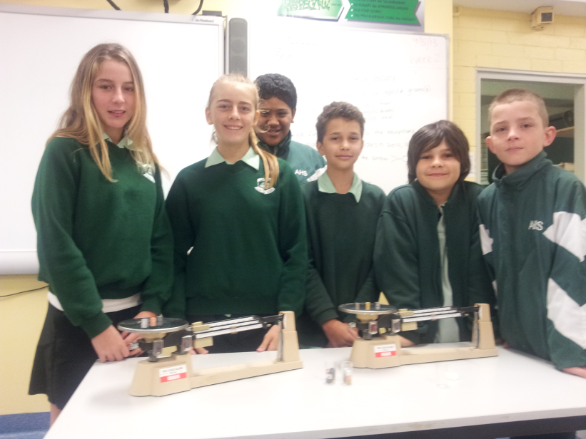

*7 Bellbird experimented on how to calculate density of objects using a triple beam balance.*

Year 8 students have been learning about the energy in our world, and there may be some aspiring electricians among them! They have been bravely wiring circuits together, following all safety precautions, to turn lights on and off with switches.

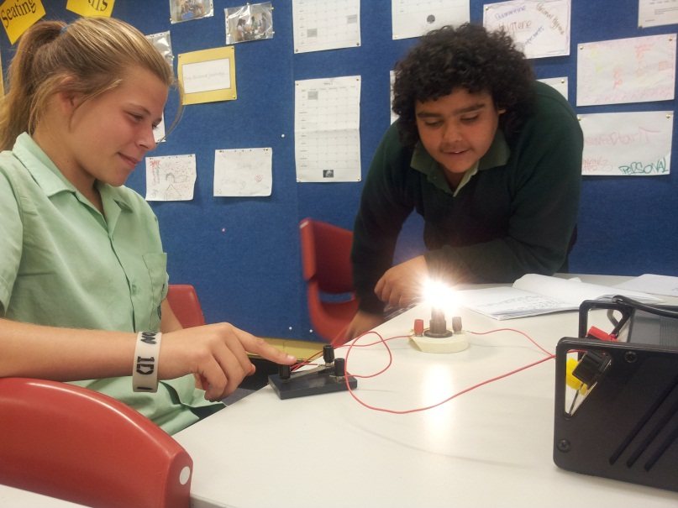

*Jaimee Morrissey and Brandan Connolly from 8 Barramundi learn how to construct an electrical circuit safely.*

Year 9 students started a new topic this term, looking at the properties of sound and light. There have been many opportunities for students to incorporate technology into this topic, including using sound meters to measure decibels and frequencies of noises in the classroom. While most students are using technology in an appropriate way in class, some students need to be reminded that the issue of the DER laptops are to promote their learning, and they should be used according to the guidelines that have been set.

Year 10 have also started a new topic, it is called Next Generation. They are focusing on the genetics and body systems involved in creating new life. It is important that Year 10 students maintain their focus on learning in the classroom heading into the examination period to give themselves the best opportunity to perform to their potential. The results from successful completion of assessment tasks, such as the half yearly exam, contribute to their Record of Student Achievement (RoSA) which they receive when they leave school.

Mrs S Stoddart

Teacher Science

**ROCK AND WATER REPORT**

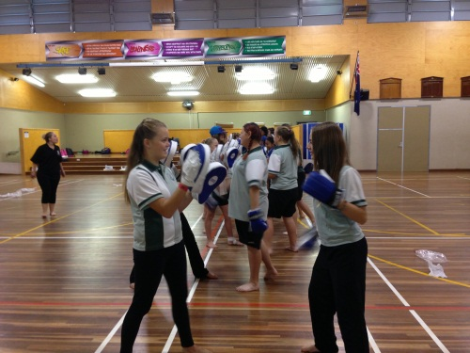

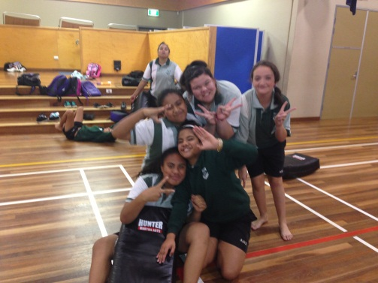

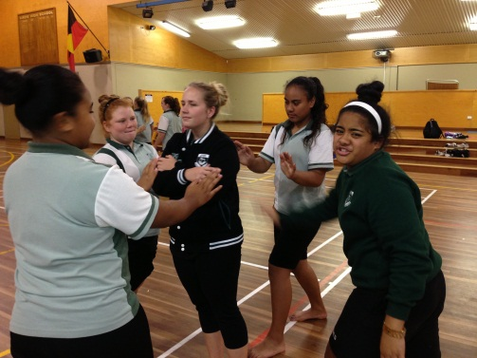

Near the end of Term 1 all Year 7 girls were involved in a Rock and Water program. This was a 2 day course that aims is to empower people and grant them the skills needed to hold one’s ground in a fast-changing multicultural society. Girls were made aware of their own bodies, attitudes, emotions and response patterns. Rock and Water embodies courage and confidence within oneself and allows students to convert their power and energy in a calm and assertive manner.

All the girls need to be congratulated for all their hard work, dedication and enthusiasm over the 2 days. We had an abundance of volunteers for all our demonstrations. It was a pleasure completing the course with all of you and I hope that you take what you have learnt and insert it into your everyday lives.

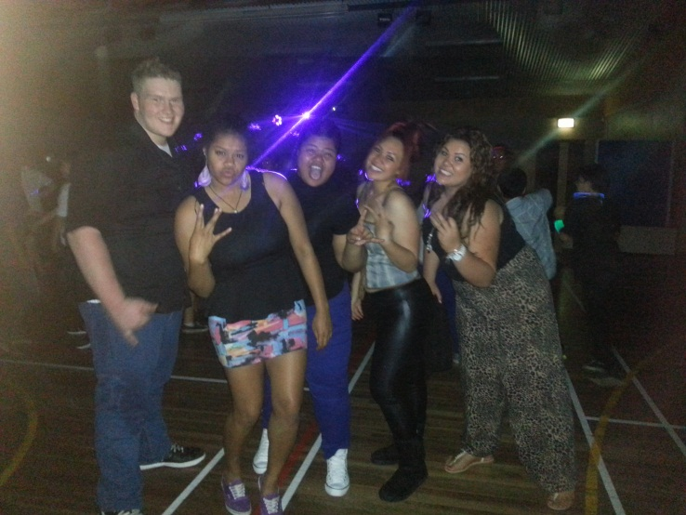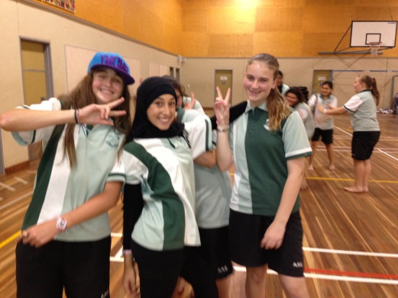

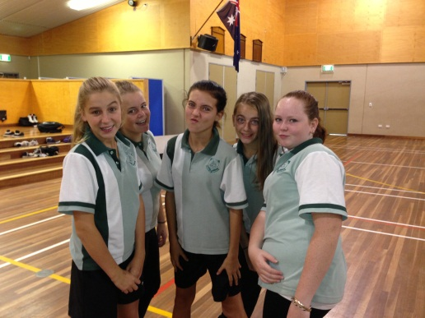

A big-thank you to the following staff for your help. Without your commitment and support of the program it could not have been as successful as it was. Thank you to Ms Vongsouvanh and Ms Fuller. A special shout out to Miss Kennedy for all your knowledge and expertise on both days.

Ms Tate

Teacher PDHPE

**SRC REPORT**

The SRC has taken to Term 2 with a flying start! At the start of this term, the SRC/Aussie leadership program was launched. With the help of Aussie and Be Learning, the SRC are going to decide on a project, or a number of projects, that they can enact to help improve the school for all students. It is up to the students what this project might be, so if anyone has any suggestions, please speak to your SRC member.

During the first workshop, the SRC set a stellar example for the school, which highly impressed the Aussie representative. Hopefully as the program progresses, students will not only build on their leadership skills, but also help improve the school environment.

At the end of last term, the first School Disco was held. This event turned out to be a huge success, and I would like to congratulate everyone who was involved. Students who attended behaved excellently and had a great time. The next School Disco will be held during Week 6 of this term, on Wednesday 5th June, from 5.30-9pm. The theme for this term’s Disco will be Neon, and UV paint and glow sticks will be available for purchase on the night.

Please be reminded that permission notes must be returned to Mr Wallace by Monday 3rd June. Also, to be eligible to attend, students must have above 85% attendance, not be on Amber or Red monitoring, and be present at school on the day of the Disco.

Lastly, I would like to congratulate Christina Lilomaiava for being selected as this year’s School Ambassador for Airds High School. As the School Ambassador Christina will be involved in a number of regional leadership programs, and be the voice of Airds to the school community. I am sure Christina will be an outstanding representative for the school!

Mr Wallace

SRC Coordinator



**SUPPORT REPORT**

**‘Together we can make a difference’**

Firstly welcome back to all the families and friends of Airds High School. I hope your holidays were both relaxing and rewarding . Term 2 has been a busy time for those in the Support Unit. We welcome Lisa Chesterfield as the new Support Learning Support Officer to our team. A motivated SLSO, Lisa works well with our students and has become a valuable member of our team.

Many of our senior students are involved in work experience programs as part of their studies. Traditionally, these programs have been very successful in providing our students with hands on experience in an area of interest. Many of these students go on to achieve jobs at their chosen place of employment.

In the area of academic achievement, a number of students from all support classes received a variety of awards at a recent School Awards Assembly. Congratulations to all those students.

Fridays of Week A are also special in our Support Unit as students participate in Life Skills activities where they are encouraged to participate in a range of community access projects. This program is proving very successful with students learning road safety, community based living skills, travelling skills and social skills. This term Mr Farmer, Miss Desplat and Miss Kennedy will be taking their classes into the city. Mrs Robinson and Mr Foster will be taking their classes to Ten Pin Bowling. We stress that this Community Access Program is compulsory for all students and failure to attend without a valid reason may result in your child becoming unsatisfactory in this subject. Well done to all the students who continue to achieve their best and be Safe, Respectful Learners at Airds High School.

Mr G Farmer

Teacher Support

**BULLYING AND HARASSMENT**

Bullying is repeated verbal, physical, social or psychological behaviour that is harmful and involves the misuse of power by an individual or group towards one or more persons. Bullying can happen face to face - some examples are pushing, tripping or name calling. At a distance bullying includes spreading rumours or excluding someone and cyberbullying which is bullying carried out through internet, email or SMS. Examples of cyberbullying can include repeated hang up calls, sending insulting or threatening text messages, publishing personal or embarrassing information about someone on facebook or other online sites and creating hate sites or starting social exclusion campaigns on social networking sites. Children who are cyberbullied are also likely to be bullied face-to-face.

Harassment occurs when someone is made to feel intimidated, insulted or humiliated because of their identity, race, culture, religion, ethnic origin, gender, sexual orientation, age, ability or disability, physical characteristics or marital, parenting or economic status. Harassing behaviour includes telling insulting jokes about a particular racial group, sending explicit or sexually suggestive emails, displaying offensive posters or screen savers or making derogatory comments or taunts about someone’s race, religion or sexuality.

Some conflicts between children are a normal part of growing up and are to be expected. These conflicts or fights between equals and single incidents are not considered bullying, even though they may be upsetting and need to be resolved. Identifying bullying can be sometimes difficult as it is often conducted out of sight of teachers and children may be reluctant to report it. Working together with the school is the best way to help your child resolve bullying issues.

**DEPUTY PRINCIPAL’S REPORT YR 7, 9 & 11**

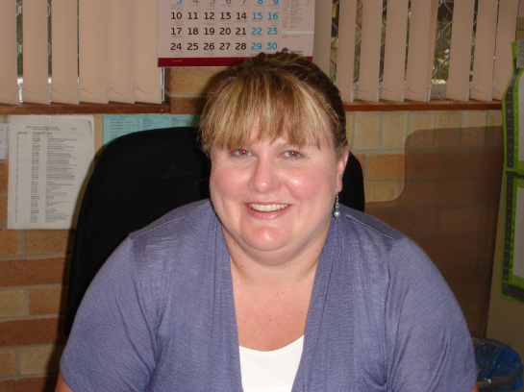

Welcome to Term 2 – certainly one of our busiest terms – at the time of printing we have already had our celebratory Formal Assemblies, our annual Flag Ceremony and NAPLAN. Not to mention all of the day to day activities, excursions and programs that we run to support and enhance student learning.

Our formal assemblies were very successful and I thank all of the staff that were involved in them, particularly our hardworking Year Advisers. I would also like to recognise Mr Lightfoot who took on the massive role of co-ordinating and organising all three recognition events. Without the hard work of all involved, and someone like Mr Lightfoot leading the team, these events would not be so successful. It is always nice to recognise our students for the positive contributions that they make to our school and their own education. Once again, congratulations to all of our award recipients and I look forward to seeing more students “striving to achieve” and being recognised at our Term 3 assemblies.

I would also like to thank Mr Lightfoot for his work in conducting the Year 11 Academic Reviews with me. We interviewed 34 Year 11 students who were causing concern – either with attendance, punctuality, or progress. Alarmingly, all of these students have one or more N-Determination Warning Letters. This means that they are placing their Preliminary Certificate in danger, especially if they have these letters in English. I encourage parents to make contact with the school if they are concerned about their child’s progress. If the students interviewed continue to cause concern, parents will be asked to attend an interview at the school.

Year 11 Aspirations begins in week 5 with our first session in at their Sydney office. The launch in week 3 was very successful and I would like to congratulate the participants on their enthusiasm and interest in the program. I look forward to seeing their skills and outlook develop as the program progresses.

Mobile phones continue to be problematic. Mobile phones are NOT to be used in class or in the playground. They are definitely not allowed to be used to access Facebook or other social networking sites. We understand that parents sometimes need to contact children while they are at school. We have no problem with this as long as those calls go through our Office rather than directly to the student during school time. In addition, please discourage your child from contacting you on their phone during the school day. If they need to contact you, they can also do this through our Front Office. We thank you for your support on this issue.

Mrs J Fuller

Deputy Principal

**DEPUTY PRINCIPAL’S REPORT YR 8, 10 & 12**



Welcome to all the parents and friends of Airds High School. I hope you all had a restful, relaxing and enjoyable holiday with family and friends. This term is already off to a flying start with half yearly examinations/assessment tasks for most of our year groups, athletics carnival, cross country carnival and of course our famous **Flag Ceremony** all happening in the first six weeks. No wonder I’m exhausted and the term has just begun!

Our staff and students should be congratulated for all the hard work and effort they have put in already this term. Days like the Flag Ceremony clearly demonstrated what a fantastic community we live in, where cultural diversity is celebrated and people work together in complete harmony. These days truly bring out the best in our students, staff, school and the community. Well done everyone!

Our Year Advisers have been extremely busy organising and delivering **formal assemblies** for all of our students. These ceremonies provide invaluable opportunities for our students to work on their social skills within their year/stage group and to take ownership of their learning, as well as celebrating their success. I was lucky enough to be invited to speak at the Stage 5 (Years 9 & 10) formal assembly and I can say what a positive, productive and enjoyable experience it was. Well done to all of our award recipients.

Of course without regular attendance your child will not have access to any of these wonderful programs. When your child misses school or arrives late it causes them to lose valuable learning time and therefore opportunities. This also has a negative impact upon their **classmates** and **staff**. It also teaches them bad habits in regards to punctuality, which will be hard to break once they enter the workforce. Please support us in encouraging your child to attend school promptly every day!

Finally I would like to remind everyone of our three core school values; we are SAFE, we are RESPECTFUL, we are LEARNERS. If every one of our community embraces these values, we will be able to maximise student learning outcomes. This term we are focussing on we are LEARNERS and in particular encouraging our students to “*bring equipment and be prepared*” and to “*accept the challenge and have a go*”. Please assist us in modelling this to our students.

That’s all I have at the moment, except to say that we can only achieve the best possible outcomes for your child by working together. I look forward to seeing or hearing from you soon. Hopefully at Parent/Teacher night on Wednesday 26th June from 4.00pm to 6.00pm, if not before!

Mr S McGuire

Deputy Principal

**DEPUTY PRINCIPAL’S REPORT**

**TEACHING & LEARNING**



It has been a busy start to the term with a lot happening already.

**Middle School Gifted & Talented Challenge**

The Gifted & Talented challenge was held on Thursday the 9th May. This was a very successful day with the students from Briar Rd, John Warby, Bradbury & Woodland Rd public schools participating in set challenges and rotating their way through KLA based quiz questions, problem solving activities & team building experiences. The challenge was run by the Year 9 Gifted & Talented students under the supervision of Ms Zalewski and Mrs Jones. The challenge will take place again on Monday 18th June. An Edmodo group has also been established for this group to communicate & set challenges during the year.

**COMMUNITY LIAISON OFFICER - EXPRESSION OF INTEREST**

Airds High School is involved in the 2011 National partnership on Low SES School Communities Funding Program. Funding includes a component to enhance partnerships between the school, parents/caregivers and our community and as such we will be appointing a Community Liaison Officer.

The position is for 3 days per week with hours negotiated according to the needs of the school. This is a paid position commencing in Week 6 Term 2 2013. This is a temporary position and will be evaluated at the end of 2013 to determine future directions. If you are interested in this position an application form is available at the front office at Airds High School and/or you can contact the school to have a copy emailed to you. (Contact person at Airds High School is Mr Jeffrey Miezio) Phone: 46255811 for any further information. Applications close 3pm Friday 24th May.

**DER Laptop Stocktake**

We are currently in the process of stocktaking all of the

Year 10, 11 & 12 DER laptops. This involves all students

using their laptop at school for a miniumum of 30 mins

before the end of Term 2. The stocktake will occur

electronically while the laptop is in use. Any student that

does not participate in this process before the end of the

term will be required to hand in their laptop to our TSO

(Michael Peppernell) next term where it will have to be

recorded for the stocktake manually.

**TAFE Course**

A number of Year 10 students have been provided with the opportunity to participate in a 100 hour TAFE Spray Painting Course it has provided further education, training options and possible employment. The students will complete the course at the end of Term 2.

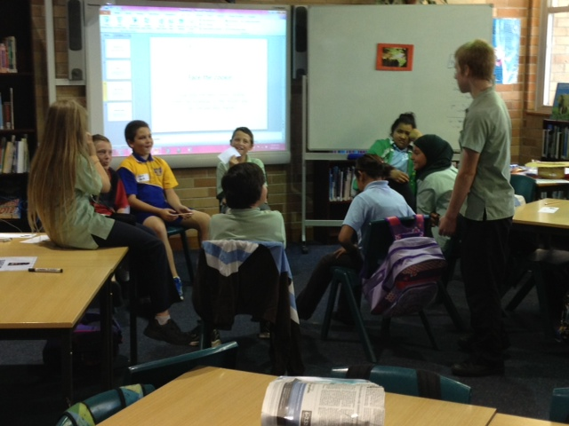

*Gifted and Talented Middle School Challenge*

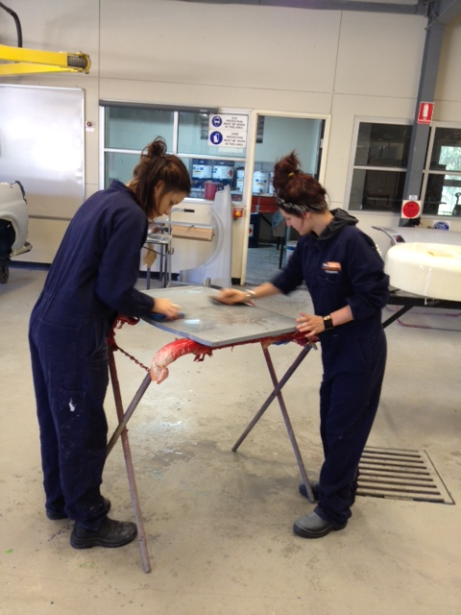

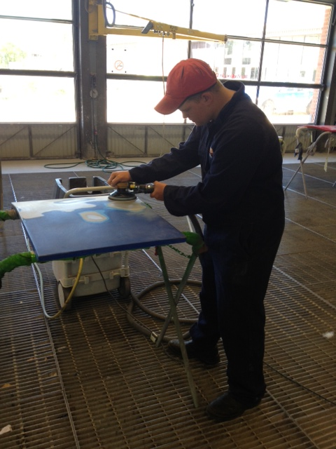

**Pacific Parent Forum**

The Pacific Parent Forum will be held on **Wednesday**

**5thJune** from 9.30am to 2pm in the library. This is a

fantastic event that is being organised by Maryanne Varu. It will provide an opportunity for our PI parents to find out more about the school and education in an informal setting. Parents will find out about: assessment & N Awards, attendance requirements, technology & how to help your child plus guest speakers and special performances.

**Year 7 Scholarships 2014**

We have had a number of applications for the Year 7 2014 scholarships. The panel is in the process of deciding who the recipients will be. We would like to thank these students for nominating and that they will be informed of the panel’s decision by Friday 31st May.

**Football United**

The Football United after school community soccer program is up and running again this term on a Monday afternoon from 3.15pm – 4.30pm. We would like to encourage any student from Year 3 to 9 to attend so they can have some fun, learn new skills and meet people. Registration forms can be picked up from your local school.

**Facebook – Advice for students**

1. Don’t respond to inappropriate messages. Bullies like getting a response.

2. Tell someone. Use Facebook’s Trusted Friend tool to send a copy of the abuse to someone you trust and who can help. This also generates a report to Facebook.

3. Document or save the content as it may be needed as evidence.

4. If you are feeling upset – talk to someone about how you are feeling. If you want to do this anonymously contact the Kids Helpline.

Mr J Miezio

Deputy Principal Teaching & Learning

School starts at 8:30am **EVERY** day. Please ensure your child arrives to school at this time **EVERY** day. If they are late, they **MUST** bring a note from you explaining the lateness. Thank you for your co-operation

**Woolworths Earn & Learn is back again for 2013. For every $10 you spend you will receive a sticker. You can either place the stickers on a sticker card and when it is full hand it into the office or just hand in the loose stickers and the office will place them on a card.

**COMMUNITY NOTICES**

**Reading challenges**

Older children with reading problems often have misconceptions about how reading works and they need additional strategies to help them. Knowing what they’re good at and what they value can help you to encourage their selections.

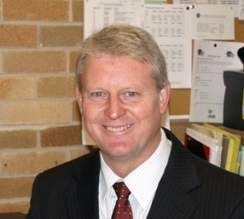<http://www.schoolatoz.nsw.edu.au/homework-and-study/english/english-tips/when-older-kids-struggle-with-reading>

**The New Curriculum**

Resources to support parents in understanding the new NSW K–10 syllabuses incorporating Australian curriculum are now available free on the Board’s [*NSW syllabuses for the Australian curriculum website*](http://syllabus.bos.nsw.edu.au/support-materials/parents-guide/).

The resources provide clear and important messages about the four new syllabuses: English, Mathematics, Science and Technology, and History.

The first resource is a video presentation that many schools have used during parent meetings at their schools.

A [brochure](http://syllabus.bos.nsw.edu.au/assets/global/files/parent_k-6_guide_web.pdf) is also provided which contains additional information for parents.

The Parents’ Guide to the new NSW K–10 syllabuses provides an excellent summary of:

* the nature of Australian curriculum
* how it will be implemented in NSW schools
* when the new NSW syllabuses incorporating Australian curriculum will be taught in NSW
* what children will learn at school using the new syllabuses
* cross curriculum priorities and general capabilities.

Teachers and parents can view the four new K–10 syllabuses for NSW schools on the Board’s [*NSW syllabuses for the Australian curriculum website*](http://syllabus.bos.nsw.edu.au/).



**PRINCIPAL’S REPORT**

Welcome back to Term 2 which is always an exciting, fun and challenging term for all. The 23rd Annual Flag Ceremony on Tuesday 21st May was once again a huge success and extremely well supported by the organising committee, student participants and the broader community of the school. It provided an opportunity for our talented performance students and staff to display skills in singing, dancing and instrument playing. Over 50 flags representing the nationalities of our school student and staff population were presented.

Of particular note, was the large number of officials who supported the ceremony. Russell Matheson Federal member for Campbelltown, Marianne Carahalious, School Education Director for Campbelltown; Tammy Anderson Principal Briar Rd; Ann Kitchin Principal John Warby PS; special guest Asmaah Helal, Football United ; Aussie and their team, Bradbury and Briar Rd students, and a large number of representatives from local support agencies, parents and ex-students.

It is extremely important that I acknowledge the main committee members for the huge amount of work they undertook behind the scenes to ensure the day was a success. Thank you to Sarah Zalewski and Samuel Rosete and the 30 other staff members and students who support them. Well done.

Last Tuesday, Wednesday and Thursday NAPLAN tests (National Assessment Program for Literacy and Numeracy) was undertaken by all students for Years 7 & 9. I’d like to thank students for their purposeful attempts and maintained focus for the entire three days of the program. I would also like to acknowledge the work of Mrs Angel and team for their organisation and support of the students during this stressful time.

The construction of the Trade Training Centre is almost complete and we look forward to opening and accessing this fabulous resource in Term 3 and the enhanced learning opportunities for students in the construction industry.

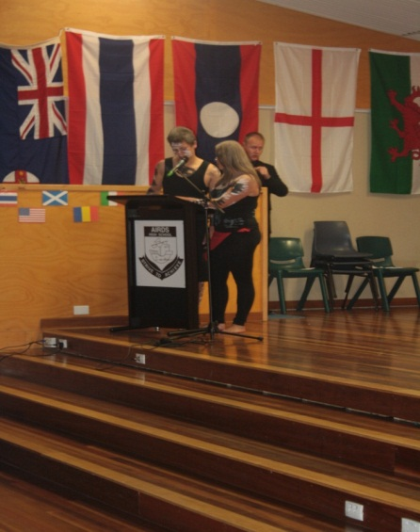In closing, I wish all students the best with their half yearly exams, and I hope their half yearly report closely reflects their level of application to their studies in Semester 1. I also encourage all students to make the most of the upcoming events and look forward to meeting many parents at Parent Teacher Night.

Mr M Foord

Principal

**2013 Flag Ceremony**

