Airds Announcer |  | 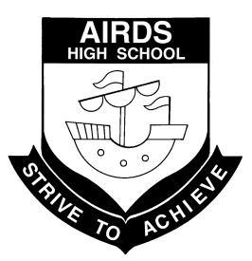
“A place to learn, lead and achieve your personal best”
Find us at: Airds High School, 2 Briar Road, Airds NSW 2560
airds-h.school@det.nsw.edu.au
Issue 5– Term 3 | August 2013

DIARY DATES

Wed 14th August Year 10 Subject Selection parent
meeting 6pm
Thurs 15th August Year 10 Subject Selection Day
Fri 16th August Year 10 School Values Day
Year 11 Skills Day
Mon 19th August Science Week excursion to
Wollongong Science Centre
Thurs 22nd August Year 10 Youth & Road Trauma
Forum
Wed 28th August Aspirations Completion
Ceremony
Year 7 & 8 Storm Boy excursion
Mon 2nd – 4th Sept Year 9 - 10 camp
Thurs 5th Sept Year 11 captaincy speeches
Mon 9th-13th Sept Year 10 Work Experience
Wed 11th Sept G&T Middle School Challenge
Thurs 12th-13th Sept Year 8 camp
Mon 16th-18th Sept Year 11 yearly exams
Tues 17th Sept Yr 7 & Yr 9 boys vaccinations
Thurs 19th Sept Year 12 Graduation Evening
Year 11 School Values Day
Fri 20th Sept Year 12 School Values Day
Last day Term 3
NEXT P&C MEETING
WEDNESDAY 4th SEPTEMBER
AT 10:15 am
IN THE STAFF COMMON ROOM

WOULD LOVE TO SEE YOU THERE!

YEAR 12 2013
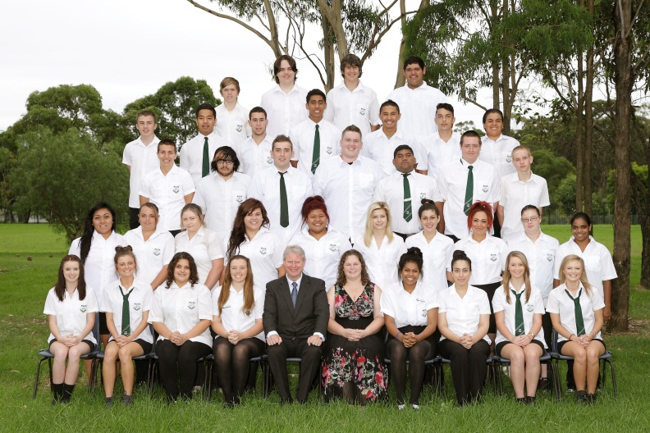

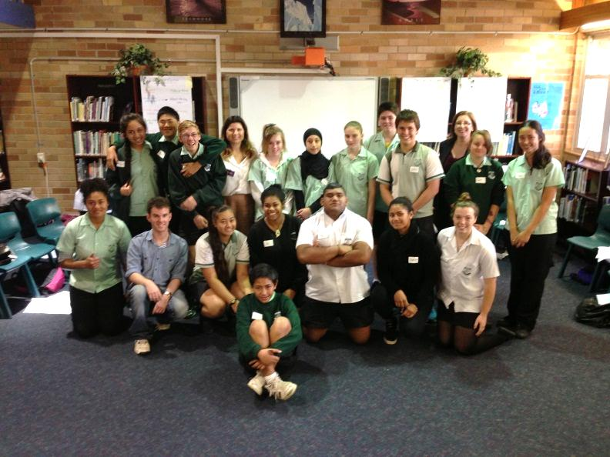
SRC 2013

P&C REPORT
I would like to welcome all staff and their families back to school for what I’m sure will be a very busy and exciting Term 3. I hope you all had a very enjoyable holiday and were able to spend some relaxing time with your families and friends. I’m sure our teachers have many fun and interesting learning experiences planned for our children this term and I hope that all the students at our school will make the most of the opportunities given to them here every day.

Congratulations to all our students who represented our school at the Zone Athletics Carnival in Week 2. It was great to see our students get out there and try their very best in many of the track and field events. We had a number of our students qualify for the Regional Carnival which is a great achievement and one which all competitors should be very proud of. I would like to encourage all our students to participate in the various school sporting carnivals that are held each year and really strive to do their best. Competing in a zone, regional or state carnival is a wonderful experience and a great personal achievement. Well done to all our athletes and good luck with your future carnivals.

Many of you may be aware that our school is holding a Performance Showcase on Tuesday 13th August at the Campbelltown Arts Centre. This is a great opportunity for our talented students to perform at a formal venue in front of an appreciative audience. On the night we will be entertained by choirs, soloists, dance groups, bands and drama groups all of whom have been working very hard to prepare for this annual event. Tickets are only $5 each and can be purchased at the school office. There are a limited number of seats available so be quick to get your tickets. It would be great to see as many people there as possible as I’m sure it will be a thoroughly enjoyable evening where we will all be impressed with the talent of our high school students.

The P&C are still working to organise a fundraising event for Father’s Day this year. We are hoping to have a Father’s Day stall where all our students will have the opportunity to purchase a gift for their dad, stepdad, uncle, grandfather or other important males in their lives. We are hoping that the gifts will range from $2 to $10, making them affordable for everyone. Once the details have been finalised we will send more information home with the students regarding when and where the stall will be held and the final pricing of the gifts. We hope that this will help our families to make Father’s Day a special celebration and a chance to say a big ‘thank you’ for everything our dads do for us.

Later this term, on Friday 6th September, the 2013 Campbelltown and Macarthur Schools Parent Conference will be held at John Warby Public School. The topic this year is ‘Imagination-Embracing Change’ and like previous years it is sure to be a fun-filled and extremely informative day. The conference includes talks by various presenters, audience activities and participation, and a beautifully catered lunch and morning tea. If you are interested in attending the conference please contact me at school on 4625 5811 before Wednesday 28th August as all parents must be registered by this date. If you have any enquiries about the conference please contact Ha Nguyen at John Warby PS on 4628 1637.

Finally I would like to encourage all our parents to come to our P&C meetings and support the hard work of all the staff here at Airds HS. Our meetings are held in the common room at 10:15am on the first Wednesday of every month. Our meetings are relaxed so come and enjoy a cuppa and find out about all the amazing things going on in our school for our children.

I hope all staff, students and their families have an enjoyable and productive third term. I’m looking forward to seeing many of you at the Showcase and the Parent Conference later in the term.

Melanie Cutts
P&C President

SRC REPORT
Term 3 is proving to be another busy term for the SRC. After receiving $2000 from Aussie to help with renovating the school toilets, the SRC – working with staff – now have to implement their project plan. Hopefully with the support of the student body, Airds High School will soon see newly renovated toilets.

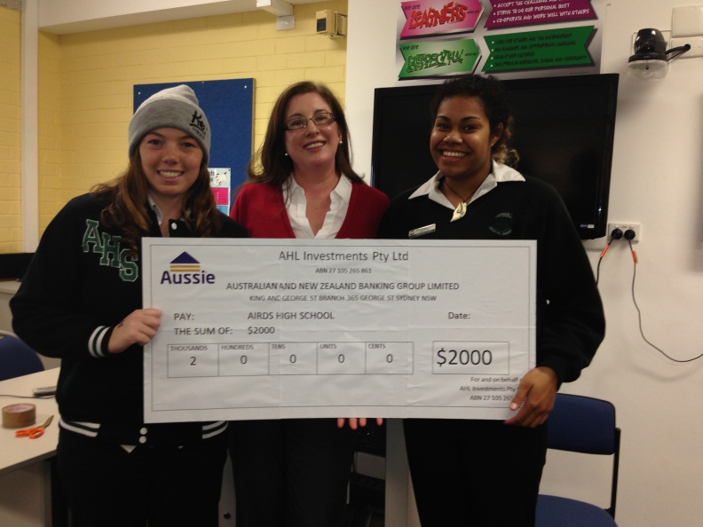

Coming up toward the end of the term, the SRC will be holding another Disco. This will be happening on the 10th September, from 5.30-9pm. The theme for the Disco will be Neon, and it will feature a newly purchased black light canon, and UV paint will be available for purchase on the night. All students are encouraged to attend, especially Year 12, as this will be their last ever Disco.

Finally, Year 11 members of the SRC should start thinking about their final year of schooling, and whether they might like to run for School Captain. I encourage all Year 11 students to consider this, as the skills and confidence that you will develop as School Captain will assist you later in life. Any students who wish to find out more about the selection process should talk to Mr Wallace, Mr Lightfoot or Ms Fuller.

I wish everyone a productive and safe Term 3.

Mr Wallace
SRC Coordinator

PICLO REPORT
Pacific greetings to everyone and I hope you are all well. We have been kept busy with so many activities happening out and about the community and within the school.
Practice for the Pacific Combined High Schools is well under way, Pacific students from five local high schools have combined to form a super group which will perform at the opening of “The Navigation” launch at the Powerhouse Art Gallery Casula in October and this same group has also been invited to perform at the Salvation Army Multicultural Festival which is a major annual event to be held at Homebush. Pacific students from Airds HS will be participating in these events and we are fortunate to have leaders from Te Kete Kahurangi Maori Culture group choreograph and co-ordinate the performance for this super group. It is wonderful to see the students coming together and building lifelong relationships with other schools and communities, and realising the benefits of learning and respecting other cultures.
A meeting was held recently to discuss fundraising ideas and some suggestions were made, it was decided that each family would contribute $20 a month for 3 months after which we would discuss another form of fundraising. This fundraiser is to contribute to costs involved with Nesianfest 2014. The next get together will be on Monday the 26th August 9.30am in the library.
The annual Pacific Achievement Awards night is a most prestigious event for our Pacific communities celebrating and recognising those who have put in much work and effort within their respective categories, this will take place on Thursday 8th August 2013 at “The Cube” Campbelltown. Tickets are $60 per adult and $30 per student. I am very proud to announce that the Pacific students who performed at the Pacifica Combined Nesian fest 2013 are finalists and that Paul Vaai and Anna Mata-Leifi will be attending and accepting the award on behalf of the group, this is a great achievement for the students as there were over 168 nominations this year, if would like to attend the event tickets are available from The Cube.
Congratulations must go out to vice captain Paul Vaai for attaining a position with the National Gold Squad Rugby Union team which is a pathway to the Wallabies academy. Well done Paul and all the best for your future.
Year 10 subject selections are coming up and this would be a good time to talk with your children about career choices so they can decide what subjects would best suit their career choices please find the time to discuss the different options available and if you have any questions you can talk with the Careers Adviser Mr Tyler who will be happy to help you.
Have a great August and stay warm.
Kia manuia
Mrs M Varu
PICLO

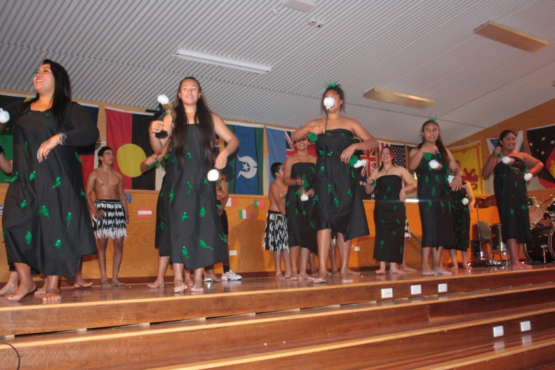
Pacific Achievement Awards Performing Arts finalists

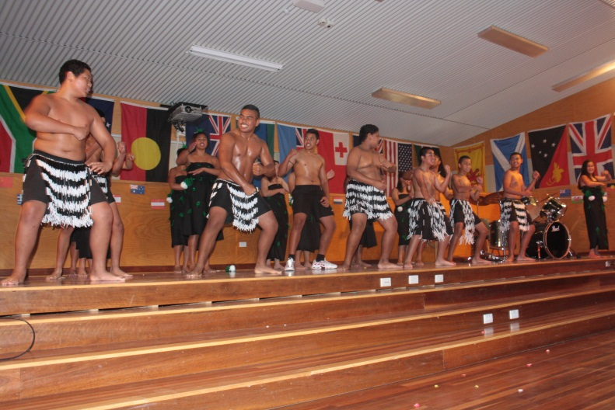

CLO REPORT
Welcome back to school for the start of the second semester. I hope you all had an enjoyable holiday and staff, students and their families were able to relax and unwind after such a busy first semester. Term 3 is well underway with many in-school and extra curricular activities already taking place. In Week 2 our Year 12 students sat their trial HSC exams and hopefully the study and hard work undertaken by our students leading up to these exams will have paid off. These exams can give students a good indication of the areas and subjects they are doing well in, as well as an idea of where they need to revise and study more in order to be more successful in the HSC exams later in the year. I trust that our students will use the results of these exams to help them prepare thoroughly for the final school exams they will ever encounter. They are really only a few months away so good luck to all our Year 12 students and remember that in life the more effort we put into something, the greater the rewards.

In Week 3 a number of our students in Years 7-12 had their measles vaccinations. The morning went very smoothly thanks to the mature and sensible behaviour of the students and the efficiency and organisation of the nurses who came to the school to give the needles. On behalf of the students and their families I would like to thank these nurses who come to the school many times during the year to provide our students with their vaccinations. Their calm and caring attitude always makes it easier for the students to cope with having the needles and ensures that our children are protected against preventable illness. I would like to thank Mrs Ferderer, Mr O’Neill and Mr Rosete who also helped out on the day and made sure our students were well-behaved and recovered afterwards with some cordial and lollipops! If there are any students or other family members who haven’t been immunised against measles, we would encourage you to go to your doctor where you can receive the vaccination. The government is providing this immunisation free of charge to people in our local area due to an outbreak that affected many people. By ensuring that everyone in your family is immunised against measles you can do your part to help stop the spread of this illness in our local community.

Our teachers and students have been working very hard to prepare for the upcoming Airds HS Showcase which will be held on Tuesday 13th August from 6pm. There will be a number of acts featured on the night and these will include dance groups, choirs, soloists, drama groups and bands. This year the Showcase is being held at the Campbelltown Arts Centre and tickets are available from the school office for only $5 each. There are a limited number of tickets available so be sure to get yours quickly and come along and enjoy what I’m sure will be a wonderfully entertaining night.

I would like to encourage all our students and their families to take a little bit of time to think about the importance of regular attendance at school. There has been a great deal of research done about how students’ absences affect their learning, their career and employment prospects, as well as their social and psychological development. There are a lot of articles and information in relation to this topic that can be easily accessed on the internet. However, just think about this for a moment. Let’s say a student is absent from school one day a week every week of a term. Over the course of the term 10 days of school are missed, that’s two full weeks out of a 10 week term that the student has missed out on lessons for all subjects, instruction and guidance for assessment tasks, not to mention any social and extra-curricular activities that they could have been involved in. If this pattern continues all year the student will be absent from school for 8 out of 40 weeks, nearly a whole term. If this pattern continues for the 6 years of high school 48 weeks of school will have been missed by the end of Year 12. So many incredibly valuable educational opportunities missed out on simply by being absent from school an average of one day a week.

We all want our children to do well at school so they can improve their chances of having successful and productive lives. By not attending school regularly students are limiting their learning time and ultimately limiting the opportunities they will have when they leave school. Missing one day a week doesn’t sound like much, but when you look at it over a whole year or the whole time your child is in high school, the impact of student absences becomes much more obvious. So I would like to encourage all our parents and caregivers to talk to their children about the importance of attending school every day. Of course if a student is sick or has a medical appointment it is not expected that they attend school that day. Missing school for a birthday, a shopping trip or simply because a friend is not going to be there is not a good enough reason to jeopardise how well you do at school and the opportunites you may have in the future. As parents we want to have a positive influence on our child’s education and by having the expectation that they will attend school regularly we are guiding our children in the best way we can.

I hope you all have a very productive and enjoyable Term 3 and I’m sure I will see many of you at various events at the school throughout the term. If you have any questions or suggestions for me please do no hesitate to contact me on 4625 5811. I am at school on Tuesdays, Wednesdays and Fridays and messages can be left for me at the front office if I am unavailable. Have a great term and I’d like to leave you with a Chinese proverb: “Learning is a treasure that will follow its owner everywhere”

Ms M Cutts
CLO

FROM THE PASTORAL CARERS DESK
Welcome back to school for Term 3. I hope everyone enjoyed the break and are now settling into another busy term. The calendar this term is filling fast with many events and activities planned, but one of the highlights for this term was Education Week (Week 3). Education Week showcases the achievements of our inspirational teachers, staff, students and school community. The theme this year “Celebrating Our Stories” was an opportunity to reflect upon Airds High School’s proudest moments. Mr Foord said “It’s a great time to focus on the positive energy in our school and celebrate the many happy stories and experiences.”

And, did you know? Happiness is contagious… It’s a proven fact. When you are happy, it can spread to your friends, family and co-workers, but sadness is catching too. In addition to experiencing empathy, we also actively share our emotions, and as human beings want to share our feelings. Whether they are positive or negative! However, you are more likely to become happier, because each happy friend you have increases your probability of being happy by about nine per cent. It can be surprising how much our social networks shape our lives. So, be aware of your mood and the mood of others. And if you have leadership responsibilities remember that your emotions are more “contagious” than others.

“Happiness is contagious…but worry is like a rocking chair, it gives you something to do but it doesn’t get you anywhere.”

I would like to remind everyone that I am at AHS on Wednesday and Thursday this term. If I can be of any assistance, please do not hesitate to contact me.
Cheers and I hope everyone has a happy Term 3.

Mr R Hodgson JP

TEACHING AND LEARNING REPORT

SLSO’s
Ms Hopwood and Ms Addamo would like to welcome back all students to the school after the holidays. This terms focus for the mainstream SLSO’s is Numeracy and both Ms Marie Addamo (Yrs 8, 10 and 12) and Ms Julie Hopwood (Yrs 7, 9 and 11) are working on a long term strategy to assist targeted students with the objective of improving numeracy results. Both Ms Addamo and Ms Hopwood have been assisting with Trial Higher School Certificate exams Special Provisions and were pleased to report that all the students survived! Although exam time can be stressful, most students took the exams in their stride.

Year 12 students are working relentlessly preparing for their final examination at Airds High School. After six years of High School study, the exams will springboard their futures and there is a lot of pressure on the young adults to achieve. As the Higher School Certificate approaches, students become naturally stressed but, Ms Addamo has been, and will continue to, work closely with targeted students to help them maximise their results and offer guidance to maintain calm. Ms Hopwood is continuing to prepare Year 11 for their final year but will naturally offer help to any Year 12 that needs support.

Of course, both Ms Addamo and Ms Hopwood are happy to offer assistance to all mainstream students in any year, in any subject. Period 5 every Tuesday has been specifically dedicated to the Year 11 students. This gives Year 11 an opportunity to work on assignments, homework, or classwork with the aid of an SLSO. With prior arrangements, and written permission from their teacher, all students can book in with their SLSO’s for individual assistance. The Activity Hub is also a valuable resource for students who need extra help from their teachers, and this service is available every Wednesday afternoon. Ms Addamo and Ms Hopwood are more than happy to support any student achieve their learning goals within the values framework of safe, respectful learning.

We are:
Safe
Respectful
Learners

TAS/CAPA REPORT
TAS and CAPA students have been working well this term and there have been a few changes within the faculty. The first exciting change is the highly anticipated completion and handover of the Construction Trade Training Centre. The official opening of the facility will occur later in the year and this will allow our Construction students to utilise this fantastic resource. The second great change is the sound proofing of the main Music practical room allowing students to take part in practical lessons without being concerned of the noise level. These excellent changes provide students who are studying these subjects the opportunity to enhance their learning.

Our Year 12 students completed their Trial HSC Examinations and Visual Arts students have been working well to complete their Major Works. Their Bodies of Works due date for Visual Arts is to be submitted to their teachers by 3.00pm on Monday 26th August, 2013. I would like to acknowledge the dedication of Mrs Bateman and Mr Wallace who are our two Year 12 Visual Arts teachers. They gave up two days out of their holidays to allow Year 12 students to work on their Major Works at school and will be doing it again on Sunday 25th August. If your child would like to take this opportunity to complete their Major Works then please check with these two staff members for the time to attend.

Mrs Drakefield’s Year 10 Food Technology class was looking at Food Trends last term. This topic required students to plan, design and produce their own Cupcake Recipe Card. Students have worked really hard and their efforts were outstanding. The end results were fantastic and the cupcakes were photographed. An excursion into Chinatown has been organised to allow students to observe current food trends in food courts and to incorporate Food in Australia from Term 1. For further details regarding this excursion please contact Mrs Drakefield.

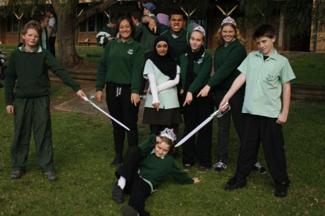
Following a very busy Term 2, the Music rooms have continued to be busy with the preparations for Showcase Night. A number of students have auditioned with strong performances. From this a large singing group has formed for the Junior students, mentored by some of the Year 10 Music Elective students and the Year 11 band is continuing to raise the bar. Year 12 have been working towards their HSC practical examination in early September and although there is still work to be done, they are well on the way to positive results. Ms Adair’s Year 8 Music classes created a short silent movie based on “Fractured Fairytales”. They had a lot of fun dressing up in different costumes such as fairy wings and flashing plastic swords. The musical element of the task was to provide a soundtrack with mp3’s.
Year 8A Music

The following students were recognised for their wonderful efforts for Term 2 during the Formal Recognition Assemblies early at the start of this term. The following students gained awards for outstanding academic achievement in TAS and CAPA subjects.

TAS –
YR7: Pelenise Taala (7A Technology Mandatory), Demour El-Tahach (7B Technology Mandatory), Hayley Stokes (7C Technology Mandatory), Kyle Osborne (7D Technology Mandatory)
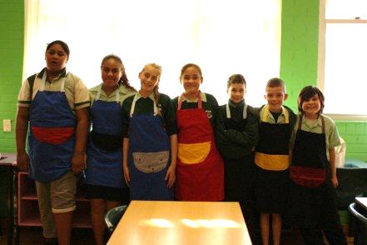
YR8: Nora Al-Katify (8A Technology Mandatory), Jessica Wirtz (8B Technology Mandatory), Brandan Connolly (8D Technology Mandatory)
YR9: David Baker (Industrial Technology - Automotive), Angela Franks (Industrial Technology - Metal), Emily Philliskirk (Food Technology)
YR10: Brock Baker (Industrial Technology - Metal), Khaled El-Tahach (Food Technology), April McDonald (Child Studies)
YR11: Cody-Lee Cunningham-Erwin (VET Metals and Engineering), Jade Baker (Food Technology)
YR12: Stephanie Wasson (Community and Family Studies), Christopher Pekarek (VET Metals and Engineering), Tahlia Colbourne (Food Technology) Jessica Jacobs (VET Hospitality)
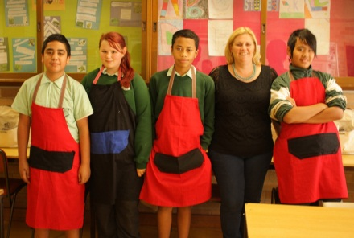
Support: Emma Lynch (Prada), Samara Lynch (Gucci), Kayleeigh Johnstone (Blundstone), Austin Harris (Manolo)

CAPA –
YR7: Jacqueline Willer (7A Visual Art), Jennifer Clissold (7B Visual Art), Jonathan Souleyo (7C Visual Art), Noreislyn Fuimaono (7D Visual Art), Masei Fetui (7A Music), Madison Tidmarsh (7B Music), Hassan Saleh (7C Music), Noreislyn Fuimaono (7D Music)
YR8: Hayley Greatley (8A Visual Art), Michelle Naicori (8B Visual Art), Mahmoud El-Tahach (8C Visual Art), Mitchell John (8D Visual Art), Nora Al-Katify (8A Music), Tanisha Kassem (8B Music), Oscar Charlesworth-Budge (8C Music), Brandan Connolly (8D Music)
YR9: Robert Nicholls (Visual Art), David Ta'ase (Photo - Moving), Ashley Davis (Photo - Still), Chloe Montcalm-Sparks (Music)
YR10: Sonja Ta'ase (Visual Art), Blayke Bugatto (10/11CC Visual Art), Margaret Leato (Music)
YR11: Samuel Bowden (Visual Art), Christopher Dent (Music)
YR12: Adi Turaganivolo (Visual Art), Holly Reed (Visual Art), Stephanie Wasson (Photo), Anna Mati-Leifi (Music)
Support: Michael Stark (Blundstone), Jackson Baxter (Manolo), Joseph Michael (Cooper), Joel Foy (Gucci)

Congratulations to the above mentioned students and we all look forward to the continued efforts of all students in TAS and CAPA subjects throughout this semester.

Ms N. Vongsouvanh
Head Teacher TAS/CAPA

Year 10 Food Technology

Year 7A and 7C Technology Mandatory

VET REPORT
Over the last semester, the building of the Construction Trade Centre has finally been completed and the keys have been handed over to the school. The Construction Trade Centre has state of the art Construction resources and there will be lessons held there in the near future. The Construction Trade Centre will be shared with Dorchester School and Eagle Vale High School.

The Retail simulation room is up and running for the Retail students to practice serving customers, stocktaking etc. If you have any jewellery, accessories, scarves you would like to donate, please give to Mrs Mak the Retail Teacher.
Mandatory 35 hour Work Placement News
Year 11 VET students are now beginning their first mandatory 35 hour Work Placements. It is important for students to complete the Work Placement to achieve their HSC. Please encourage your children to go to Work Placement and to complete the experience of working in a real life situation. If students are sick, they must obtain a doctors certificate and catch up on the days missed. The students need to complete the Mandatory Work Placement Journal, have it signed by all parties and hand back to their VET teacher. Students need to complete 2 Work Placements (70 hours) during the course of the 2 years of their HSC. If you have any concerns of your child’s Work Placement, please do not hesitate to contact their VET teachers or Ms Coogan (VET Coordinator).

Personal Protective Clothing and Fees
It is important that students are wearing the correct PPE (personal protection equipment) e.g. chefs uniform and the correct shoes e.g. lace up leather shoes, leather joggers with full leather uppers or work boots for their practical subjects. Any students not wearing the correct PPE or shoes will not be allowed to take part in the practical lessons and this could have an effect on the students’ competencies in their subjects.
Fees for students VET subjects need to be paid as soon as possible, as this allows the teachers to buy the resources needed to complete the practical components of their subjects. Please contact your students VET teacher of current fees to be paid.
Regional VET Awards
We have nominated one student for Regional Vocational Education Awards for 2012. The student is Stephanie Wasson for Sports Coaching taught by Ms Simms. In order to be eligible, the student had to be studying a school VET subject in the HSC year of the course and show outstanding achievement of course competencies and complete work placement to a high standard.
We wish Stephanie all the best and will find how well she has done in an award ceremony to be held in September this year. The Regional student awards are only available to Year 12 students in their current year of study in their vocational course.
Ms P Coogan VET Coordinator
SCIENCE REPORT
August includes the celebration of all things Science with Science week! (August 10th- 18th). The Science Faculty have organised a variety of interesting and engaging Science excursions to encourage the budding scientists of the future.

All Year 7 students will be enjoying a trip into the city to see the technological marvel of Imax to watch a 3D film on Bugs. The excursion will be held on August 22nd at the cost of $17.10.

Selected Year 8 will have the exciting opportunity of visiting the Wollongong Science Centre on August 19th. The number of students attending is limited to 23 due to the size of the school bus. The students who have demonstrated a commitment to their learning have been rewarded with an invitation to this excursion. The cost is $10 with permission notes having already been sent out.

All Year 9 students are invited to The Ultimo Science Festival occurring at the Powerhouse Museum on September 16th. The focus of the festival is Careers in Science which is ideal for our students to attend as subject choices are not too far away. The cost is $16.60 which includes train fare to the city.

Finally, Year 10 students will be participating in a Science Incursion on August 13th. The incursion will comprise of three sessions, each focusing on a branch of Science. All Year 10 will have the opportunity to perform experiments usually reserved for our senior students. As this incursion is held at school and delivered by our talented Science staff, there is no cost.

Happy Science Week!

Ms M Holmes
Science Faculty

SUPPORT REPORT
‘Together we can make a difference’

Term 3 has come so quickly. All students are working well and all staff continue to work tirelessly to support our students in their learning and personal development. Along with our fortnightly community access programs and various work experience courses taking place, the support unit has been abuzz with activity all of a positive and rewarding nature.

Congratulations to a number of students who received academic awards at the recent Year Awards Assemblies. You are all a credit to our Support Unit and should be very proud of yourselves.

We are very pleased to welcome our new Support Teacher, Mr Gentle to our faculty who will be joining us for the remainder of 2013. He has already made a great impression with our staff and students. He will be teaching our Year 7-8 students.

Finally, I would like to encourage everyone to bring in their signed notes for Community Access. Once again in Term 3, all students will be required to attend this compulsory community based program. Also, it is important that all students continue to use their diaries/planners so that ongoing correspondence can continue between all support staff and parents. Could all parents please inform the school if contact details change so that we have up to date records if collaboration between support staff and parents is required.

Mr G Farmer
Teacher Support

DEPUTY PRINCIPAL’S REPORT YR 7, 9 & 11
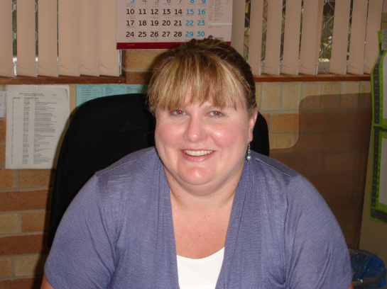

Welcome to Term 3! It has certainly been a busy start to the term. Already we have held Formal Assemblies, had students represent the school at Zone level, Year 11 have had their final two sessions of Aspirations, Year 9 students have had LEAPS, Year 12 have completed their Trial Exams, and Year 10 have participated in High Resolves, Girls Achieving their Potential focus groups have also occurred. And, it’s only Week 4!!

I would like to take this opportunity to welcome Mr Rosete to the position of Year 7 Year Adviser, taking over from Ms Kennedy. I know he has hit the ground running dealing with many of the issues and concerns from Year 7 and I thank him in advance for the contribution he has made to the students and to our Wellbeing Team.

Year 11 are currently completing their Preliminary HSC. Any student who has not completed the requirements of the Preliminary HSC cannot begin the HSC in Term 4. That means that all N Determinations need to be resolved before students can start the HSC pattern of study. Mr Lightfoot and I have been holding senior academic reviews, in order to motivate, guide and support our students. Please support your child by encouraging them to attend school every day on time, equipped and ready to learn.

Unfortunately, we have a number of students who are not meeting expectations in terms of attendance. When a student’s attendance is below 85%, they will not be permitted to participate in extra-curricular activities such as excursions, sporting competitions or school discos. Our focus is always on learning and if attendance is not meeting 85% or above, we can’t have students missing even more class time. Those students who are continually causing concern will be sent a warning letter notifying them that if there is no improvement in attendance, they will be referred to our Home School Liaison Officer.

Mrs J Fuller
Deputy Principal

DEPUTY PRINCIPAL’S REPORT YR 8, 10 & 12

Welcome to all the parents and friends of Airds High School. I hope you all had a restful, relaxing and enjoyable holiday with family and friends. This term is already off to a flying start, with most of our year groups having their formal assemblies in the first two weeks of the term. It is fantastic to see so many of our students taking ownership of their learning and “Striving to Achieve”. Well done to all the award recipients.

The level of excitement at Airds High School is reaching fever pitch as we near our “School Values Showcase” extravaganza. It will be held for the first time at Campbelltown Arts Centre, starting at 6 pm sharp! We have only 150 tickets left and they will not be available at the door, so purchase them ASAP from our school office. Our students have been working extremely hard to perfect their acts and it would be wonderful if they could perform to a full house. I hope to see you there!

The process of subject selection is upon us for Year 8 and Year 10. Year 10 will have their Subject Selection and their Parent Information Session on Wednesday 14th August, with the presentation starting at 6 pm. We hope to provide you with a greater understanding of the expectations of being a senior student and of the various pathways that are available to your child. We look forward to strengthening the school-family partnership to ensure that your child has chosen the appropriate pathway for them.

Should you, or your child, require further assistance in this process, I would like to remind you of some key personnel at our school:

Ms Taylor – Year Adviser
Mr Mitchell Tyler – Rel Careers Adviser
Ms Ros McClure – School Counsellor
Mr Peter Giltrow – School Counsellor

All of the staff can be contacted on our school number 4625 5811.

Year 8 will be commencing their subject selections. For the first time in their secondary education, they will make a significant choice in regards to the subjects that they choose. They will spend an afternoon with various key learning areas (KLA) to learn what electives are on offer for them in 2014. I urge parents to become involved in the process and guide your child to study electives which they like, or, are interested in. Picking subjects because they like the teacher or because their friends are picking it will often lead to poor performance and disengagement. Again, parents are welcome to contact any of the personnel listed above to assist in this process, the only difference being the Year Adviser, Mr O’Neill.

It is countdown time for Year 12 as they head towards their last weeks of their secondary education. Whilst there may be a ‘light at the end of the tunnel’ – I would remind them that they still have a way to go. They will now be approaching their final assessment tasks and they need to make it count. They must be continually studying and revising, asking teachers for that extra help where needed. I would also like to take this opportunity to remind parents that their Graduation will be on Thursday 19th September at 6 pm. The following day, the last day of Term 3, will be their School Values Day. It is a normal school day and their attendance should be encouraged.

As always if you have anything you wish to discuss please contact the school and we can arrange a meeting. During weeks 5, 6 and 7, I will be travelling around to various NSW schoosl working for the Board of Studies as an itinerant marker (Industrial Technology). Ms Angel will be the Relieving Deputy Principal during my absence. I look forward to seeing you all when I return.

Mr S McGuire
Deputy Principal

DEPUTY PRINCIPAL’S REPORT
TEACHING & LEARNING

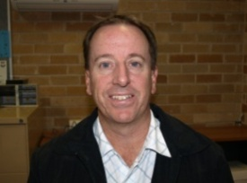

The Subject Selection Evening for Year 10 students going into Year 11 in 2014 will be held in the Airds High School Library on Wednesday August 14, 2013 from 6-7.30 pm.

This is an important time in the lives of Year 10 students and represents the next phase of secondary education.

NSW Government regulations introduced from January 2010 now mean that after Year 10 – and until students turn 17 – students must be:
- In school; OR
- In approved education or training (eg TAFE, traineeship, apprenticeship) OR
- In full-time, paid employment (average 25 hours/week); OR
- In a combination of work, education and /or training

The evening serves as a compulsory part of the subject selection process and students who are not able to attend this meeting should supply a letter signed by a parent/carer to Ms Taylor (Year 10 Adviser). Students will receive a Subject Selection Form for Year 11, 2014. This form will be used to indicate the students’ preferences for Senior School.

On the night there will be presentations on the:
- requirements for senior study including guidance in subject choice
- options for those students who are looking at alternative pathways including representatives from various agencies to discuss TAFE, traineeship’s & apprenticeship’s.

After the presentations you will have an opportunity to talk to representatives from each Faculty area about the different subjects on offer as well as representatives to answer questions re: TAFE & apprenticeships.

This is an important step in your child’s education and we look forward to working together to help them make informed choices about their pattern of study.

There will be a light supper between 5:20 and 5:50pm for those who can make it. (We will stop serving this at 5:50pm so that everyone is settled by 6pm for the presentation).

Up2now – Year 10 & 11 Students
Students in Year 10 & 11 will soon have access through a link in their email account to the Up2now website.
The up2now website allows students to record, organise and share their academic Results, Awards and Achievements. Students can add an overview of themselves and build a portfolio with supporting evidence attached. Students are able to organise their portfolio into several profiles that can be shared with prospective employers or education providers.
Students can add to their portfolio via four sections:
- Results include school reports or a student’s Record of School Achievement (RoSA) – their transcript as an eRecord from Students Online and optional literacy and numeracy tests.
- Awards include publicly recognised, formal accreditation provided by an organisation upon successful completion.
- Achievements may not necessarily come with any official certificate, but are just as important to acknowledge and share. To help students organise their achievements some areas have been added: Leadership, Service, Work Skills and Career Development, Performance, Creative Development, Sustained Participation and Academic. Students are provided with examples of the types of achievements each area could include.
- Student Profiles include an overview where students can provide a summary of their portfolio and a personal description. Students can also select a theme for each profile to adjust its appearance. Multiple profiles can be created with a customised overview and selected list of Results, Awards and Achievements. Each profile has a unique website address that can be shared and reset to a new address at any time.

Mr J Miezio
Deputy Principal Teaching & Learning

School starts at 8:30am EVERY day. Please ensure your child arrives to school at this time EVERY day. If they are late, they MUST bring a note from you explaining the lateness. Thank you for your co-operation

PRINCIPAL’S REPORT
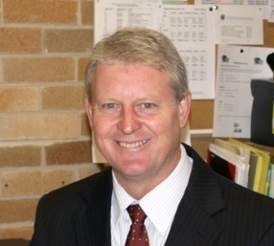

Welcome back to what will be both an exciting and challenging Term 3. As I near the end of my fourth year as Principal things have certainly flown bye, and in that time, I have found that the journey has presented many challenges and opportunities. Airds High is a great place to work, with highly motivated staff, very capable students, fantastic resources, and a supportive community. That’s not to say that it’s not without its challenges. Overall, the need to address educational expectations and improve student outcomes continues to be the number one priority in the school.
As Year 12 begins their final term of secondary education I would like to encourage them to make the most of their remaining time at Airds High School. It is important that learning is their number one priority and that every day of learning (attendance) counts and will make a difference to their final result. Best wishes and we look forward to your graduation at the end of this term.
I would also like to take this opportunity to thank staff for preparing Year 12 for their final exams, and a special thank you to those staff who spent considerable time during the last school holidays with students completing major art and construction works and providing additional study workshops in selected subject areas.
At the end of last term a very successful Parent /Teacher evening was undertaken and it was great to see so many parents in attendance. It is essential that parents play a role in their child’s schooling and the greater the level of involvement the better the eventual outcomes. So a big thank you to those parents who attended and all staff who stayed back to provide quality feedback to parents about their child’s progress.
Last week the schools welfare team ran an extremely successful recognition assembly program. The assemblies highlighted the wonderful achievements of students who contributed positively to their schooling, through outstanding classwork, attendance, contributions to sporting and academic activities. Well done to all certificate recipients.
At the end of last term Campbelltown AECG with assistance of many local organisations ran an Aboriginal Health and Careers Expo. It was extremely well attended and supported by a large number of organisations, local elders and Aboriginal students from a number of local high schools. The major focus of the event was to encourage Aborignial students to pursue a career in the health sciences. A huge thank you to all concerned.
Every week we celebrate Education Week with quality lessons supplemented by activities and experiences occurring across the school, but last week in particular we had a focus on cementing relationships between students and staff through sporting challenges. By all accounts the encounters were positive and enjoyable, well done to the SRC who organised the events and the staff and students who participated.
On Tuesday the 13th August we will be holding our Values Showcase performance at Campbelltown Arts Centre from 6-7pm. There are limited seats available and tickets are $5 each. These will be sold at the front office prior to the event and No tickets will be available at the door.
I wish everyone an enjoyable and educational Term 3.
Mr M Foord
Principal

ADMINISTRATION
Absent Notes
When writing absence notes for your children it is requested that you please add your child’s surname as we have a lot of students who share a first name and this makes it very difficult at times to determine who the note is actually for.
Student medical forms
During Terms 3 and 4 we will be updating our medical records systems to ensure we have the most up-to-date information on your child’s health.

If you have a child with a medical condition you will receive a copy of the new forms in the mail and will need to fill them out and return them to us as soon as you can.

The good news is we have already started collecting some of this information, which means less for you to do. The new forms will help us collect your child’s important medical information and the introduction of new systems will mean we'll be able to better manage the daily and emergency health needs of your child.

We appreciate your support as we start collecting the information, and if you have any questions please call.

Make Online Payments
It is now possible for parents to make online payments to the school via a secure payment page hosted by Westpac. Payments can be made using either a Visa or Mastercard credit or debit card. The payment page is accessed from the front page of the schools website by selecting $ Make a payment.
Items that can be paid include subject fees, excursions and sales to students. Complete payment of a school invoice can be made by accessing the category called Other.
When you access $Make a payment you must enter the students name and class OR the students name and date of birth. These details are entered each time you make a payment as student information is not held within the payment system. This is a secure payment system hosted by Westpac to ensure that your credit/debit card details are captured in a secure manner, these details are not passed on to the school. Receipts can be emailed or printed. Details of the payments are passed daily to the school where they will be receipted against your child’s account. As a receipt has been issued from the payment page a further receipt will not be issued from the school.
For any enquiries regarding the online payment process please contact the Front Office.
COMMUNITY NOTICES
CAMPBELLTOWN JUNIOR OZTAG
2013 SUMMER REGISTRATIONS

VICTORIA PARK, MINTO played THURSDAYS
Registrations being held:
Thursday 8th & Thursday 15th August 4.30 – 6.30
at Victoria Park, Minto

Comp kicks off Thursday 5th September 2013
Registration $65 per player

For further details contact
Helen: 0409 301 660
campbelltown@oztag.com.au
www.greaterwestjunioroztag.com

