Airds Announcer |  | 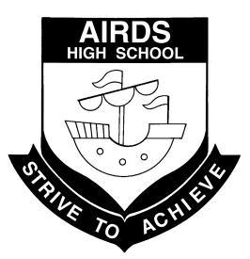
“A place to learn, lead and achieve your personal best”
Find us at: Airds High School, 2 Briar Road, Airds NSW 2560
airds-h.school@det.nsw.edu.au
Issue 2– Term 1 | April 2013

DIARY DATES
Mon 8th-11th April Year 12 Half Yearly Exams
Wed 10th April Year 10 School Values Day
Thurs 11th April Year 9 School Values Day
Fri 12th April End of Term 1
Mon 29th-30th April School Development Days
Wed 1st May Students return Term 2
Thurs 2nd May Yr 10 Hamlet English excursion
Fri 3rd May Formal Assemblies
Cross Country
Wed 8th May Zone Cross Country – Mt Annan
Fri 10th May Year 12 Bake Sale
Mon 13th-17th May Yr 7 & 9 NAPLAN
Fri 17th May Yr 11 Romeo & Juliet English
Excursion to Riverside Theatre
Tues May 21st Flag Ceremony
Thurs 23rd May Yr 7 & Yr 9 boys vaccinations
Fri 24th May Athletics carnival
Mon 27th-31st May Year 7 – 10 half yearly exams

NEXT P&C MEETING
WEDNESDAY 1st May
AT 10:15 am
IN THE STAFF COMMON ROOM

WOULD LOVE TO SEE YOU THERE!

PICLO REPORT
Pacific Greetings to all staff, students and their families.
Combined Pacifica Nesia Fest
Pacific students are busy practising what sometimes can be a demanding and hectic routine, they have worked really hard to get to where they are now. I applaud the students who have made this commitment, as one student has said “I’m doing this to change the way people think about our school” what a profound statement, it truly shows the dedication these students have to becoming wonderful role models and leaders in the future. Please come and support the Pacific students as they participate in the Combined Pacifica Nesia Fest on April 20th 2013.
Thank you to all those parents and students who contributed to the cake stall fundraiser, because of your efforts we are able to purchase costumes and costume materials. We had plenty of compliments for the chocolate cheesecake, mars bar slice, caramel slice and the vanilla and choc chip cupcakes. Yummy.
UWS Pathe Workshop - Pacifica Achievement to Higher Education
We were fortunate to have Moera Sakimi and her team come and do a workshop with the students. They got to learn about how to make the right choices that would benefit their careers and the best ways to get into University through bridging courses and pathways.
They enjoyed the activity which required them to question and answer each other to find out what they needed to obtain certain careers, the personal stories from Pacific students who are currently attending UWS were inspiring and at times moving and gave a true insight into life before and after university.
Pacific Achievement to Higher Education PATHE are a group of Pacific students and teachers who support Pacifica university students while they are at uni. There will be a ‘BRING THE FAMILY TO UNI DAY’ Wednesday 24 April from 5.30-9.00pm.
A bus will be provided for families who would like to attend, the afternoon involves a mini lecture, tour of the campus, Pacific buffet and presentation. If you are interested in going to university contact me for your spot on the bus. Ph 46255811 Maryanne Varu
Hope you all enjoy the school holidays coming up and don’t forget to come and support our students at the Nesia Fest. Thank you to all those parents who are helping with costumes etc and the best of luck to our students who are performing I know you are going to be absolutely AWESOME.
Kia Manuia
Mrs M Varu
PICLO

FROM THE PASTORAL CARERS DESK
The end of first term is approaching. Our school community has been very busy this term with so much activity, and we can see where considerable improvements are being achieved. We are very fortunate to have such dedicated staff; who as a team, continue to work tirelessly together. It is a privilege to work with such committed and supportive people. Airds High School has strong core values of excellence, respect, responsibility, co-operation, participation, fairness and caring for others. These values and focus are of real benefit to all our students.

The Easter holidays and then school holidays (which include Anzac Day), are a welcome break and opportunity to recharge the batteries. The messages of hope and sacrifice at Easter and Anzac Day are worth reflecting upon, and being thankful for. Although, the cultural diversity of our nation is reflected in the many ways Australians spend these holidays. Some will spend time with family and friends, or relax on the beach, some will be working, and others will stand together in reverence. How ever we choose to spend this time, we should be united and rejoice in the freedom and tolerance we all enjoy. These are precious values and will maybe encourage us to take stock of our lives and our society.

Now I’ll ask you these questions…
Are you going to show tolerance?
Will you respect differences and accept others?
And will you stand strong to support these values of freedom and tolerance?
These qualities of decency are important to learn, practice and live in order to have a fair and caring society for all!

I would like to wish everyone a safe, happy and restful holiday. Next term I will be at AHS Wednesday & Thursday. If I can be of any assistance please do not hesitate to contact me.

Until next time, cheers.

Rob Hodgson, JP

TEACHING AND LEARNING REPORT

SLSO’s
Term 1 has been an exciting term in the T & L faculty for the SLSO’s. Ms Marie Addamo has been supporting Years 8, 10 and 12 and Ms Julie Hopwood has been supporting Years 7, 9 and 11. Ms Hopwood has worked hard assisting the Year 7’s with their transition into high school and all of the supported students seem to be thriving in their new environment. Ms Hopwood is assisting Year 11’s prepare for their senior years, getting on track for HSC.
Ms Addamo has worked closely with Year 12 to ensure they are keeping on the fast track to their HSC. Year 8 students have been targeted for literacy assistance and Year 10 has been assisted in their preparation of narrative scaffolds. Both Ms Addamo and Ms Hopwood are enjoying working within the classroom, offering assistance to both the student and the teacher, working towards their goal of assisting all targeted students to achieve their personal best.
Ms Addamo and Ms Hopwood participated in Professional Development this term, undertaking a two day conference presented by the SPELD organisation designed to provide new strategies to augment our literacy improvement program.
We are:
Safe
Respectful
Learners

SCIENCE REPORT

YEAR 7
Year 7 have been working hard in their Science classes this year. All students should have now received their Bunsen Burner Licenses. This allows the students to demonstrate their ability to be safe in the laboratory when working on experiments for many years to come.
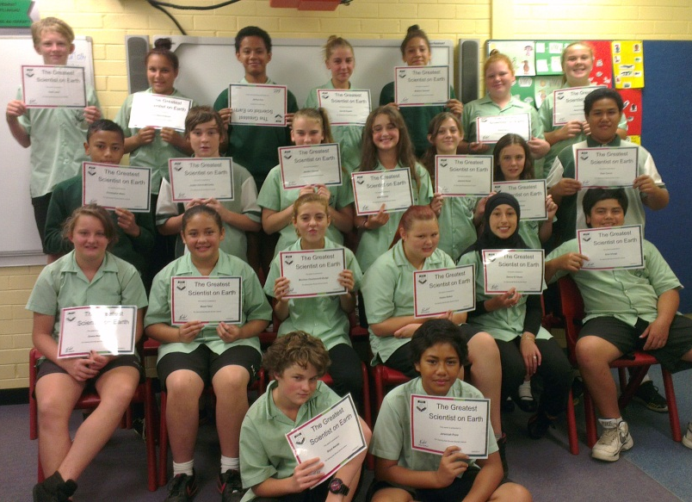
7 Lorikeet and the Bunsen Burner Licenses

Year 7 have now transitioned nicely into their streamed Science classes. There are 4 classes and their teachers are as follows:

7 Bellbird | Mrs Stoddart
7 Lorrikeet | Mrs Fuller
7 Rosella | Miss Radford
7 Kookaburra | Mrs Stoddart

YEAR 8
Year 8 have finished their first topic on the Ecosystem and are currently studying the topic Energy. It looks at how energy can undergo many changes relevant to the use required and electricity. All classes have now received back their assessment tasks on an Australian Endangered Animal. If you are unsure of your childs marks, please don’t hesitate to contact their relevant teacher.

8 Moray | Mrs Holmes
8 Snapper | Mrs Stoddart
8 Trevally | Miss Radford
8 Barramundi | Mrs Stoddart

Assessment task results – Endangered Species Research Task:

Moray
1st Place: Melissa Simpson
2nd Place: Aurin Jones and Nora Al-Katify
3rd Place: Jasmine Thomas and Joel Etherington

Trevally
1st Place: Mylove Puia
2nd Place: Adrian Endicott and Jaycob Oloaga
3rd Place: Tara Drake

Barramundi
1st Place: Aaron Longley
2nd Place: Jaycob Cumberland
3rd Place: Jaimee Morrissey and Chloe Baker
YEAR 9

9 Echidna | Miss Radford
9 Koala | Mrs Stoddart
9 Wombat | Ms Simms

Year 9 have completed the topic Staying Healthy. Students were involved in growing bacteria and dissecting a lambs brain to examine and identify the different areas.

They are now completing the topic Sense and Control, where each of the five senses are examined in further detail. Each class started with the sense of sight. A number of classes completed a bull’s eye dissection and most students were fascinated by the actual structure of the eye. They were able to identify the different parts of the eye.

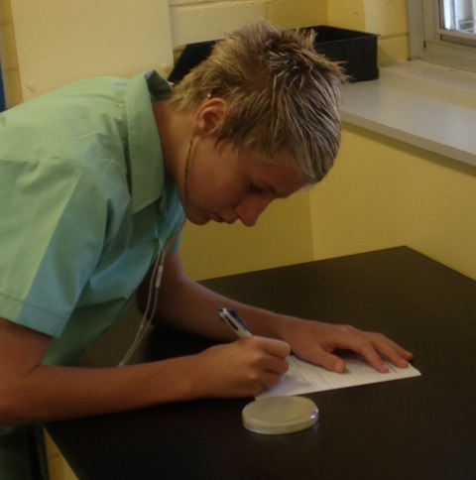

9 Wombat students writing their results on the growth of their bacteria from around the school

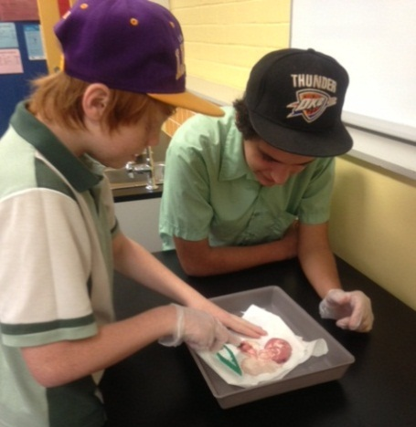

and dissecting a lamb’s brain.

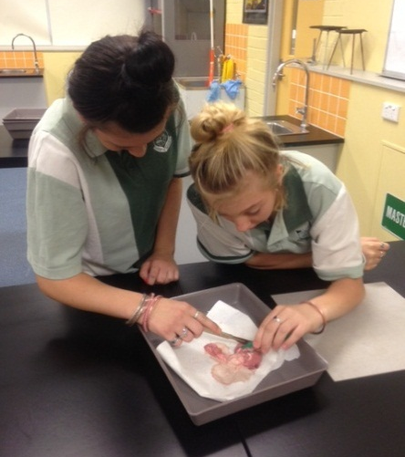
The eye as we see it

The inside of the eye
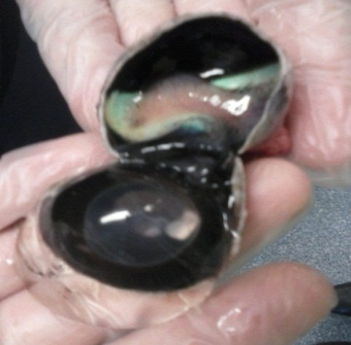

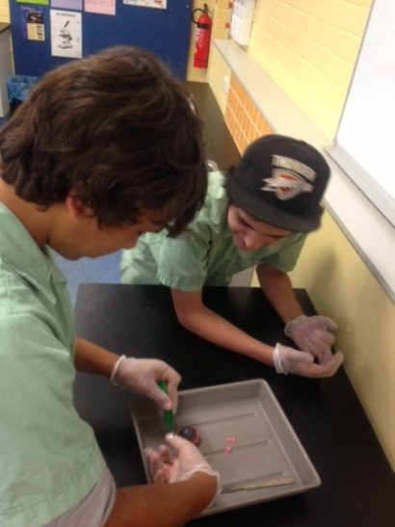
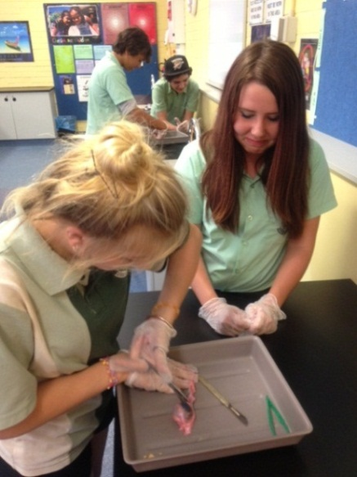

Year 9 students received their Infectious Diseases Assessment Tasks back. If you are unaware of what your child received, please don’t hesitate to contact their teacher. There were a number of students who did not complete this assessment task which will now affect their ROSA.

9 Echidna | Miss Radford
9 Koala | Mrs Stoddart
9 Wombat | Ms Simms

Assessment task results – Infectious Diseases Research Task:

Echidna
1st Place: Angela Franks
2nd Place: Rhiannon Cuthbert
3rd Place: Emily Moore
Koala
1st Place: Naya El-Abd
2nd Place: Emily Pilliskirk
3rd Place: Tyrone Turner
Wombat
1st Place: Megan Pollard
2nd Place: Damien Ellis
3rd Place: Shianna Holt
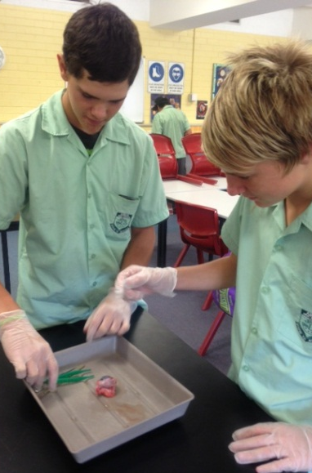
YEAR 10
Year 10 have just completed their first topic on Chemistry, where they have learnt about a number of different reactions and how acids and bases react. They have also completed their first assessment task for the year. It was a practical task which involved students working safely with acids and bases determining how they react. If you are unsure of your child’s result, please don’t hesitate to contact their teacher.

10 Goanna | Mrs Holmes
10 Python | Miss Radford
10 Turtle | Mrs Stoddart
Assessment task results – Acids and Bases Practical Test:

Goanna
1st Place: Kyle Brown
2nd Place: Kimberley Gimbert
3rd Place: Al-Harraz Hudaja
Python
1st Place: Killara Bell-Stewart
2nd Place: Sammantha Dickinson
3rd Place: Tai Burogolevu, Namiro Puia and Isimeli Ratuvou
Turtle
1st Place: Joshua Woodin
2nd Place: Natasha Eteaki, Bonnie Kendrick and Sonja Ta’ase
3rd Place: Shannon Morrissey

YEAR 11
The three classes in Year 11 are continuing to work hard and they have now all completed their first topic and their first assessment task. Senior Science students have received back their marks. Biology and Chemistry have not yet received their marks; however, they will be back to students in the coming weeks.

YEAR 12
With only 2 terms left of high school for these students they are currently busy knuckling down and ensuring that they are learning to their potential. Recently they went on an excursion to the Museum of Human Disease (situated at the University of New South Wales). This excursion directly related to a number of syllabus outcomes for the students which needed to be met. Reports from both staff and students is that the day was a great learning experience and thoroughly enjoyable for all.

Miss E Radford
Science Teacher

ABORIGINAL EDUCATION REPORT
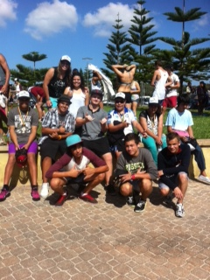
Airds High School students made both their families and community immensely proud by attending National Aboriginal and Torres Strait Islander Sporting Chance Academy (NASCA) Careers Academy Program (CAP) for the week.

Mr Tyler accompanied 15 students on the camp where they joined other schools from South Western and Western Sydney to explore a variety of career pathways options. The students and Mr Tyler stayed at the National Centre for Indigenous Excellence (NCIE) at Redfern and attended a number of workshops run by the NASCA network partners including Lend Lease and Qantas. Students also gained Surf Lifesaving qualifications at Maroubra beach.

It was wonderful to hear of the activities of the camp, but we were also thrilled to hear about the outstanding behaviour and participation that students displayed throughout the week. Well done to all those attended!

The Airds Community of Schools conducted a parent and community excursion to the Opera House to watch ‘Wulamanayuwi and the seven Pamanui’ as part of the annual Sydney Message Sticks festival. We were pleased to see many parents and community attend the event. There will be a number of events upcoming over the year for parents and community and we look forward to seeing the many new faces.

The Sistaspeak program being implemented by Bobby Ann Trindall and Lisa Chesterfield held a luncheon for community and Mums at John Warby to wrap up Term 1 of the program. We were extremely pleased with the number of mothers, grandmothers, aunties and community role models who turned out on the day. We have seen the confidence of the girls grow and we look forward to seeing what wonderful activities they come up with in Term 2.

The Brospeak program has been exploring culture and heritage with Jason Sampson and Kevin McGuinness for a number of weeks. They were fortunate to have a visit from the Aboriginal Legal Service and have been supported through the volunteer work of Terry Manton who we thank for his continued commitment to our school.
Aboriginal Education is continuing to grow at Airds High School and we thank the support and involvement of students, staff and community.

Ms T Anderson
DP Aboriginal Education

OFFICE NEWS
When an absence letter is sent out to you, you may see a time after an absence date. That time denotes a partial absence eg, your child has arrived late to school after 8.30am and therefore is recorded as a partial absence according to DEC policy. You are required by law to provide a reason at the bottom of the note as to why your child was late.

It is essential that we have the correct details in the case of an emergency, so we are sending out to parents a Student Emergency Contact Report to accurately update our details. We would appreciate it if you could change any relevant details and sign the bottom of the form and return it to the school. It is required by legislation that we have the details correctly updated for the safety of your child.

Parents/Guardians

When writing an absent note for your child, could you please include your child’s surname. This will make it easier for the office staff to record the absence.

SRC REPORT
March has been a very busy month for the SRC. Earlier on in the month, Angela Franks, Justin Peachey and Rhiannon Cuthbert joined Mr Wallace at AB Central for Clean Up Australia Day. The students worked tirelessly throughout the day and managed to gather a mountain of rubbish from around the local area. These 3 students should be congratulated on their efforts and the great citizenship they showed.

The SRC has also been very busy this month preparing for the end of term Disco. To make the night enjoyable, the SRC has purchased two professional Disco lights and a smoke machine. They have also been working hard on preparing music and games for the night – including creating a giant twister mat! The Disco will be running on Wednesday, April 3rd from 5.30-9.30pm, and we hope that all those who attend have an enjoyable and safe night.

Coming up at the end of the term, Year 7 will be selecting their SRC representatives. Joining the SRC is a rewarding experience for students, helping them gain confidence and leadership skills. Any students in Year 7 who wish to nominate themselves should see Mr Wallace or Ms Kennedy for nomination forms.

Finally, the SRC have a very exciting opportunity coming up next term. To help improve their leadership skills, Aussie will be running a leadership program with the SRC during Term 2. This program is going to be both fun and rewarding for everyone who will be involved, and I look forward to seeing what the SRC will produce in conjunction with Aussie. Stay tuned for further details!
The SRC hopes everyone has a safe and enjoyable break!

Mr Wallace
SRC Co-ordinator
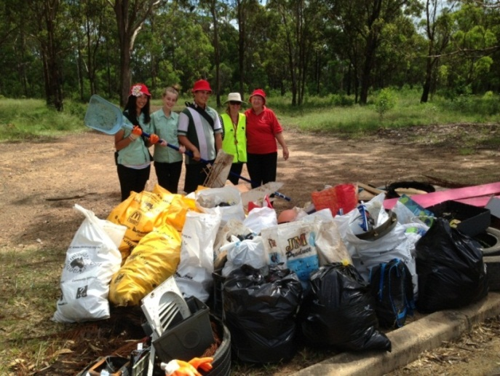

FOOTBALL UNITED REPORT
It has been a very busy start to the year for the Football United program. Football United uses the magic of football to bring people together for the common goal of creating harmonious and cohesive societies. They aim to build on and improve the skills of people in diverse areas that includes high proportions of refugee, migrant and Indigenous Australian children, youth and families.

The Football United After School Training program recommenced in Week 6 of this term. Numbers at this point have been disappointing especially since this is a fantastic opportunity for the students to have some fun after school and learn some soccer skills (also it is absolutely free!!!). Students from our local feeder primary schools John Warby, Briar Road, Bradbury and Woodland Road as well as Airds High School students in Years 7-10 are welcome to attend. Sessions run on a Monday afternoon from 3:15pm – 4:30pm on the back oval at Airds High School with Stuart and his team of coaches. If you want more information or a permission note contact the Sport Organiser at your primary school or Ms Simms or Mr Miezio at Airds High School on 4625 5811.

We were lucky enough to have the Football United Director Anne Bunde-Birouste attend our launch day as well as Sydney FC players Terry McFlynn (Captain) and Vedran Janjetovic (goalkeeper). The students really enjoyed the talk given by Anne and they learnt the Football United song “Field of Dreams” and they featured in the video clip. If you would like to watch the clip go to http://www.youtube.com/watch?v=PS3CV0yVSAg.

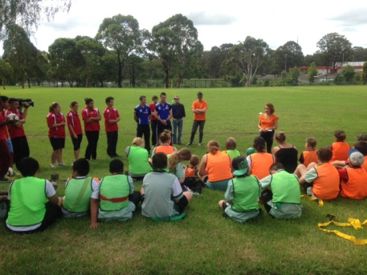
Anne introducing everyone

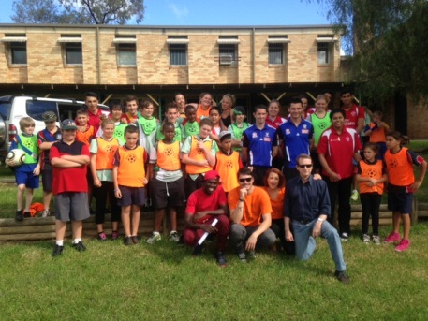
Group photo
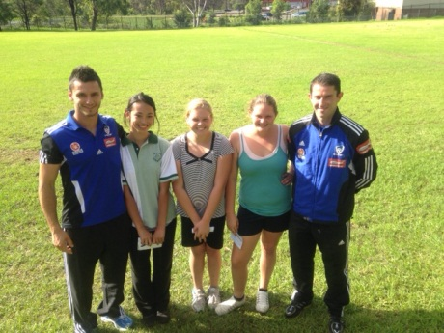

Angela, Hayley and Chloe with the Sydney FC players

A number of students in the Football United program were invited to attend the Harmony Day match with Sydney FC taking on Melbourne Victory at Allianz Stadium. Participants and their families got to not only see a great game but many of our students carried relevant flags from their home countries to celebrate multiculturalism and diversity. Many of them also got to participate in small sided games on the field at half time. The Football United song was launched on the day and the kids got a kick out of watching themselves on the big screen in the video clip!

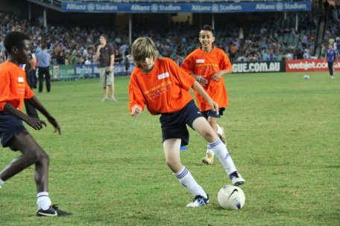
Joshua McDonald showing his skills
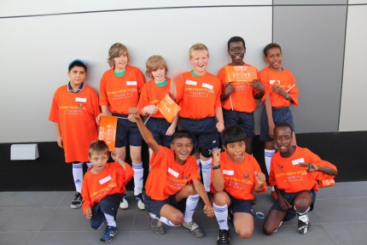
Group shot
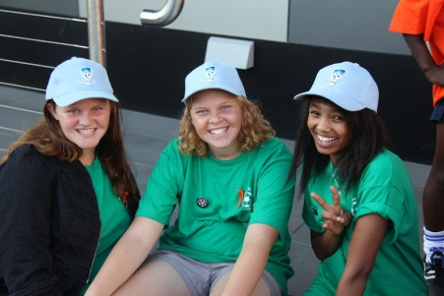
Chloe, Hayley and Adde

If you have any questions about the Football United program, please do not hesitate to contact Ms Simms or Mr Miezio.

PDHPE REPORT
It has been a busy start to 2013 with the Swimming Carnival being held and knockout sporting teams commencing their competitions. Mr Halliburton will update you with the progress of these in the sport report.

It has been very pleasing to see students achieving their personal best in PDHPE lessons. The majority of the students have been remembering their change of shirt for PE lessons which demonstrates they are turning up to class prepared to be a learner. Please remind your child to pack their sport shirt for practical lessons as this does make up 50% of their assessment mark for the subject.

We had Mr and Mrs Philipsen come out from East Campbelltown Eagles Soccer Club and run skills sessions during sport lessons for Years 7-11. They ran through some drills that enabled the students to practise their soccer skills and then put them into action with some small sided games of soccer. Thanks for taking time to come out and expose our students to the world game of soccer.

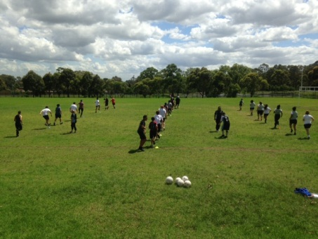
Year 11

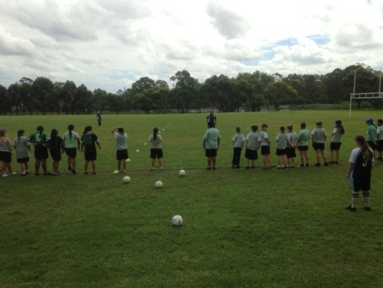

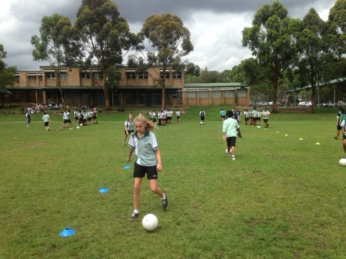
Year 7
Miss Simms’s Year 11 and 12 Coaching classes have been busy accumulating hours for their Work Placement by assisting at the school swimming carnival, primary school zone swimming carnival and at the primary school gala days. Well done to all students involved in these activities as we have received lots of positive feedback about your assistance on these days. The Year 11 Coaching class had a visit from the local ARL Development Officer Drew Dalton who is putting them through a Rugby League accreditation. The skills they learn from these workshops will be put into practice to run a Gala Day with Year 7 midway through Term 2.

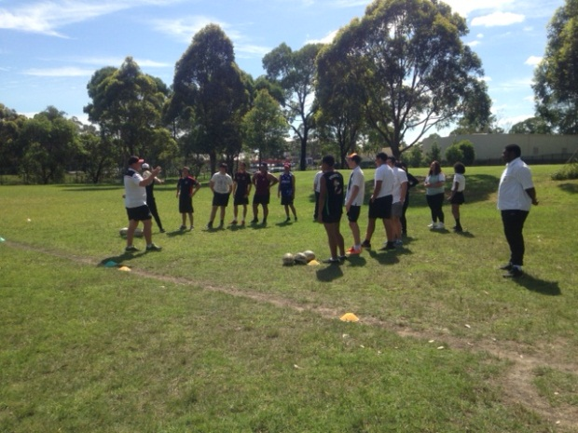

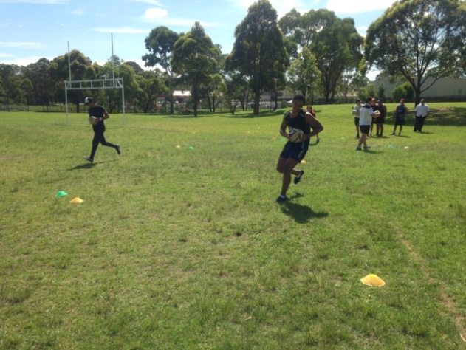
Year 11 participating in the Rugby League clinic

We hope that everyone enjoys the first holiday break of the year.

Mr S Wagner
PDHPE Head Teacher

TAS AND CAPA REPORT
As Term 1 draws to a close after an exceptionally busy term, it would only be fair to comment on what our students have achieved in TAS and CAPA thus far.

TAS
During this term Mr John conducted a two day Construction Induction Program with selected students from his Year 9 and Year 11 Construction class. This allows students to learn about essential Workplace Health and Safety practices within the Construction industry. The successful completion of this program means that students will now be qualified with a White Card, enabling them to work outside on a Construction worksite. This program is highly beneficial for our students who not only will be going out on work placement throughout the year but would also like to work in the Construction Industry. Students will be issued with their qualification certificate when they arrive next term. Well done to our students and thank you to Mr John for this valuable day and giving this opportunity to the selected students.

TAS VET subjects such as Hospitality with Ms Coogan, Metals and Engineering with Mr Lightfoot and Construction with Mr John necessitate that our senior students complete work placement as part of their course requirements. Some students have already successfully completed their work placement while others will be completing their placement during their allocated weeks throughout the year. For any enquiries regarding work placement please do not hesitate to contact and speak with any of the relevant teachers who will be more than happy to answer your questions.

CAPA
Our Year 12 Visual Art students have been placing great effort working towards their Year 12 major works.

Students from Ms Taylor’s Year 11 Visual Art class attended an excursion to the Art Gallery of New South Wales to see the Artexpress exhibition, which showcases the highest ranking HSC Visual Art students from the previous year. The students were inspired and intrigued by some of the artworks that were displayed and hopefully sparked some early interest as to what they may like to comment on when their time comes later this year. All round it was an enjoyable day, exploring the gallery’s permanent collection as well as a lovely stroll through the Botanic Gardens as we made our way back to our transport home.

The Year 7 Showcase night allowed for all our TAS and CAPA students to exhibit the wonderful work they had completed in class. It was not only a great opportunity for parents to see firsthand the exceptional work produced by our students but also for staff to have the chance to meet with parents.

As many parents may be aware there have been changes to our Year 7 Technology Mandatory, Music and Visual Art classes. This change means that your child may have been moved to a different class with a new teacher. Students will have the one teacher for the full year but will be completing different specialised areas in Technology Mandatory. The new teachers for each Year 7 classes are as follows:

Class | Teacher | Subject
7A | Ms Vongsouvanh | Technology Mandatory
 | Mrs Bateman | Visual Art
 | Ms Green | Music
7B | Mr Lightfoot/Mr John | Technology Mandatory
 | Mrs Bateman | Visual Art
 | Ms Adair | Music
7C | Mrs Drakefield | Technology Mandatory
 | Mrs Bateman | Visual Art
 | Ms Adair | Music
7D | Mr John/Ms Coogan | Technology Mandatory
 | Mr Wallace | Visual Art
 | Ms Adair | Music

All TAS and CAPA subjects contain fees. Your child’s fee includes all the resources and materials required to complete projects which they will use in their practical lessons. If your child’s fees have already been paid in full then it has been greatly valued. If fees have not been paid then it would be appreciated if it could be paid at the front office prior to the end of the term or early next term. Fees letters can be obtained from your child’s teacher outlining costs and equipment involved for each subject.

If any parent/guardian is concerned of the progress their child is making in any TAS or CAPA subjects they can contact me or any of the relevant staff in our faculty and we will be able to give valuable information on your child’s progress.

There are many activities happening within TAS and CAPA in Term 2. Until then, have a safe holiday.

Ms Vongsouvanh
Rel HT CAPA/TAS

YEAR 12 REPORT
Term One has been a fantastic Term for Year 12.
The Year 12’s had a ball at the Year 12 Values day that had a focus on teambuilding and leadership. The students were involved in a number of teambuilding and initiative games competing in groups for the ultimate prize. Later that day, Year 12 was taken to Penrith Ice Palace for some extra team work challenges.
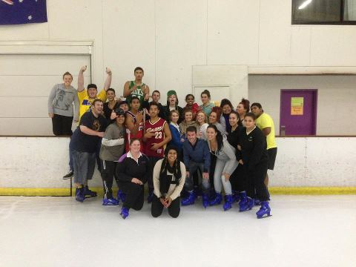

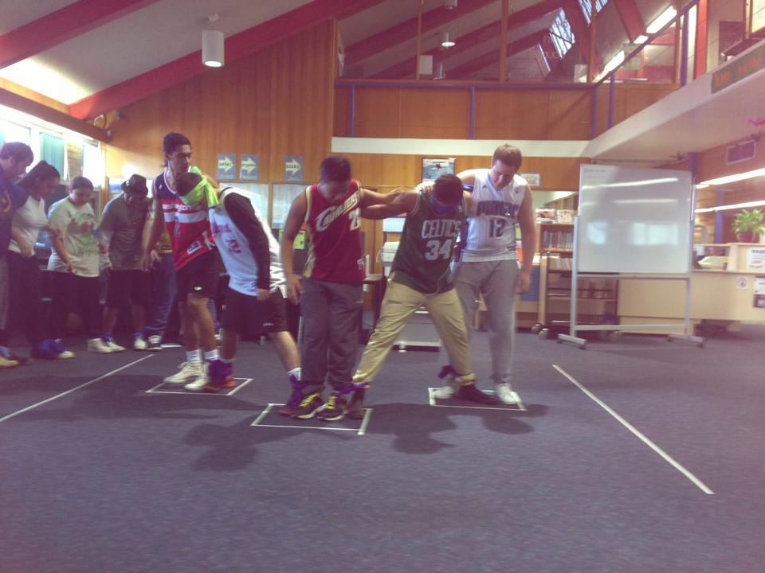
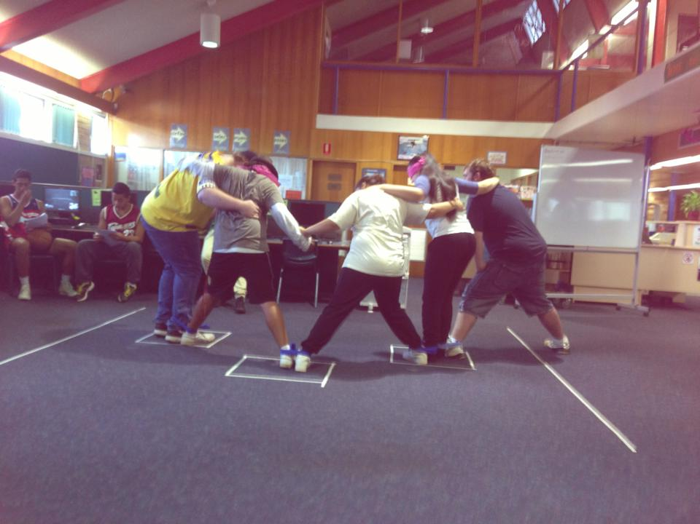
Year 12 Values Day
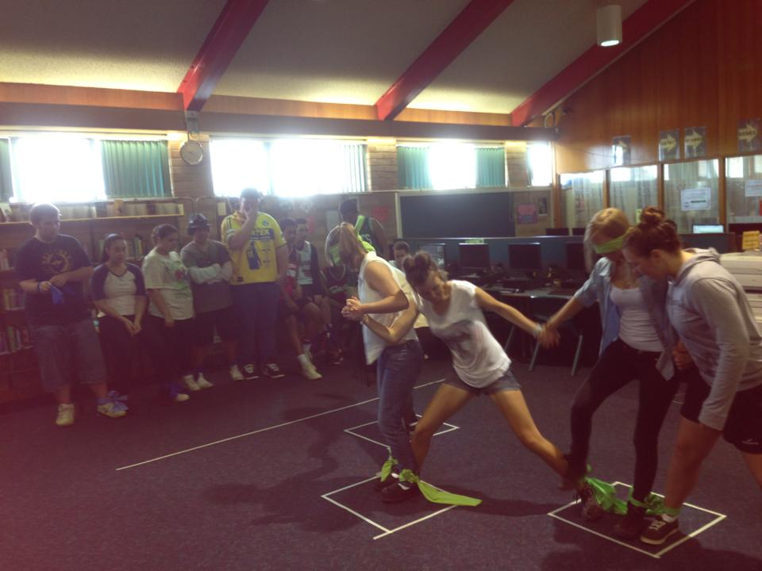

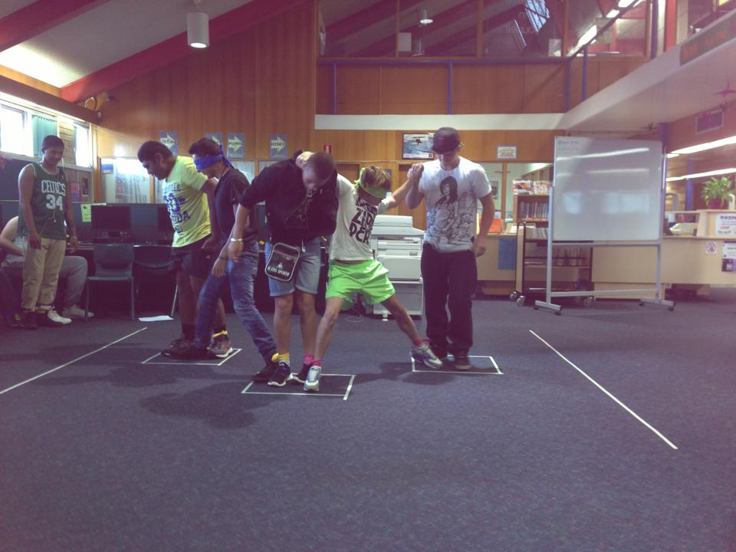
Year 12 Values Day

The fundraising committee have been working really hard this term. Here are a few of the events they have facilitated.

On the 4th of March, Year 12 held a Family Fun Night Fundraiser at Campbelltown MacDonalds. The committee worked tirelessly in the days leading up to the event distributing flyers to all the houses in Airds and Bradbury. Well Done Girls! We would like to thank everyone who attended and purchased food to support the Year 12’s fundraising committee.

The Year 12’s also held a successful fundraiser at the school Disco selling sausage sangas, drinks, ice blocks and glow sticks. The students had a great time and the fundraising was a huge success. A huge well done to the Year 12 students who attended and helped out on the night.

While this article is being published the Year 12 will be involved in a helper for a day and staff car wash. It is sure to be a huge success with many staff cars booked in and many helpers purchased.

I wish all the Year 12’s the best of luck for their half yearly exams. I hope you have a fantastic 2 weeks holiday – be safe and study hard.

“The difference between a successful person and others is not a lack of strength, not a lack of knowledge, but rather a lack of will.” - Vince Lombardi

Ms Green
Year 12 Adviser

DEPUTY PRINCIPAL’S REPORT YR 8, 10 & 12

As we approach the end of Term 1, it is only fitting to reflect on what has been achieved so far. Most of our students have been working hard to build upon their learning; this was clearly evident as the Senior Executive conducted lesson observations for every teacher. I myself witnessed many exciting and dynamic lessons where our students demonstrated their ability in safe, fun and happy classrooms.
By the time you receive this newsletter Year 12 will have completed their Half Yearly examinations. The results of these will give you and your child an opportunity to gauge how well they are travelling. There is no substitution for hard work and it is vital that your child establish a regular study program. At least a couple of hours revision is required every evening if your child is to achieve to their potential.
With the clocks moving back one hour, this should make getting out of bed in the morning a little easier. Our school day commences at 8.30 am each day. This is when the rolls are marked and important information is given to our students. If your child arrives after this time they may be recorded as absent; this can affect Centrelink payments, lead to a Home School Liaison Officer (HSLO) referral and even affect their ability to meet mandatory Board of Studies and Higher School Certificate requirements. I would like to thank Mr Rosete and his team for the hard work they have done to improve our attendance rates.
Recently a number of parents have contacted me in regard to Cyber Bullying issues. This hideous misuse of today’s technology has caused significant disruption to the learning of our students. In some cases this has been the direct cause of aggressive behavior in our school. The school and community must work together if we are to prevent this type of harassment and remove unnecessary stress and anxiety for our students. Please monitor your child’s internet usage, especially when using facebook. I have a number of pamphlets that deal with Cyber Bullying, feel free to contact me if you would like one.
Lastly, I would like to take this opportunity to wish everyone a peaceful, restful and relaxing holiday break. I look forward to seeing you at our upcoming school events.
Mr S McGuire
Deputy Principal

DEPUTY PRINCIPAL’S REPORT YR 7, 9 & 11

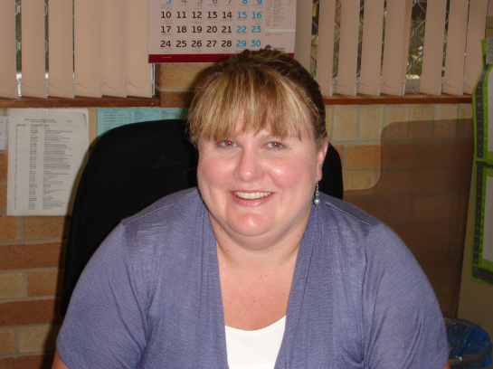

By the time this edition is printed Term 1 will be nearing an end. It has been an extremely busy yet productive term. At this point, there are several highlights that I would like to mention and recognise.

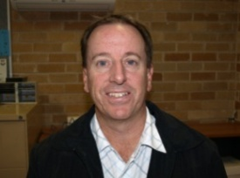
Our first school disco, in quite a while, was held on April 3 and was a huge success. I would like to thank Mr Wallace and the SRC for all of their work in making this event so enjoyable for all of the students. It was great to see so many students being rewarded for being safe, respectful learners throughout Term 1 and keeping their attendance above 85%. Congratulations to all concerned. We hope that this event will become a regular feature of our school calendar once again.

The SRC will also benefit from our connection with Aussie this year. In Term 2, students will be participating in a program that will consolidate and strengthen their leadership capacity. The staff at Aussie have developed a very intensive and engaging program that will see our SRC challenged and moved out of their comfort zones. Mr Wallace and I are very excited about this opportunity and look forward to keeping you informed about the program as it evolves.
The Year 7 Showcase was held on March 8 and was another excellent opportunity for our school to celebrate the achievements and talents of both our students and staff. It was wonderful to see so many parents supporting their children and taking an interest in the work that they have produced across all key learning areas since the start of the year. As outlined, Year 7 have all moved into their 4 classes and the majority seem to be settling well. The Year 7 camp for the boys will finally have happened (thanks to improved weather) and I am sure that Mr Foord and the boys will be able to report on their adventures in the next edition!

On the camp note, Mr Lightfoot and 32 Year 11 students will depart on their camp in the coming days. I am sure that they will enjoy the experience as they bond and prepare themselves with the necessary study and stress management skills to be effective learners in the coming months. I look forward to hearing of the challenges that these students faced over their two days at camp.

Last night I had the pleasure of attending the LEAPS launch with our Year 9 students. I would like to congratulate Mr Latulipe for his organisation of this event and commend the students involved. They were exemplary ambassadors for our school and I am sure that each of them will benefit from this invaluable experience.

I hope that you all have a wonderful break and look forward to working with you all again in Term 2.

Mrs J Fuller
Deputy Principal

DEPUTY PRINCIPAL’S REPORT
TEACHING & LEARNING
It is hard to believe that we are at the end of first term already. I would like to thank all staff for their hard work and dedication in providing a supportive learning environment for the students of Airds High School.
Firstly I would like to acknowledge all of the Year 7 parents and students that attended the Airds High School Showcase on Thursday 7th March where each KLA presented material representing the Relationships unit. I was very impressed with the quality of work that was on display. The tour of classrooms and facilities was very successful with a lot of questions and interest shown.

Earlier in the term I visited all of our feeder Primary Schools (Briar Rd, Bradbury, John Warby & Woodland Rd) with Ms Holmes to introduce our transition to high school program and to provide information about the scholarships for Year 7 students in 2014. In 2013 8 Year 6 students will be offered scholarships to attend Airds High School. These scholarships will include: provision of a full school uniform, payment of school fees and excursions in 2014 and full payment to participate in the Year 7 “Get to Know You Day” events. Applications for the scholarship can be obtained from the front office at Airds HS; copies will also be left with the stage 3 coordinators at each of the primary schools. If you would like further information re: these scholarships please contact me at school.

We also discussed the Middle School Gifted and Talented Challenge which involves students from the Primary Schools (6 students are nominated from each school).The challenge will take place one day each term at AHS and will be run by the Yr 9 G & T students under the supervision of AHS G & T teachers. These students will participate in set challenges rotating their way through KLA based quiz questions, problem solving activities and team building experiences. Each school group will be given points for each challenge and these will be collated after each day. At the end of the year, the school group who has the most number of points will win the annual G & T Middle School Challenge. Woodland Rd Public School is defending their title. A cross school blog will also be established for this group to communicate and set challenges during the year.

Year 9 students have all received their laptops and it is pleasing to see them being used in the classroom. This is the last year for the DER laptops being issued to Year 9 students. For those parents of students in Year 10 to 12 we are seeking your views on the DER - NSW one-to-one laptop program.

A formal evaluation of the program is being undertaken by the New South Wales Department of Education and Training in collaboration with the University of Wollongong. It is an effort to determine how the DER-NSW program may impact on learning and teaching education across the state. The evaluation has taken place over 4 years. Please go to the link below and complete the 2013 survey. It won’t take you too long.
http://www.surveymonkey.com/s/DER-NSW-Pr2013?c=8493

To access the link please enter it into the long address bar at the top of the page of your internet browser (not into a search engine such as Google) and press enter or go – this will take you to the survey.
Individuals cannot be identified in the data.
Evaluation reports to date can be viewed online: https://www.det.nsw.edu.au/about-us/how-we-operate/national-partnerships/digital-education-revolution/rrql/research.

Finally I would like to promote the Football United After School Community Soccer Program. Football United uses the magic of football (soccer) to bring people together for the common goal of creating harmonious and cohesive societies. Every Monday afternoon between 3.15pm & 4.30pm students get to participate in football activities run by trained coaches and mentors in a fun supportive environment. It is open to all students that attend Airds HS (Year 7-9), Briar Rd, Bradbury, John Warby & Woodland Rd Public schools. Flyers have been distributed to all school with further details. It is free, so come along and join us.

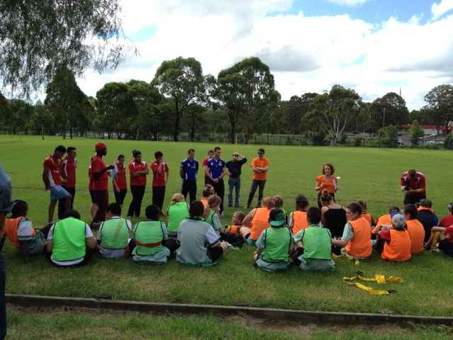

Launch day held on Monday 4th March with two
Sydney FC players.
For further information about football united you can go to www.footballunited.org.au

Mr J Miezio
Deputy Principal Teaching & Learning

School starts at 8:30am EVERY day. Please ensure your child arrives to school at this time EVERY day. If they are late, they MUST bring a note from you explaining the lateness. Thank you for your co-operation

PRINCIPAL’S REPORT

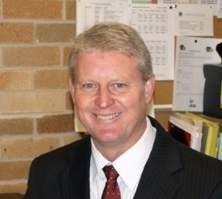

As we near the end of Term 1 for 2013, I would like to take this opportunity to acknowledge firstly the commitment and enthusiasm of all Airds High School staff whom on a daily basis provide a quality education for all of their students. This is not an easy job and at times extremely stressful. So I commend you on the work that you do and the effort you make to enhance the lives of our students.

A number of extra curriculum activities have also been organised by staff to supplement the quality work in classrooms. These additional activities enrich the quality of the learning experience and give it some relevance, thus ensuring a deeper understanding of subject knowledge delivered across various KLAs. Details concerning the various activities and excursions have been reported on throughout this edition.

In brief, a big thank you to all staff who have provided additional activities for students. The coaches of the boys and girls; Soccer, Volleyball, Basketball; Touch and League teams have been extremely pleased and proud of their students’ performances and we wish all students the best in these competitions. Mr Halliburton organised a very successful competitors only swimming carnival. A number of students will go on to represent zone at the Regional Championships. Mr Wallace and the SRC organised a great school disco.

I would like to acknowledge the quality work of all Year 7 teachers who have ensured that the majority of our new group have transitioned successfully into high school. Special mention to the T & L team which have worked with staff to ensure that Year 7 class placement best aligns with student ability and need.

I would also like to announce the successful appointment of Mr Andrew Ryder as permanent HT English. Mr Ryder has had 12 years teaching English at Illawarra Sports High, and assisted the school as Rel HT English in Term 1, 2013. He brings to Airds High a great deal of experience and a passion for making a difference to the learning outcomes of our students and staff under his guidance.

I would like to wish all members of the school community a safe and enjoyable break and look forward to a productive and eventful Term 2, where there will continue to be a clear focus on Learning, Safety and Respect.

Mr M Foord
Principal

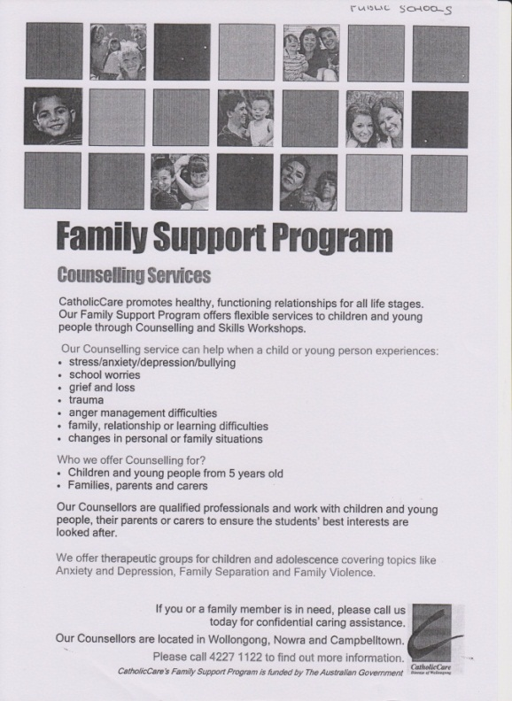
COMMUNITY NOTICES

Woolworths Earn & Learn is back again for 2013. For every $10 you spend you will receive a sticker. You can either place the stickers on a sticker card and when it is full hand it into the office or just hand in the loose stickers and the office will place them on a card.

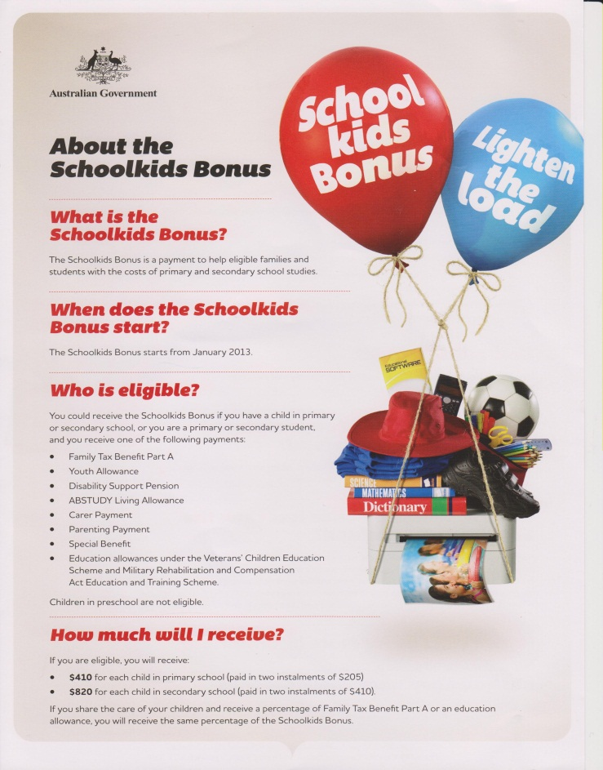

WHAT’S HAPPENING AT AB CENTRAL

