Airds Announcer |  | 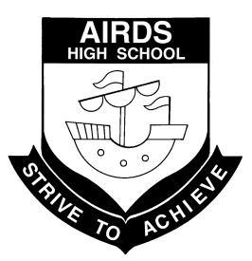
“A place to learn, lead and achieve your personal best”
Find us at: Airds High School, 2 Briar Road, Airds NSW 2560
airds-h.school@det.nsw.edu.au
Issue 7– Term 4 | October 2013

DIARY DATES

Mon 4th-8th Nov Year 7-10 yearly exams
Fri 8th Nov HSC concludes
Mon 11th-15th Nov Year 7 swimming scheme
Wed 20th Nov Year 6 Orientation Day
Fri 22nd Nov V8 Supercars excursion
Tues 10th Dec Presentation Night & Sports
Presentation
Mon 16th-17th Dec Make the Most of Life
Wed 18th Dec Last day for students
HSC results released
NEXT P&C MEETING
WEDNESDAY 6th November
AT 10:15 am
IN THE STAFF COMMON ROOM

WOULD LOVE TO SEE YOU THERE!

Year 12 Hospitality students
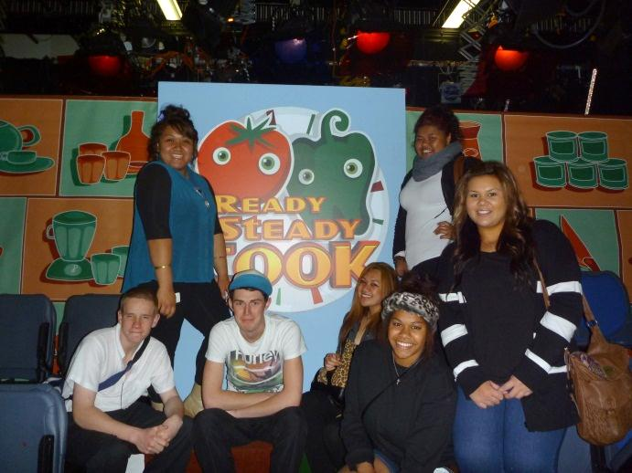

CLO REPORT
Welcome back to what I’m sure will be a very busy and fast-paced Term 4 here at Airds High School. I hope our Year 12 students are finding that they were well-prepared for their exams and all their hard work and time spent studying is paying off. Remember that just completing your HSC has greatly improved your opportunities for a productive and interesting future. Enjoy your well-earned break once the exams are over and all the best for whatever path you choose to follow in the coming years.
There are some great programs running in our local community that many of our students and members of their families may be interested in. The Koch Centre for Youth at Macquarie Fields runs a free support group for Young Mums every Thursday. They provide practical help and support, regular outings, and fun activities for both mums and children. Transport is also available but bookings are required. The group meets from 11am until 2pm each week and lunch is provided. For more information about the group please contact Billea on 02 8796 6700 or 0406 816 598.
WorkVentures Connect Centre in Airds runs a number of workshops and courses that can help people in a variety of different areas. They are currently running a course in Resume Writing that can help you to organise and create a great resume that includes all the relevant information to help you impress prospective employers. Another workshop they are running is called MoneyMinded : Financial Skills for the Future. This workshop is designed to help people set financial goals, learn how to budget and ways to generate extra money.
If you are thinking about getting your Learners Driver’s Licence, WorkVentures also has a course that might be able to help you achieve this. They are running a 5 week programme starting on the 13th November. There is one session each week for 2 hours at a time that can help you to get your learners licence and give you much more freedom in your life. The course starts on 13th November and runs every Wednesday for 5 weeks from 10:00am until 12 noon each day. There are limited places available in this course so please contact WorkVentures Connect Centre to book your spot. You can call them on 46 28 8622 or visit the centre to find out more information about any of their courses and workshops at 86A Greengate Rd, Airds.
Last week saw the first of our Year 6 Taster Days for the students who will be starting Year 7 at Airds High School in 2014. The support students were involved in a number of fun and interesting activities on Wednesday as they got to know some of the staff and the various subjects they will be studying in high school next year. I was able to watch the students take part in an Art lesson where they were making small masks out of clay. Everyone seemed to enjoy working with the clay and each student came up with a unique and interesting design. I am looking forward to seeing the students paint their masks this week as they bring them to life with colour and more creativity.
On Thursday the rest of the Year 6 students visited our school and were given a taste of high school lessons in 4 different subjects - Maths, Science, English and HSIE. The students really seemed to enjoy the lessons and meeting students from other primary schools that they will be attending high school with next year. This week the students will be taking part in the more hands-on subjects such as Food Technology, Woodwork, Art, PDHPE and German. I am sure the students will thoroughly enjoy these lessons as they begin to get a real taste for high school and feel more confident about starting here next year. A big thank you to Miss Tate who has worked very hard to organise these Taster Days for the Year 6 students, and to all the other staff who were involved on the day, be it preparing and delivering the lessons, helping the students in the classes, or providing the lunches. These Taster Days are so valuable in preparing our incoming Year 7 students for high school and play a big role in making the transition from primary to high school an easy and pleasant experience for the students and their families. There will be an Information Day for the parents of these students later in the term, so please keep a look out for information in regards to the date and time of this day.
The Year 7 and 9 NAPLAN results were recently distributed to households and I’m sure many of you were pleased with your children’s results. These tests give a good indication as to where each student is performing in relation to the rest of the state and how well our school as a whole is performing in various areas of Maths and English. If you are at all concerned about your child’s results please do not hesitate to approach the school to discuss ways in which you may be able to help your children at home in order to improve their literacy and numeracy skills. The school has a number of resources that you would be able to use very easily to help your children at home. It is so important that our children are competent and confident in their literacy and numeracy skills as it will affect their ability to learn and achieve in all their subjects throughout high school. If you would like some assistance please contact the school and speak to your child’s year adviser or one of the teaching and learning support staff who are located in the library. You would be really making a difference in your child’s education and the opportunities they will have in the future.
I hope that everyone has a great Term 4 and I would encourage all students to keep working hard right through to the end of the year. It will be a very busy term with exams, reports, the Year 7 Swim Scheme, Awards Presentations and all the great ‘Make the Most of Life’ activities in the last week of school. I hope everybody does make the most of all the opportunities given to them here at Airds High School as they will no doubt lead you to a better and brighter future.
Ms M Cutts
CLO

PICLO REPORT
Bula Vinaka
The Fijian greeting of Bula Vinaka means ‘wishing you happiness and good health’
Bula Vinaka to all staff, students, their families and particularly our Fijian students and their families as they celebrate the Fijian Independence Day this month.
During the month of October we have been busy working together with the UWS Pacific Achievement to Higher Education (PATHE) staff and volunteer students who have facilitated numerous in-school workshops for students from Years 7-12 throughout the year, Students have had the opportunity to hear from Pacifica students who currently attend University and gain knowledge of their journey, many of these students have come through the same obstacles that a lot of our students face and their stories give inspiration and encouragement to our Airds High students. The Pacific Careers Expo held recently gave our students an insight into what you can achieve when you believe in yourself , they heard from Pacific professionals such as lawyers, teachers, NRL sports players, artists/photographer, prison officer trainer and a fashion designer. Their stories were amazing and truly inspirational and encouraging for our students, many students left the Expo with a better and clearer outlook on their future prospects. It has been an incredible experience to work with such a committed and dedicated group of young people, Thank you to the Airds students who attended the Expo for being excellent examples of the school and Mr Vaiotu for attending the Expo with us. The following photos are some of the Pathe projects throughout this term.
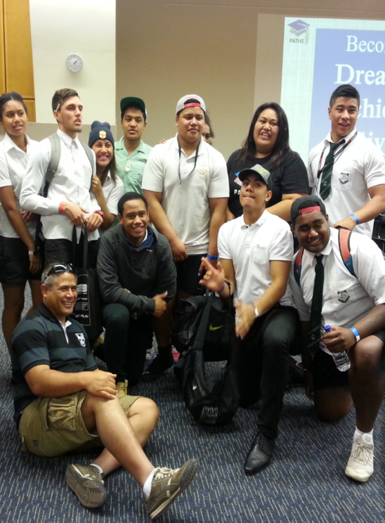
Year 10-11 at the Pathe Pacific Careers Expo

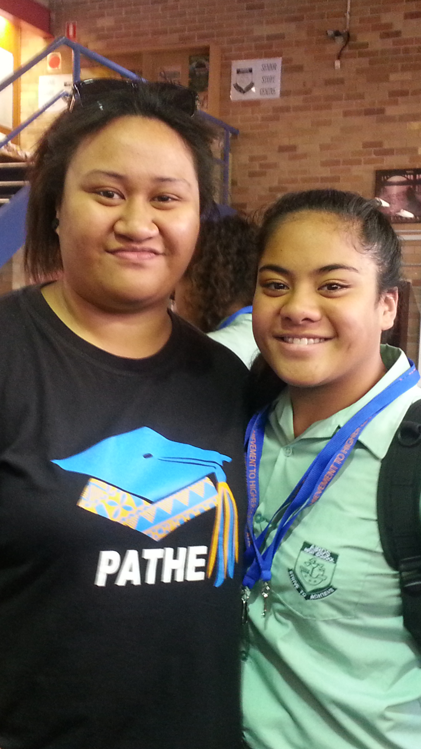
Yolandi Fuimaono Yr 7 with Lupe who attends University and studying Travel and Tourism Management.
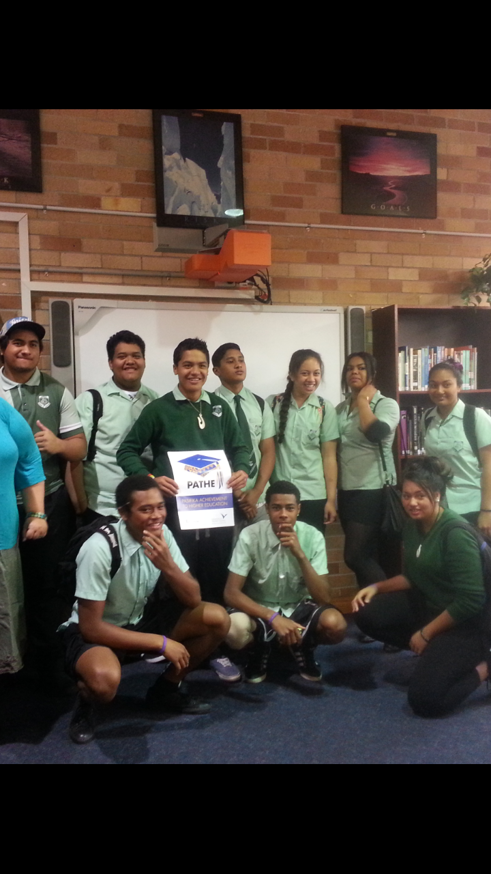
Year 10 with Pathe in-school workshop
Taster days at Airds
Students transitioning from primary to high school next year will get a taste of an in-class lesson this week which will be an exciting time for students , please make sure you have enrolled your children for high school next year and if you have any queries you can call the school.
NAPLAN results are out and if you have any concerns with your child/childrens results please contact the school PH 46255811.
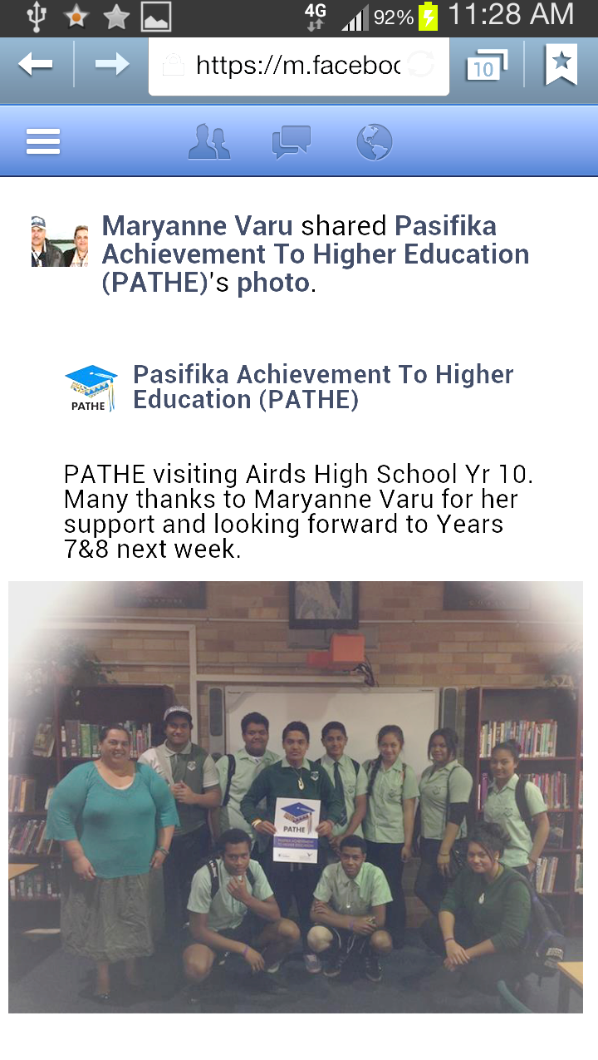
Kia manuia
Mrs M Varu
PICLO

FROM THE PASTORAL CARERS DESK
Term 4 is well underway. It will be another busy term of activities with many “end of year” events to be organised. The time seems to fly when we get to this time of year, and our dedicated teachers and staff are especially stretched with many extra demands. It should be a great time of celebration for our students and school community and there will be many opportunities to focus on the positive teaching and learning experiences of 2013. However; for some, additional support will be required! This can really highlight the need for extra understanding, and that Airds High School ability to continue to work together in partnership.

Establishing partnerships in life are important for groups as well as individuals. Most of us are familiar with them, but there are many different kinds of partnerships. Families and couples are in partnership to raise their families and live their lives together. Sports teams are in partnership, with each person playing their role in the game. Government services and community groups work in partnership to offer support to those in need. Work places and especially schools see people with different skills and responsibilities working together in partnership for the common good.

In school communities partnerships are essential to achieve success. As in any partnership or relationship; we should be realistic and expect challenges along the way, but strong partnerships are a commitment to each other to be united in purpose. At AHS we should be thankful for the leadership that continues to encourage these qualities to develop strong partnerships.

And with this in mind, it is with real sadness that we say farewell to Mr Foord. After 4 years of outstanding leadership and service to the Airds High School community, he will leave us in Week 6 this term. With so many wonderful achievements as Principal, I would like to say thank you for your support of my position. And congratulations and best wishes for the future at Nepean Performing Arts High School.

I would like to remind everyone that I am at AHS on Wednesday this term. If I can be of any assistance, please do not hesitate to contact me.

Cheers and I hope everyone has a happy Term 4.

Until next time, Cheers
Mr R Hodgson JP

We are:
Safe
Respectful
Learners

TEACHING AND LEARNING REPORT
LIBRARY
Effective learners are not just those who are knowledgeable but rather they are people who are able to find and use information as required. It can be said that effective learners are those that are information literate. Information literacy is knowing how to learn. This means that the ability to process and use information effectively is more than a basic tool for school students: it is in fact the basic survival skill for those who wish to be successful members of the 21st century. The capability to respond to changing information is now a critical life skill. (ASLA & ALIA 2001) At Airds High School Library the Teacher-Librarians work alongside students to help them find, transform and effectively use information to advance their learning. If your child needs a hand in this area, encourage them to speak with one of us; alternatively, feel free to contact us and voice your concerns.

The Premier’s and Principal’s Reading Challenges have now finished. We share in the pride of a senior student who read way above the amount needed to complete the challenge. Although the PRC Challenges do not officially start until March 2014, students can start their reading now! This adds an extra four months to their available reading time. Encourage your child to take up the challenge!

It is with regret that we farewell Ms Yabsley who has been an important part of the library for over 20 years. Without her able work and assistance, many pleasant aspects of the Library environment would not have occurred. She has processed thousands of resources for students to use, designed and mounted numerous thematic displays, been “mother hen” for a large number of Library monitors and has been an excellent, supportive colleague to work with. We all wish her well in her retirement.

Library stocktake will occur during Week 8. It would be great to have all the overdue books sorted out before then. Check your children’s books. If one has a barcode stuck to the front or inside the front cover and is covered in contact; it’s quite possibly a library book. Please assist us in this endeavour by getting such items back to the school.

“A book is a dream you hold in your hand” Neil Gaiman

Ms Burgess & Ms Jones
Teacher-Librarians

SLSO’s
It has been sad for Ms Addamo and Ms Hopwood to work without the guidance of Ms Angel for the last few weeks but it has been wonderful to have dedicated substitutes in the form of Mr O’Neill and Ms Pardy. We would like to take this opportunity to thank you both for filling the shoes and making the transition easy for us. In preparation for the National Partnership submission it has been necessary for us to reflect on our roles within the school. Working with so many of our students it is hard to quantify results and put these down on paper. However, the final product was gratifying as neither of us realised the impact we have on some of our students, academically and emotionally. We would like to thank our students for always showing us respect and working with us to achieve some impressive results. Last term’s focus on literacy saw some students exceed expectations and gain greater confidence in reading and writing.

The Higher School Certificate examinations have just concluded and we would like to thank the volunteers who helped our identified students with Special Provisions. Good luck to all our students! We would like to take this opportunity to wish you all the best for your futures. School is certainly a quieter place without our Year 12 cohort.

Ms Hopwood is still responsible for supporting Years 7, 9 and 11 and Ms Addamo is still supporting Years 8 and 10 focusing on achieving class outcomes. Ms Addamo will also be assisting in the preparation of Year 6 for transition into high school, always an exciting time. With exams coming up and end of year assessments due, Ms Addamo and Ms Hopwood are happy to offer assistance to all mainstream students in any year, in any subject. Period 5 every Tuesday has been specifically dedicated to the Year 11 students. With prior arrangements, and written permission from their teacher, all students can book in with their SLSO’s for individual assistance. The Activity Hub is also a valuable resource for students who need extra help from their teachers, and this service is available every Wednesday afternoon. Ms Addamo and Ms Hopwood are more than happy to support any student to achieve their learning goals within the values framework of safe, respectful learning.

YEAR 7 REPORT
Year 7 started Term 3 with a tinge of sadness, starting the term without their illustrious leader Ms Kennedy who had gained a new position at a special education school in Sydney’s west. I know from the entire Year 7 cohort the motivation and inspiration she provided to all students throughout the year will be missed. It is always a shame to see talented staff move on but we wish her all the success in her new role. So now Year 7 have Mr Rosete as Year Adviser and I would like to thank Mr Ryder for his support this term and the Year 7 Welfare team: Ms Tate, Ms Sapparth, Mrs Mak and Mr McDonnell for their continued effort to guide Year 7.

Over the last term Year 7 students have achieved both within the classroom and out of the classroom. We have had stars on the track, with the 13 years girls winning in the 4x100 relay at the Fisher Zone carnival. We have had stars on the stage with several Year 7 students stepping up and performing in the school choir and school showcase production, special mention to Yolandi Fuimaono for her solo performance and Rose Taala who accompanied her on the piano.
Academically I challenged the students who did not receive an award last semester to step up and be counted. At the recent Formal Assembly 12 new students out of 29 recipients received awards for academic performance that had not previously received any award. Year 7, rising to the occasion, showing the growth and potential that this group has. Special mention needs to go to Blake Trudgen who received the Year Adviser award for Term 3 and again to John Souleyeo who also received the Year Adviser Award and Deputy Award for outstanding Academic Achievement in Term 3.

So what is in store for Year 7 in Term 4? Firstly in Week 6 all Year 7 will be participating in the learn to swim program run by NSW Surf Lifesaving at Bradbury pools. Ms Tate and the PE faculty have worked hard to get this going for Year 7 this year and let’s face it in Australia swimming is a vital skill to have. Every child should be given the opportunity to learn how to swim and with the warmer weather now on us I’m a little envious of the Year 7’s spending time in the water while I stay back and sweat it out in the classroom.

In Week 8 the Year 7 Girls will be going down to Killalea State Recreation Park to participate in 2 nights camping. Earlier in the year the girls missed out due to the weather and due to recent bush fires in the Blue Mountain’s this camp has been relocated to the South Coast instead. The girls will be participating in a range of activities ranging from mountain biking, canoeing, bushwalking and a series of team building exercises that will encourage them to develop leadership skills and learn to work with others. Could I encourage all parents to make sure permission notes are returned by Thursday the 14th November it will be a positive experience for the girls and one that should create many fond memories of their time in school. The boys during this time will be participating in the Rock and Water Program which will be targeting bullying and encouraging the boys to feel empowered and confident in dealing with life challenges, this will take place at school.

Some exciting times ahead for Year 7, somewhere between all these activities they also have to learn in the classroom. I’m sure year 7 will continue to rise to the challenge.

Mr Rosete
Year 7 Adviser

SUPPORT REPORT
‘Together we can make a difference’

All students are working well and all staff continue to work tirelessly to support our students in their learning and personal development. The Support Unit continues to buzz with activity all of a positive and rewarding nature. On behalf of the Support Unit I would like to congratulate Miss Desplat on her marriage and announce that her new surname is Mrs Bassman.

In 2014 the Support Unit will be accommodating a sixth class next year. This class will be another Autism class. In the coming weeks parents will be notified of their child's class teacher and location for 2014.
Congratulations to Mr Farmer, Mrs Tailby, Stacey Thompson , Kayleeigh Johnstone and other staff who have ensured that all our upcoming Year 7 Support students transition into Airds High is a smooth and rewarding experience. A big thank you to Mrs Bassman for taking Mr Farmer’s class over the duration of the Yr 6-7 Transition Program. Well done to Mr Foster for his tremendous job in stepping up as the 2IC while Mrs Robinson has been away.

Prada Year 12 students have now finished for the year and the new Year 12’s have stepped up to their new responsibilities. In particular Evelyn Lardner has made huge improvements. Well done Evelyn.

Finally, I would like to encourage everyone to bring in their signed notes for Community Access. Once again in Term 4, all students will be required to attend this compulsory community based program. In a couple of weeks all Support students will be required to be tested on their swimming ability. Failure to participate in this swimming assessment will limit students’ activities at Jamberoo Recreation Park. Furthermore, all students are encouraged to bring in their signed notes and money for the Jamberoo excursion at the end of Term 4.

Also, it is important that all students continue to use their diaries/planners so that ongoing correspondence can continue between all Support staff and parents. Could all parents please inform the school if contact details change so that we have up to date records if collaboration between Support staff and parents is required.

Mr G Farmer
Teacher Support

Sports Presentation 2013
On the 10th December, Airds High School will hold its annual Sports Presentation. It will be held in the hall and all parents are welcome to attend and support their children. There will various awards given out and our special guest is a former Australian basketball player. There will be light refreshments after the presentation for award recipients and parents. The presentation will start at 8.45am. We look forward to seeing you then.
Year 6 Taster Days 2013
This term we have had many primary schools visiting us to introduce Year 6 into high school. Year 6 were involved in a variety of lessons showcasing all the wonderful things they get to study when they come to high school. I am very proud of all the students who helped out over the 2 days to make it successful and believe they were all excellent role models for our future Year 7 cohort.

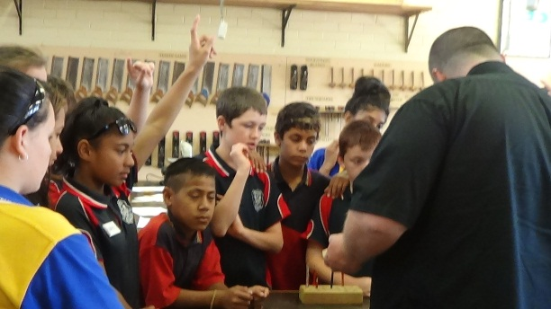

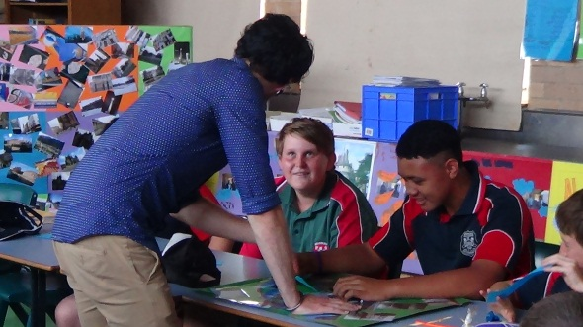
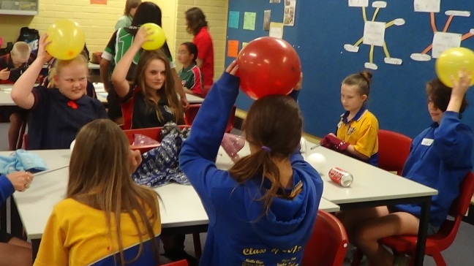

A big thank you to Cheyenne Smith, Chris Santoro, Thomas Burt, Kiara MacDonald, Cougar Smith, Nickolas George, Angela Franks, Emma Walsh, Hans Taala, Justin Peachey, Marrenars Srey, Loata Peter, Amy McDonald, Kimberley Gimbert, Christina Lilomaiava, Jason Phoumivong, Aidan Ferderer, Zac Dunn, Brock Baker, Anthony Le and Mathew Leatuafi. On the 4th December we will have Year 6 students back here for their Orientation Day. I am looking forward to our next encounter with Year 6.

Ms N Tate
Year 7 Adviser 2014

SCIENCE REPORT
The Science faculty has been extremely busy over the last term and the beginning of this term, with a number of events occurring. Science week was celebrated in great style this year, with Year 7, 8 and 10 participating in a number of different activities. Year 9 are currently working with their class teachers to finish a number of topics before the end of the year. Year 7 and 8 have recently trialled an online Science program in preparation for their exams and Year 10 are currently working on an engineering project in small groups, which ties in with the Technology topic to finish off the term.

Science Week
Year 7 attended the IMAX Theatre, Darling Harbour where they saw the 3D movie Bugs. This tied in directly with the topic Living Things, which they were studying at the time. Year 8 travelled down to the Wollongong Planetarium, where they observed a number of scientific shows. Year 10 were a part of an incursion where they participated in a number of different practical experiences led by their Science teachers.

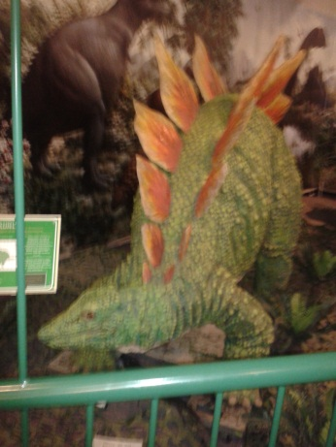
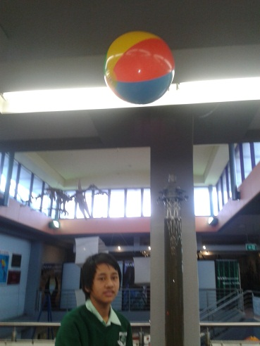

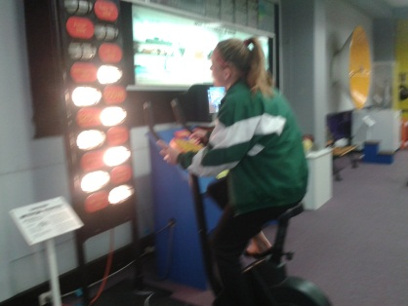

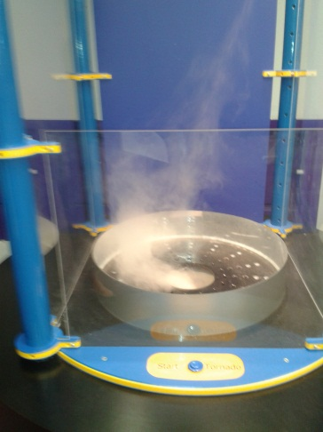
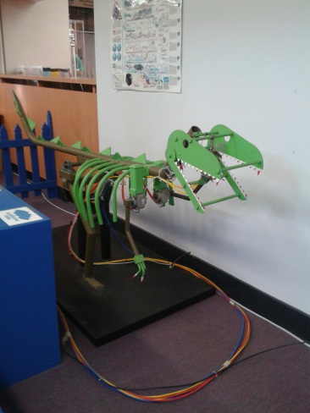

ESSA
Year 8 are participating in ESSA (Essential Secondary Science Assessment) which is compulsory for all government schools across NSW, on 16th November 2013. All students were sent home with a note about this testing. If your child did not receive one please contact Ms Radford in the Science department.

Year 8 Gifted and Talented Students
This term Mrs Holmes is taking 4 selected Year 8 students to a Science Gifted and Talented Expo on 28th November 2013 at UNSW. The expo involves a hands on approach to a number of Science experiments which we are not allowed to perform at school. There is a $10 charge for the day and these students will be contacted closer to the date.

Make the Most of Life
The Science faculty is once again running the highly popular Animal Adventures activity. This option for “make the most of life” involves 2 days of sightseeing around Sydney Harbour. Students will catch the train from Campbelltown into the city, with Day 1 at Sydney Aquarium and Day 2 at Taronga Zoo. Students will be escorted by Mrs Holmes, Mrs Stoddart and Ms Radford. The cost for this activity will be approximately $40.

Year 9
Ms Radford’s Year 9 class recently visited Airds Pond to complete a number of water testing activities for the topic Our Environment. There were a number of results that astounded the students e.g. water is meant to be a pH of 7 and in some areas of the pond it was as low as pH of 5, meaning that the pond is acidic. The students came to the conclusion that the community needed to ensure that they look after this ecosystem in order to protect and preserve the natural wildlife.

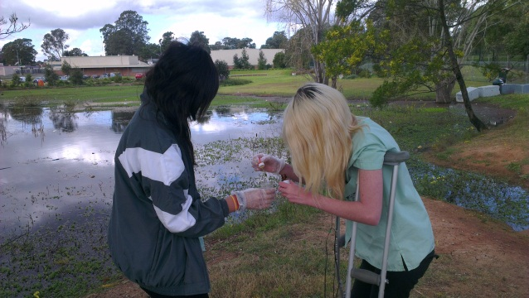

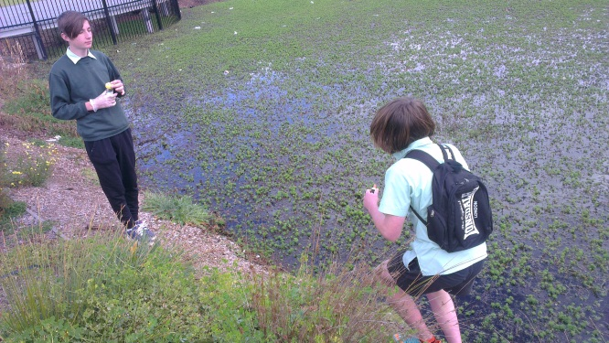

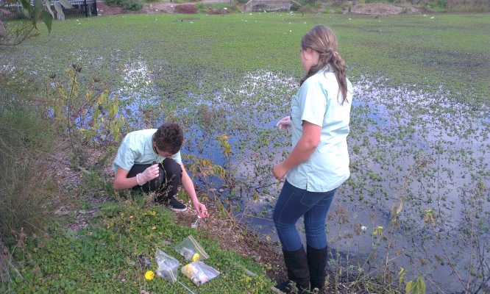

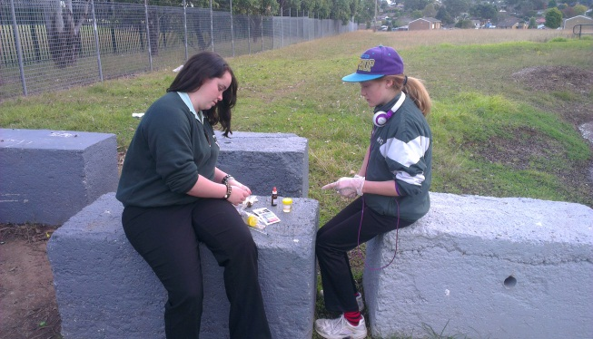

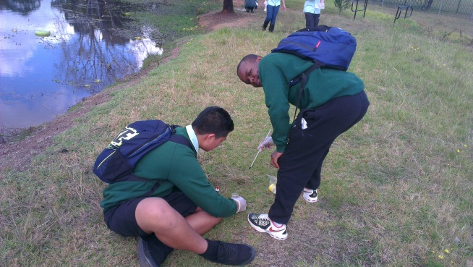
Currently all of Year 9 are completing the topic Electricity. Ms Radford’s class are in the process of designing a board game for their peers based on this topic.

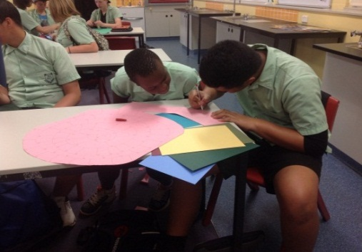
David Taase and Samuel Vyzgiro
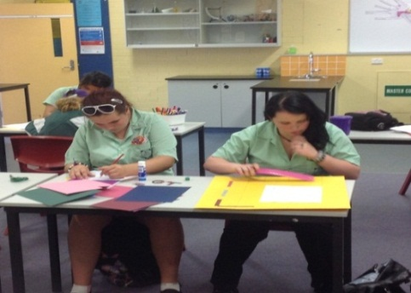

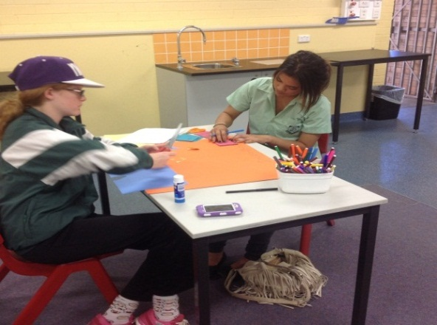
Emma Walsh and Ashley Davis

Nadine Hakes and Shantel Etiaki

Dounia Baklaje

New Science programs for 2014
The Science faculty is currently in the process of creating brand new programs for the implementation of the National Curriculum. In 2014 Year 7 and Year 9 will have first access to the new curriculum (Year 8 and Year 10 will be implemented in 2015). The new programs have a strong inquiry based learning process, which allows the students to develop a greater understanding of science through the questioning of their own knowledge.

Into Science
Stage 4 Airds High School students are currently trialling a new program called Into Science, which is designed for the new syllabus for 2014. The students have been able to explore the program using the schools brand new class set of ipads. Each student who participates in this trial will receive a certificate of appreciation from 3P learning.

7 Bellbird -Zac, Masei, Steven, Venita, Jasper and Alexander

Jasmine, Madison and Hayley

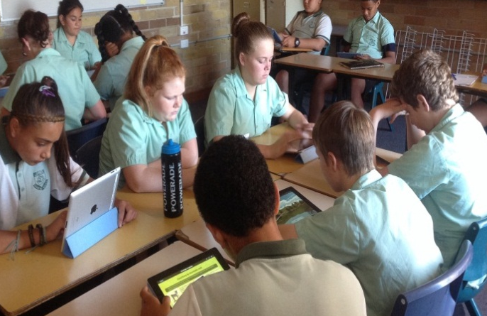
7 Kookaburra-Tara, Rachel, Brianna, Tonu, Braydon, Kyle

7 Lorikeet - Jasmine, Madison and Hayley

Science Awards for Term 3

8 Trevally – Sam, Jaycob and Mahmoud

Congratulations to the following students who have received awards from their respective Science teachers at their Formal Assemblies.
Year 7 | Masei Fetui (Bellbird) | Tonu Papali (Kookaburra)
 | Victoria Fuentes (Lorrikeet) | Sharni Hardy-Fisk (Rosella)
Year 8 | Jason Kasemsuk (Moray) | Kimberly Anderson (Snapper)
 | Jasmine Hillman (Trevally) | Aaron Longley(Barrunmundi)
Year 9 | Justice Gardiner (Koala) | Lucy Hardy-Fisk (Wombat)
 | David Ta’ase (Echidna)
Year 10 | Sonja Ta’ase (Turtle) | Brock Baker (Python)
 | Victoria Peagam (Goanna)
Year 11 | Damien Manu (Biology) | Chris Dent (Chemistry)
Adde Liban-Wako
(Senior Science)

SRC REPORT
The start of Term 4 has seen some changes for the SRC. During Week 2 and 3, each year group had the opportunity to nominate new representatives for 2014. I would like to congratulate all students who made speeches to their year groups. It takes a lot of courage to get up in front of your peers to make a speech, and all students who nominated themselves should be very proud. Based on student votes, our new SRC representatives are:

Year 7 into 8:
Wendell French
Jeremiah Pone
Emma Morris
Yolandi Fuimaono
Aboriginal Education Representatives:
Madison Tidmarsh
Tamika Ferguson
Year 8 into 9:
Mandy Talaoloa
Michelle Naicori
Sione Teisi
Vanessa Siitia
No Aboriginal Education Representatives
Year 9 into 10:
Hans Taala
David Ta'ase
Angela Franks
Emily Philliskirk
Aboriginal Education Representatives:
Wizz Foster
Justin Peachey
Year 10 into 11:
Aidan Ferderer
Anthony Le
Marrenars Srey
Christina Lilomaiava
Aboriginal Education Representatives:
Killara Bell-Stewart

I look forward to working with this great new team of students. I am sure that the year to come will see some excellent student initiatives, and some positive changes for Airds High School.

Coming up next week the SRC will be running a MUFTI day on Friday 8th November. Students who wear MUFTI need to make a gold coin donation. All money raised will go towards the Blue Mountains Bushfire appeal. Please be aware that students will still need to wear appropriate clothing, and appropriate footwear.

I wish everyone a productive and safe Term 4.

Mr Wallace
SRC Coordinator

Supervisor of Girls Report
Selected Year 8 students completed a Drum Beats session with ladies from Youth Connections Australia on Wednesday 30th October. Drum Beats team building activities transform and unite groups of people through rhythm. With a drum for each participant, the group is led on an exhilarating rhythmic adventure. The girls really enjoyed the session.

Ms Byrne and myself started Girls Fitness classes last week. They are held on Monday, Wednesday and Friday at lunchtime in the New Hall. Sessions range from zumba, strength circuits, BAT (butt, abs and thighs) and yoga. This is a great opportunity for female students to improve their fitness and meet new people.

Miss Simms
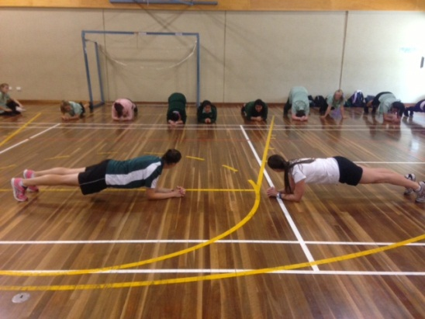

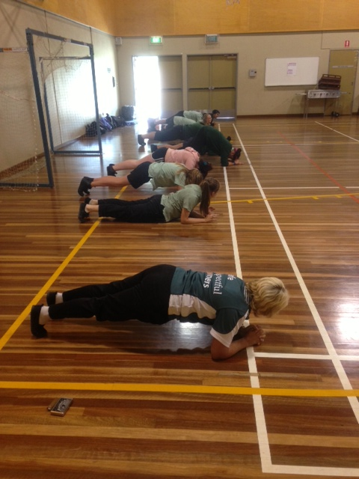

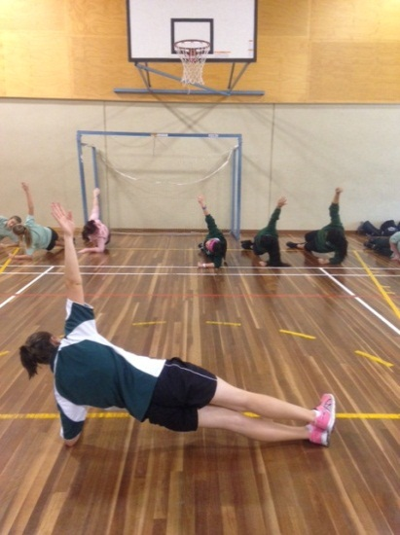

ENGLISH REPORT
In English, the poetry and animated drawings of some
Year 7 students from English classes in Term one were
entered as a collection into a local Macarthur film
festival for short films that celebrate diversity.
More information about the film festival can be found
athttp://www.macarthurfilmfest.org/.
In Year 9 drama, the class has completely embraced
small screen acting. They began creating a zombie
apocalpyse video game, inspired by our student zombie
expert, Chloe Montcalm-Sparks! First all the
potential options were planned and the students are
now in the process of filming each piece of the action
for a choose-your-own adventure film where the goal is
to escape without being eaten by the zombies. They
are happily using the "dead flesh" supplied by Matthew
Wallace in the art department.

Ms P Cruz
Classroom Teacher

TAS/CAPA REPORT
Term 4 is well and truly underway for both staff and students in the TAS and CAPA subject areas with many students working extremely well toward completing all their work before the end of the year.

The Year 10 Food Technology class has completed the ‘Food for Special Occasions’ unit of work. To conclude this unit, Mrs Drakefield’s class were asked to cater a SASS High Tea for 27 people in the staff common room. The students produced a high standard of afternoon tea items including chocolate mousse, 2 flavours of quiche, 2 types of sandwiches, citrus tarts, raspberry melting moments and baby scones served with jam and cream. This function was a huge success with the SASS staff giving plenty of praise as their feedback. The students found it enjoyable and this was a great learning process for all involved. Well Done Year 10 Food Technology!

It has been wonderful for our TAS and CAPA staff to meet the wonderful students who came for the Year 6 Taster Days. Students were given the opportunity to complete a variety of activities with various teachers such as completing Visual Arts items with Mr Wallace; making ceramic masks and going into the darkroom to produce a photogram. Woodwork with Mr Lightfoot; producing their own well designed boomerang and Food Technology products with Ms Coogan and Ms Vongsouvanh; making delicious chocolate truffles and decorating Halloween cup cakes. It was a successful day where students were able to briefly experience what they can expect when they come to our school. All the TAS and CAPA staff look forward to seeing all the Year 6 students back next year.

The studying, stress and hard work is over for our TAS and CAPA Year 12 students who have finally completed their Higher School Certificate. A big round of applause and congratulations to all our Year 12 students!

Here is a list to acknowledge all of our wonderful students who received an award for Term 3 Outstanding Academic Achievement in TAS and CAPA subjects.

TAS –
Year 7:
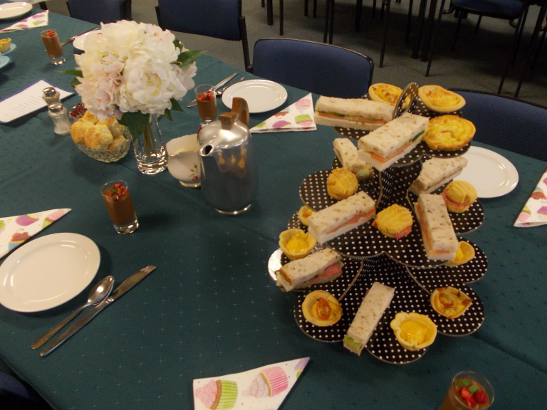
Technology Mandatory –
7A: Steven Leului,
7B: Jennifer Clissold
7C: Britney Holahan
7D: Kyle Osborne (Food)

Year 8:
Technology Mandatory –
8A: Ethan Rutledge
8B: Luke McDonald
8C: Jaycob Oloaga
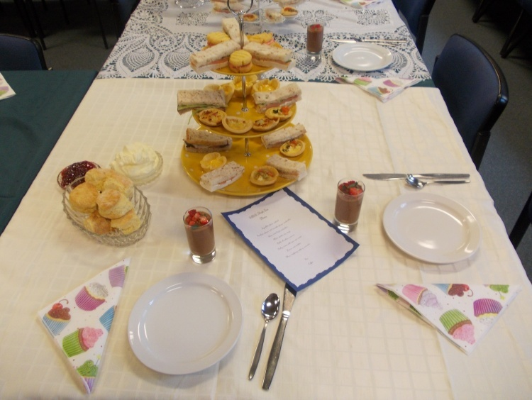
Year 9: Angela Franks (Industrial Technology - Metal), Joshua Dent (Industrial Technology - Automotive), Jake Taylor (Food Technology)
Year 10: Liam Stark (Industrial Technology - Metal), Ashley Bell (Child Studies), Anthony Le (Food Technology)
Year 11: Samuel Bowden (VET Metals and Engineering), Jessica Rendell (Food Technology)
Support: Shyan Tupufia (Gucci), Emmanuel Bandonill (Manolo), Digby Brady (Blundstone), Bradley Clarke (Prada)

CAPA –
Year 7:
Visual Arts -
7A: Portesano Leuliu
7B: Demour El Tahach
7C: Joshua John

Year 8:

Visual Arts -
8A: Nora Al Katify
8B: Kiara McDonald
8C: Jaycob Oloaga

YR 9: Emma Walsh (Photography)

YR 10: Sonja Ta’ase (Visual Arts), 10/11CC Ziggy Munro (Visual Arts)
YR11: Jade Baker (Visual Arts)
Support: Nicoletta Malakos (Cooper), Samara Lynch (Gucci), Dylan Polsen (Prada)
There is still plenty of work to be completed for all our students before the year draws to a close. That means there will be plenty to report on in the next article, so until next time...keep being Safe, Respectful Learners!

Ms N Vongsouvanh
HT TAS/CAPA

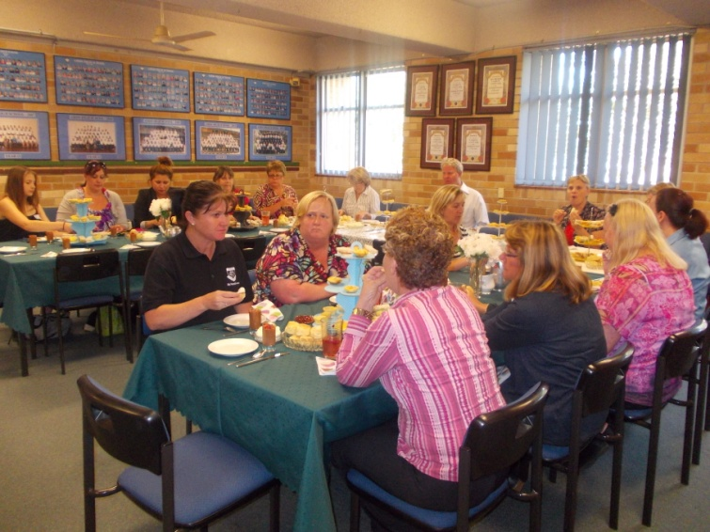
Year 10 Food Technology – SASS High Tea

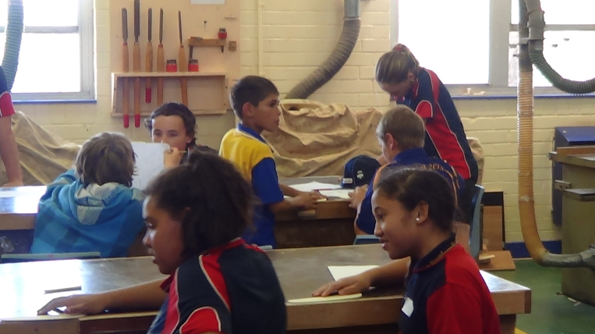
Year 6 Taster Day

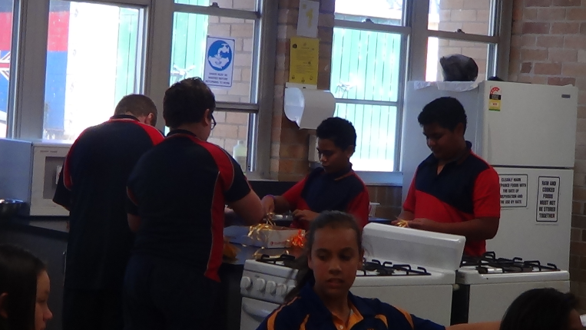

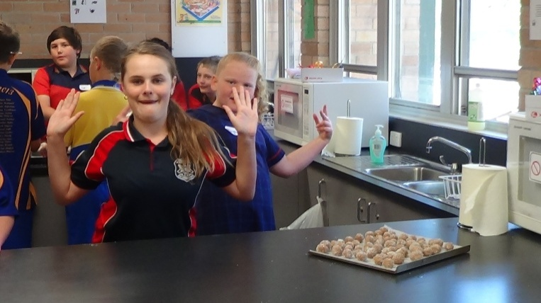

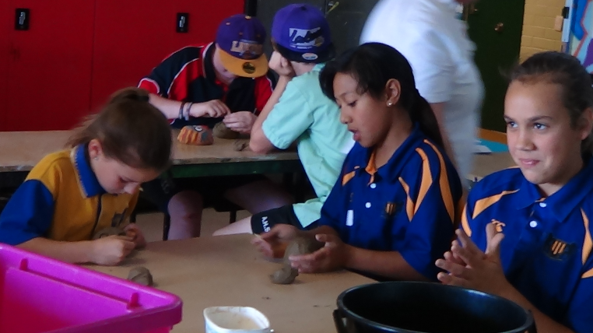

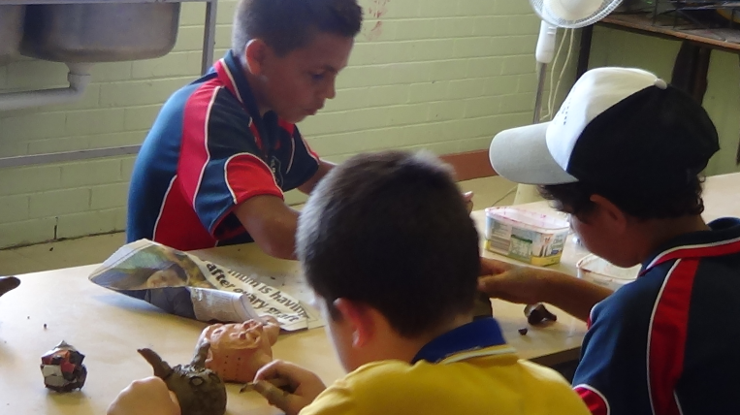

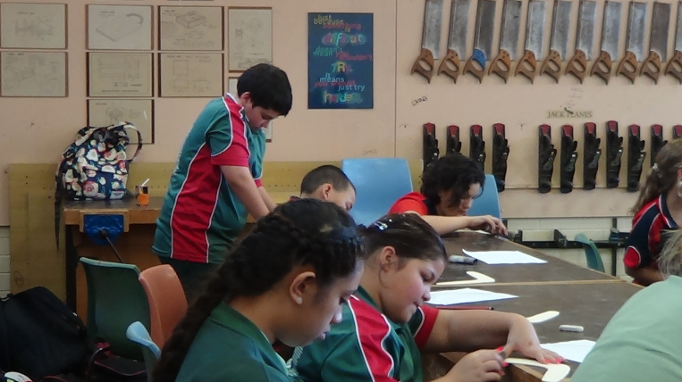

YEAR 12 REPORT
Farewell Year 12 2013!
It only seems like yesterday that Year 12 2013 were starting high school; but here we are six years later and you have complete your HSC. It has been a long 13 years of school and now you are finally ready to enter the world outside of school. Time will start to speed up and before you know it high school will be a past memory.

The Year 12 Graduation will always be a night to remember, you all looked stunning and I am proud of each and every one of you. I would like to thank all the family and friends of the students who came to support and celebrate with the graduates. Congratulations to the following students who received special awards on the night.

Brodey Beetson -
Highly Commended English Standard
Most Improved Business Studies
Most Improved PDHPE

Matthew Blundell –
Highly Commended Life Skills Science
Most Improved Life Skills HSIE
Most Improved Life Skills TAS

Aimee Burke –
Highly Commended General Mathematics
Most Improved English Advanced
Consistent Effort Community and Family Studies

Tahlia Colbourne –
Highly Commended Mathematics Applied
Consistent Effort English Studies

Amy-Lee Cooper-Fuentes –
Most Improved Biology
Most Improved Geography
Consistent Effort English Standard

Charmaine Edwards –
Highly Commended Ancient History
Consistent Effort Business Studies

Yasmine Eldaye –
Highly Commended Biology
Highly Commended Geography
Highly Commended Business Studies
Highly Commended PDHPE
Consistent Effort English Advanced

Leata Faamausili –
Most Improved Retail

Katelyn Ferderer –
Consistent Effort Biology
Consistent Effort Ancient History

Chloe George –
Highly Commended Food Technology
Most Improved English Standard
Consistent Effort Visual Arts
Consistent Effort Photography

Emily George Cox –
Most Improved Life Skills Maths

Hayden Harrison –
Most Improved English Studies
Most Improved SLR

Tyler Hoskins –
Most Improved Ancient History

Jessica Jacobs –
Highly Commended Retail
Most Improved Visual Arts
Most Improved Hospitality

Dwight Jenkins –
Most Improved Life Skills Visual Arts
Most Improved Life Skills Work Ed
Most Improved Life Skills PDHPE

Ali Kassem –
Highly Commended Industrial Technology Construction
Consistent Effort English Standard

Johnny Leontios –
Most Improved Coaching
Consistent Effort Mathematics Applied

Emma Lynch –
Highly Commended Life Skills English
Highly Commended Life Skills HSIE
Most Improved Life Skills Science
Consistent Effort Life Skills Work Ed
Consistent Effort Life Skills TAS

Lucas Macdonald –
Highly Commended Metals
Most Improved Industrial Technology Construction
Consistent Effort SLR

Anna Mati-Leifi –
Highly Commended Music
Consistent Effort Hospitality

Logan Maxwell –
Most Improved Visual Arts
Most Improved Photography
Most Improved Food Technology
Consistent Effort Metals

Joshua Mokoroa –
Highly Commended SLR

Cheyenne Morrissey –
Consistent Effort Retail
Consistent Effort Visual Arts

Christopher Pekarek –
Most Improved Metals
Consistent Effort Industrial Technology Construction
Dylan Polsen –
Highly Commended Life Skills Visual Arts
Highly Commended Life Skills PDHPE
Consistent Effort Life Skills Maths
Consistent Effort Life Skills Science

Holly Reed –
Highly Commended English Standard
Highly Commended Visual Arts
Consistent Effort Coaching

Andrew Roberts –
Most Improved Life Skills English

Kayla Scafidi –
Highly Commended Life Skills Work Ed
Highly Commended Life Skills Maths
Consistent Effort Life Skills Visual Arts
Consistent Effort Life Skills HSIE
Consistent Effort Life Skills PDHPE
Highly Commended Life Skills TAS

Augustina Tautalafua –
Most Improved Music

Alexander Thornton –
Highly Commended Hospitality
Consistent Effort Geography

Adi Turaganivolo –
Highly Commended Visual Arts
Consistent Effort Music

Paul Vaai –
Most Improved Mathematics Applied

Kane Walsh –
Highly Commended English Advanced
Consistent Effort General Mathematics’
Consistent Effort PDPHE

Stephanie Wasson –
Highly Commended English Studies
Highly Commended Photography
Highly Commended Coaching
Highly Commended Community and Family Studies

Brooke Williamson –
Consistent Effort Life Skills English

Tjaden Wood-Morris –
Most Improved English Standard
Most Improved General Mathematics
Most Improved Community and Family Studies

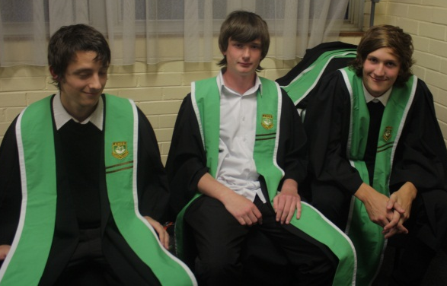
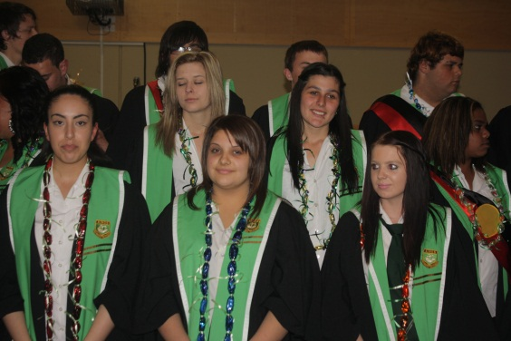

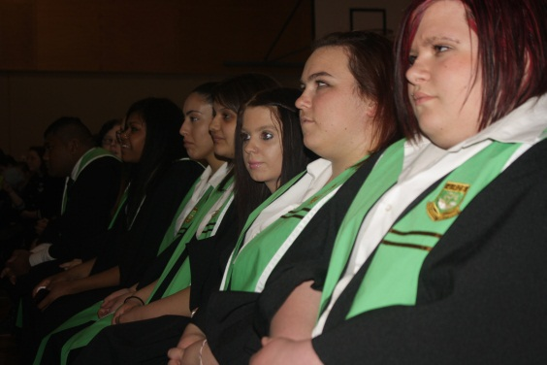
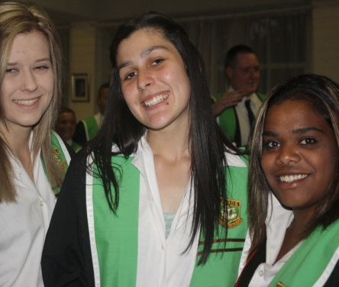

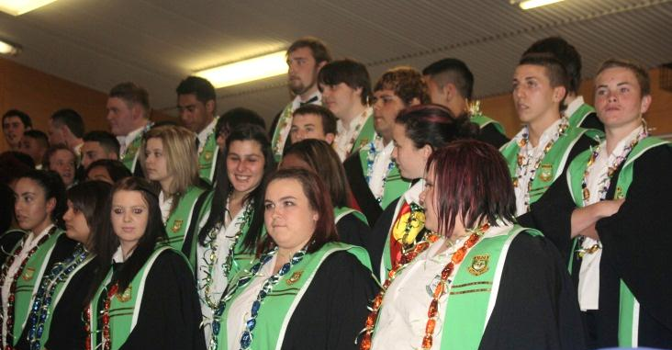
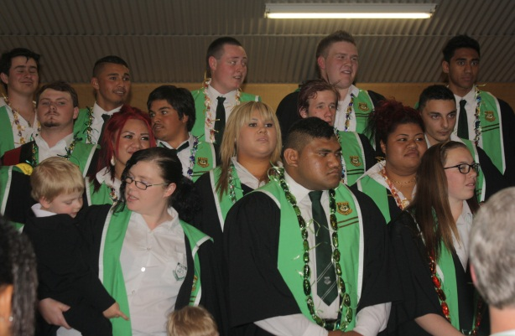

YEAR 12 2013
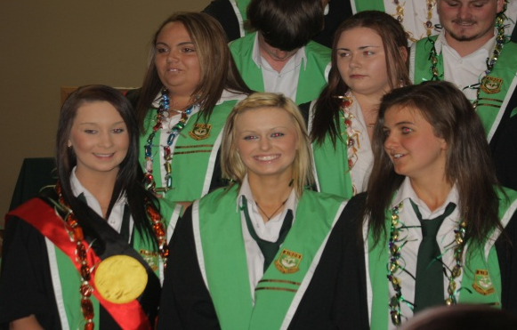

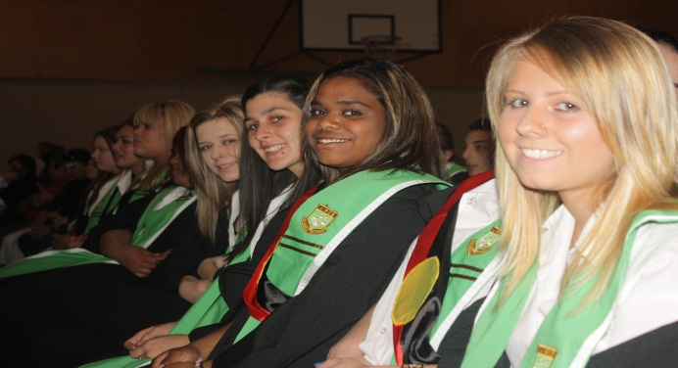

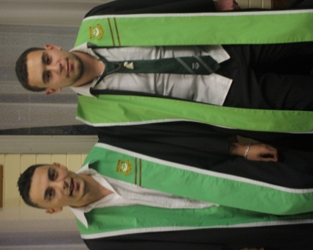

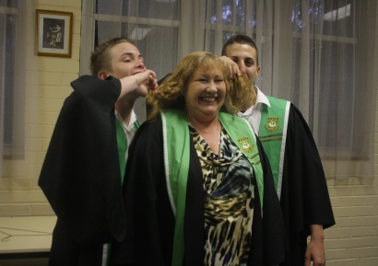

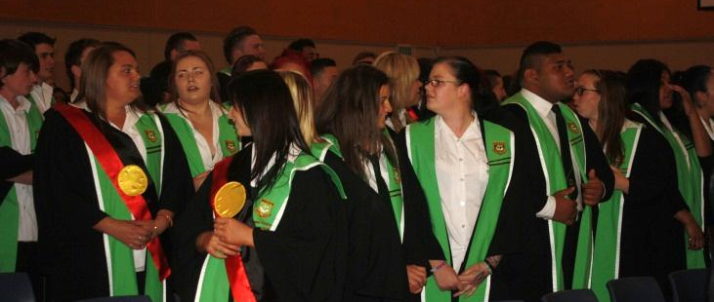

YEAR 12 GRADUATION

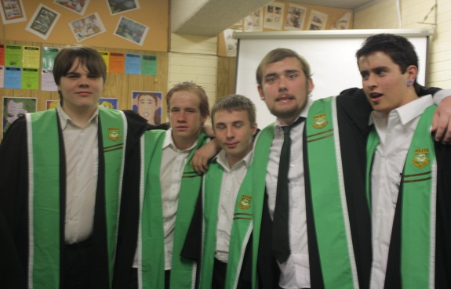

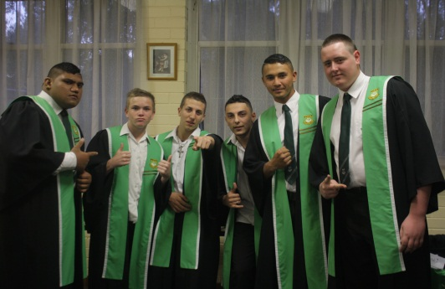

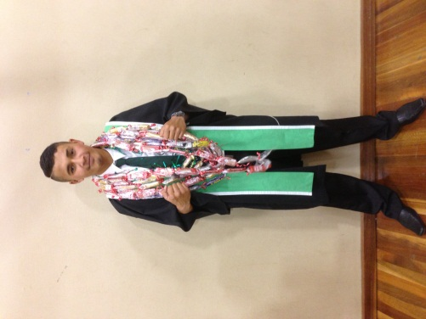

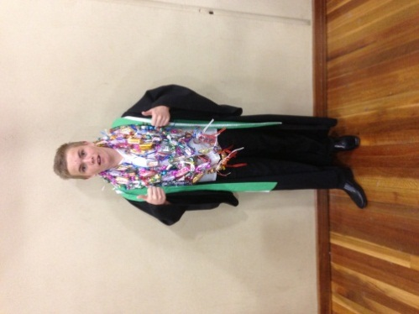

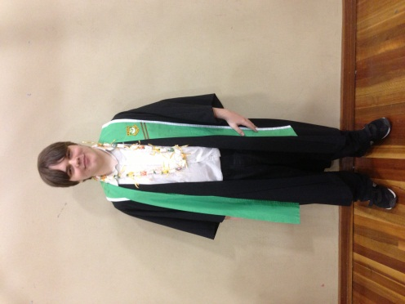

The staff of Airds High School would like to say a big CONGRATULATIONS and well done on completing the HSC.
A big Thank You to all staff who have supported Year 12 throughout their HSC – you have done a fantastic job. A special thanks to the Wellbeing Team – Mr McGuire, Ms Vongsouvanh, Mr Wallace and Miss Zalewski.

“The future belongs to those who believe in the beauty of their dreams.” - Eleanor Roosevelt

Best of Luck Year 12 for the future
Ms Green

DEPUTY PRINCIPAL’S REPORT
TEACHING & LEARNING
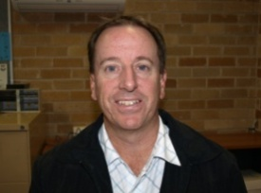

Year 12 Laptop Graduation Student Transfer of Ownership
As part of the Digital Education Revolution program Year 12 students can have their laptops unlocked which they cant then have for their personal use. This process needs to be completed to all Year 12 students’ laptops. It is important that laptops are returned to complete this process otherwise laptops will essentially be turned into bricks if the unlocking has not occurred and will not be able to be used.

Alternatively if you do not wish to use the laptop in the future or it may be broken then it would be highly appreciated if the laptop were to be returned to the school. The school would value this as it can be used for other students learning as school class sets or for parts.

An important note: before you return the laptop ALL work must be backed up onto an USB or a portable hard drive, as this upgrade will provide a new image. (All non-related work such as movies, games and music must be deleted). If you do not back up your school work it will be lost when the upgrade is completed. Laptops need to be taken to Michael Peppernell in room 5.7 for the unlocking.

NAP-CC Civics & Citizenship assessment
I would like to congratulate the 20 Year 10 students who participated in the NAP–CC Sample Assessment which is a national assessment in civics and citizenship education. The assessment is designed to assess students’ level of knowledge and understanding of civics and citizenship matters across Australia.

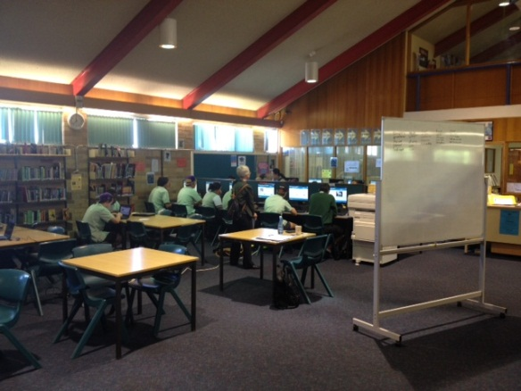

LEAPS
Law Firms Encouraging and Assisting Promising Students
This is a workplace learning program involving Year 9 students where they are matched with a lawyer from a law firm who provides mentoring support to the student. The graduation was held on Wednesday 30/10/13 it was a special night for the students as they were recognised for their involvement in the program and received a gift from their mentors. I would like to thank Leon Latulipe for coordinating LEAPS in 2013 with the assistance of Julie Hopwood.

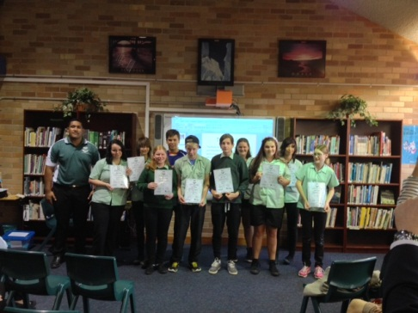
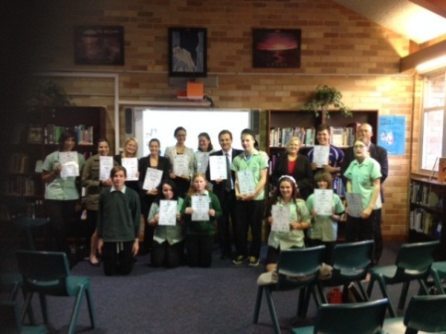

Year 6 Taster Days
I would also like to thank Ms Tate for her organisation of the Year 6 Taster Days held on Thursday 24th & 31st October, they were very successful with all students involved enjoying the lessons and activities. I would also like to thank those teachers who conducted a lesson on the day: Mr Buckley, Mr Rosete, Ms Sapparth, Ms Stoddard, Mr Wallace, Mr Lightfoot, Mr Latuilpe, Ms Coogan and Mr O’Neill. We look forward to seeing all of the students again for the Year 6 Orientation day on Wednesday 4th December.

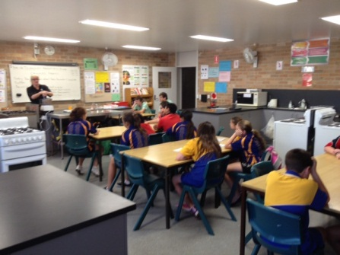
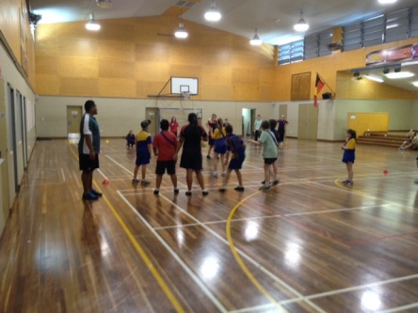

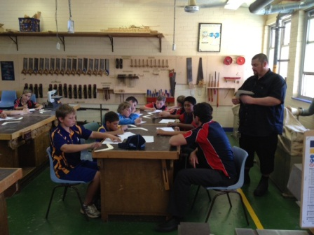

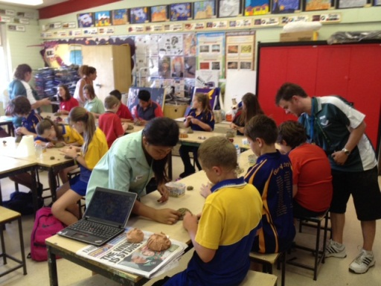

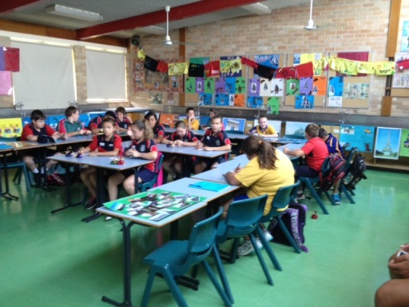

Year 6 Personalised Learning Plans (PLP’s)
To assist us in giving all Year 6 students the best possible education we would like to develop a Personalised Learning Plan (PLP) for all incoming Year 7 students. PLP’s are:
- About developing relationships between student, parent and teacher.
- For the child to express their interests and determine agreed key goals with a clear focus.
- Used to understand what the parents’ goals and aspirations are for their child.
- For the teacher to listen and support the achievement of these goals.
- For the teacher to use this information to ensure teaching and learning is relevant, accessible and meaningful to students.

There will be an opportunity for students and their parents to attend a meeting with a teacher at Airds High School to discus and develop the PLP. The meeting will:
- be arranged for a time that is convenient to all
- involve discussing your child’s progress at school and working with your child’s teacher to develop strategies that assist your child’s learning
- provide an opportunity to discuss your child’s current strengths and identify the areas your child needs to improve in?
- what things can we do to help your child achieve their goals?
- provide us with an opportunity to meet our new students and parents

This information will then be written into a specific plan and is developed to support the student in their learning.
All Year 6 students attending Airds High School in 2014 have received a note with dates and times for the PLP meeting. If you have not received this information could you contact me ASAP.

ipad’s
We are currently in the process of trialling ipad’s and how they may be used in the Teaching & Learning of student’s at Airds HS. We are in the early stages but the students are engaged and are enjoying the lessons conducted using these devices.

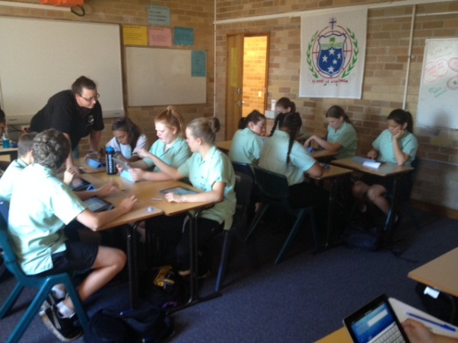

As part of this trial we are conducting surveys of students, staff, parents and community looking into the school adopting a BYOD (Bring Your Own Device) policy. Put simply, BYOD is a solution where students quite literally bring their own device to school in order to access the internet, be it a smartphone, tablet, laptop or other device. There are various models for BYOD as a school we have yet to decide on the most appropriate option and even if we will implement such a policy. That is why we need input from all concerned.

Mr J Miezio
Deputy Principal Teaching & Learning

DEPUTY PRINCIPAL’S REPORT YR 7, 9 & 11
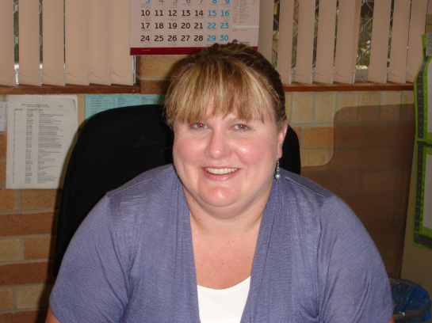

It’s hard to believe that we are already in Term 4, 2011! The year has gone so quickly, but we still have so many items on our school calendar as we count down to Christmas.
Year 7 are almost at the end of their first year of their secondary schooling and I would like to commend them for their, generally, positive behaviour and diligent approach towards their studies. Next year will see them go to three classes and, as I stressed at their Year Meeting, it is important that they revise and prepare for their Yearly Exams to allow themselves to achieve their personal best, and allow teachers to correctly place them in classes for 2014.
Year 9 should also be preparing and revising for their exams next week. Stage 5 is an assessment of what your child has learned over Year 9 & 10, so it is important that they maintain an accurate set of class notes from which they can revise for exams and assessments over the 2 year period. Year 9 continues to impress me in their Year Meetings and in their general attitude towards learning. I hope to see this reflected in their results and achievements this term.
Year 11 have started their HSC courses and will need to step up to fill the gap left by Year 12, 2013. Some students have started the process of dropping courses for their HSC pattern of study and I expect this process to be finalised by the end of Week 4. Students dropping courses will not have “free” periods. They will have designated study periods and they will be based in the Senior Study. They are also expected to remain on school grounds, they are not to come and go as they please, and are certainly not allowed to go to the shops or leave school grounds during these periods. Towards the end of Term 4, Year 11 will need to complete “Crossroads” which will be run by Mr Wagner and his team. This is a mandatory program for all Year 11 students and it addresses some of the health issues facing young people.
It was great to see so many of our students recognised for upholding our School Values of being safe, respectful learners at our recent Formal Assemblies. I had the privilege to attend the Year 11 ceremony and was impressed by the number of students who are achieving their personal best in all KLAs. Congratulations to all students recognised at these ceremonies – you should be proud of your achievements! Mr Lightfoot and his team did a phenomenal job in organising these assemblies and I sincerely thank him for his efforts.
Finally, I would like to commend the three Year Advisers that I support – Mr Rosete (Year 7), Mr Buckley (Year 9), Mr Lightfoot (Year 11). All three members of staff meet with me on a regular basis to ensure that the welfare and academic needs of your children are being met. Their dedication is impressive and I feel very privileged to work with such committed and passionate educators.
Mrs J Fuller
Deputy Principal

DEPUTY PRINCIPAL’S REPORT YR 8, 10 & 12

Welcome back to families and friends of Airds High School, to what will be an extremely busy last term. I hope the holidays were restful and relaxing for everyone and that we all had the opportunity to recharge our batteries, ready for the challenges ahead.
It has been fantastic to see so many of our students return to school in uniform. The wearing of a school uniform not only ensures the safety of all students by enabling all staff to easily identify outsiders, but also enables our students to demonstrate their pride in our school and our community. We will continue to enforce our school uniform policy with your help! Remember uniforms are available from the front office at a significantly subsidised price.
A number of students have been using a scooter or bike to get to school. I fully support any physical activity that our children engage in; however, this has caused a problem in regards to their storage. So many students are riding to school that it has become impossible to lock the scooters and bikes away in a storeroom. Keeping scooters or bikes in a staffroom raises Work Health and Safety (WHS) concerns. Therefore students will need to bring a lock to school so that their scooter or bike can be secured to the bike rack. In order for this to happen the students concerned will need to be at school before 8.20 am. This allows adequate time to secure the scooters and bikes before Roll Call.
As this article goes to print, the staff at Airds High School is working feverishly to complete all of our students’ yearly reports. These reports give a summary of how your child is progressing at school. I urge all parents/carers to take the time to discuss their child’s efforts throughout the second half of the year. Should you wish to discuss their results, staff will be only too happy to hear from you.
Year 12 is currently completing their HSC examinations, this is the culmination of thirteen years of schooling and I would like to wish them the very best of luck. I am sure that the education they have received here at Airds HS will have prepared them for the challenges of life that lie ahead. I would like to congratulate Ms Green for the wonderful job she has done in developing these fine young people. I am sure they will be fabulous ambassadors for our school and community.
Year 10 will be completing the first part of their Record of School Achievement (RoSA). They will be awarded grades ranging from A to E every subject; these grades will appear on all future Board of Studies (BOS) documentation. Therefore it is crucial that students attend school every day to maximise their learning opportunities and achieve to their potential. All students should have completed their final subject selections for Year 11, if not they need to see Ms Taylor immediately.
Our Year 8 students have almost completed their stage 4 program of study. As a result they have selected three elective subjects that they will follow for either 100 (one year) or 200 (two years) hours. Some of these courses require the wearing of personal protection equipment (PPE) in order to satisfy safety requirements. They may also have Mandatory fees to cover the cost of consumerables. If you have concerns regarding the selection of electives please contact the relevant class teacher or your child’s Year Advisor Mr Clements.
Sadly, Mr Foord will be leaving us at the end of Week 6 to take up the position of Principal at Nepean Creative and Performing Arts High School. I know that it was not an easy decision for Mr Foord to leave Airds High School and our community; however the move means that he will be much closer to home and therefore able to spend more time with his family. Mr Foord has contributed a lot to both our school and the community and both the school and the community are better off as a result of his time with us. On behalf of the school and the community I would like to publicly acknowledge his achievements, thank him for his leadership and wish him every success for all his future endeavours.
As always should you have anything that you would like to discuss regarding your child or the school please do not hesitate to contact me.
Mr S McGuire
Deputy Principal

School starts at 8:30am EVERY day. Please ensure your child arrives to school at this time EVERY day. If they are late, they MUST bring a note from you explaining the lateness. Thank you for your co-operation

PRINCIPAL’S REPORT
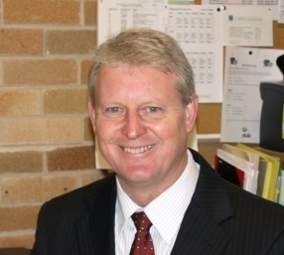

In this my last Principal’s scribble, I would like to reflect back over the past 4 years and the evolution that has taken place. The following changes: physical, educational and social have been the clear result of a large number of staff, students and community members working together to make a difference to Airds High School. It would be impossible to name all staff, students and parents who have contributed to the journey, but I have mentioned a few key stakeholders.

The good ship Airds as staff affectionately know our school has weathered the storm over the past few years and is now sailing on calmer waters. Although the odd storm emerges the frequency and severity are far reduced from those of the past.

My first executive meeting was certainly interesting when the primary focus was ensuring that the school was allowed to purchase ‘coloured paper’, that request was certainly easy to accommodate. We went one step further and purchased a colour photocopier, which then initiated a change to the format and presentation of the school newsletter: ‘Airds Announcer’. The coloured version and student reports at the start were a welcome change from the black and white publication with a heavy dense text format.

The leasing of a school bus in 2010, has ensured the isolation of the school and expense in hiring buses was no longer a concern when excursions or sporting events were organised. I’m sure the local community has also been most appreciative of our willingness and support of their endeavours through the provision of the bus at minimal to no cost. Must also thank Reiby for allowing us to park our bus in the secured carpark.

A fresh set of eyes on the school identified a number of issues next to the basketball courts. There was some contention with a derelict aboriginal building that was segregated from the rest of the school and this presented its own problems with managing truants and smokers who used it as a hidey hole. With the permission of the Aboriginal community within the school and approval of the local council the building was recycled by Mr John and his construction class. The timber frame has been used in the school for timber and wood tech classes and the Aboriginal mural on the external south facing wall has been placed into storage until it is mounted on the eastern wall of block 7.

The green fenced compound with its kicked in fence panels was also removed to make way for the extension on the COLA and the seating and gardens. The shipping containers found themselves a home in the southern highlands.

The Federal government in 2010 provided significant funding to upgrade the science facilities and the remaining funds allowed further enhancement of school facilities. The science refurbishment of 4 classrooms and two prep rooms brought the 70s science facilities into the 21st century. The firm that managed the project came in under budget and as a result we were able to get a 5th room addressed and made into a ‘connected classroom’. Still a small amount of money was left over resulting in funds to purchase a number of interactive white boards.

The BER Building Education Revolution also provided for a COLA – covered outdoor learning area above the basketball courts. A fantastic resource for PDHPE, sport and other outdoor activities. It is now also the venue for our school evacuations, ensuring students are protected from the elements during evacuation drills both real and practise. Stylemaster had the contract for the COLA and they too brought the project in under budget. As a result an additional span was added to the COLA on the southern end and landscaping and seating was installed .
But wait there is more, funds still remained from this project allowing for 23 rooms to be recarpeted and ½ the school receiving an internal paint. It was great to see some of the 1974 red carpet go to heaven.

As time progressed more and more rooms were refurbished until all rooms had either new carpet or vinyl. A total of 38 interactive white boards where installed across the school, thus ensuring all classrooms had the latest technology. A considerable amount of training ensured all staff were utilising the IWB with the students in the classroom. Thus improving student engagement.
A new computer server and wireless network installed throughout the school, quadrupled the schools computer capacity. The upgrading of all staffroom and computer room hardware ensured students and staff are at the forefront of technology. A huge thank you to Mr Miezio for driving this through the school with the help of Mr Wallace.

The training and development of staff has been a major focus in the past few years. In 2010, thirty six hours training in Accelerated Literacy, courtesy of the tireless work of Cath Angel and ably supported by Matthew Buckley was undertaken, with Cath Angel backing up again in 2011 and doing it all again for new staff. In 2012 Sue Celkys led 16 hours training in ‘Prioritising Grammar’ ensuring that the growth in our Years 7 – 9 NAPLAN was outstanding and in fact the best growth in the school education group and above state average growth in all areas, in 2011 and 2012. 14 hours of lectures from the University of NSW ensured we could extend all our students through training in Gifted and Talented education. Training and development in anaphylaxis, disabilities training, code of conduct, first aid, emergency care, n-determination processes, a plethora of ICT workshops driven by Jeff Miezio and Matt Wallace has increased the use of ICT appliances.

Julie Fuller and her welfare team relaunched the school values ‘safe respectful learners’ at a whole school showcase night. It was absolutely fantastic and now it has become part of our annual performances. In 2013, we utilised the local Arts Centre ensuring the students had a quality venue and appreciative audience. A number of quality murals exist in the school and to Mr Clements and the bombers well done.

The formation of a P & C has also occurred and the small group work tirelessly to support all school endeavours. To the originals Lynn and Theresa Clarke and Monica thank you for your fantastic support of the school and our more recent committee, continue to do a fantastic job. Melanie Cutts, Judith Ferderer, Carolynne Peagam.

2011 saw the beginning of a uniform transition from the polo shirt to a more formalised cotton button shirt, black pants and for seniors a black jumper replacing the bottle green jumper. The student body has wholeheartedly adopted the changes and the school as a result presents a far better image to the Airds and broader community. The introduction of black shoes in 2013 has smartened the uniform further. Thank you to the 80% of students who have supported that to date.

We have also had the vast experience of Mr Rob Hodgson, our school chaplain. Another state government initiative that has had a considerable positive impact on the school and Rob has gone above and beyond to support many of our staff, students and parents.

A number of applications for a trade training centre in partnership with Eaglevale HS were submitted without success. However, finally in 2012 and round 4, we scored a brand new 1 million resource that will ensure our students gain qualifications in construction in the years to come. Thank you to Mr McGuire for all his hard work. It will be affectionately be known as Steve’s Shed.

A further windfall resulted when our school canteen was refurbished and we changed from a leased canteen to a school managed canteen. Although not as financially profitable for the school it makes up for that in the provision of quality, good sized meals at affordable prices. I’d like to thank Helen and Tina in this venture.

Special mention must also go to AB Central for its ongoing support and donation of a coffee machine that has become an integral part of Maz’s Café.

It is essential that we acknowledge the outstanding work of three of our senior staff who have given unparalleled support to the school, staff and students over 20 years each. At the end of this year we will see three staff retire and thus will farewell Carol Jones, Cheryl Yabsley and Jenny Wealands. On behalf of all the students you have supported, staff you have worked with and activities you have managed, a big thank you. You have made an outstanding contribution to public education. Well done and best wishes in retirement.

To Steve McGuire, Julie Fuller and Jeff Miezio you have been outstanding leaders and supporters of our school. Your professionalism, dedication, commitment and loyalty are unquestionable. Thank you on a job exceptionally well done.

There have been numerous other changes that have taken place in the past four years, each and every one of them as a result of committed staff who care and want to make a difference to the lives of students at Airds High School. I sincerely thank you for making my journey such a wonderful experience. Airds will always hold a special place in my heart as I continue my educational journey at my new challenge: Nepean Creative and Performing Arts High School.

Mr M Foord
Principal

ADMINISTRATION REPORT
A reminder to all parents –
All outstanding invoices need to be paid by the end of the term. Due to the two government payments given to parents this year our student assistance budget was decreased and we are unable to absorb this money owed. Our uniform prices are signicantly discounted already and students are given uniforms by invoice on the understanding that they will be paid for. Please be aware that all owed amounts will rollover to the next year and will keep rolling over until they are paid. Your assistance in finalising these payments is greatly appreciated.

YEAR 12 GRADUATION 2013

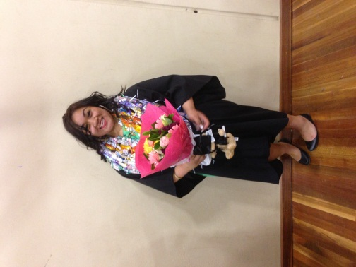
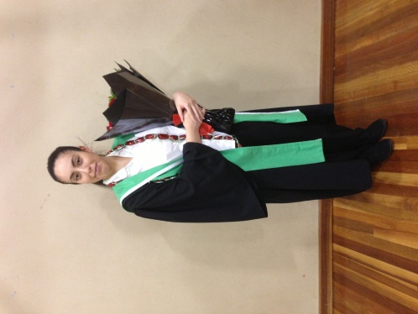

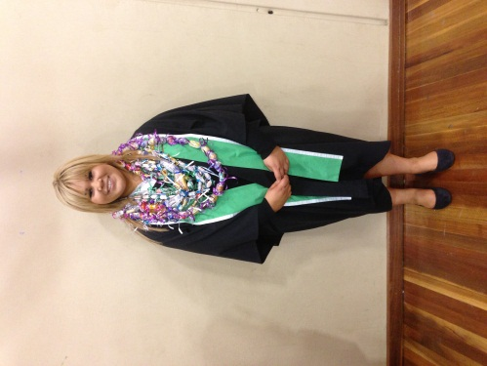
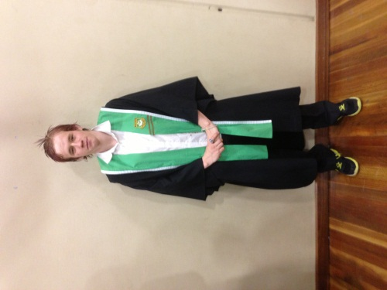
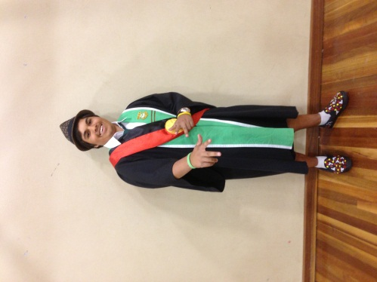

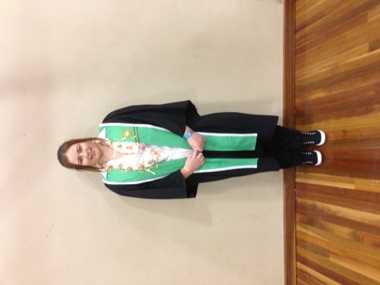
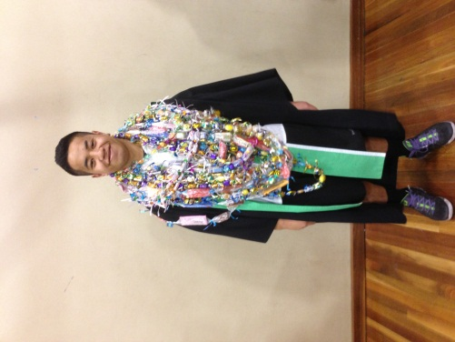
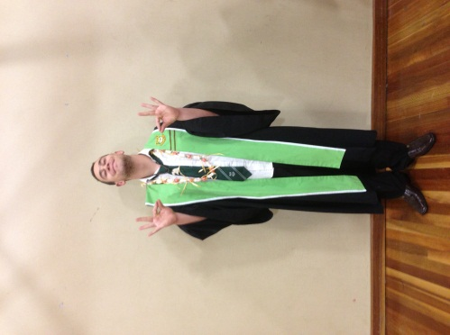

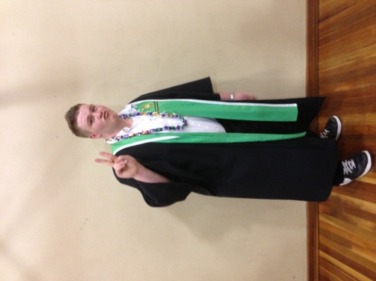

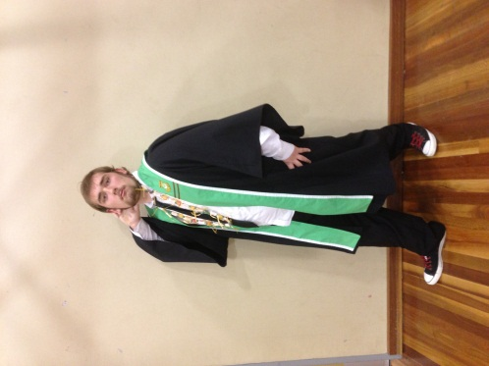

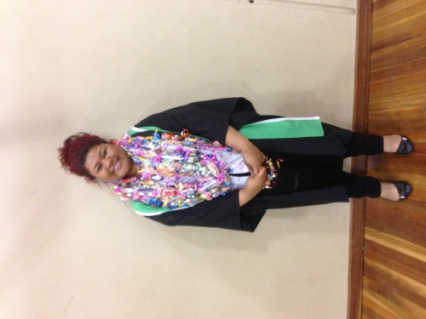

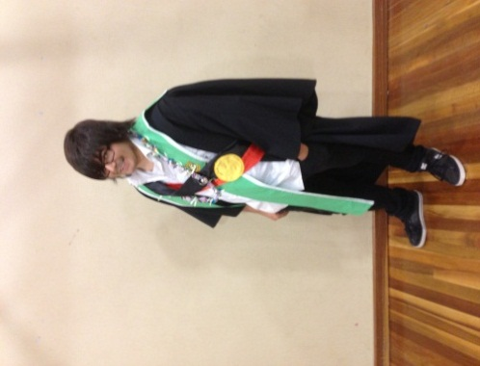

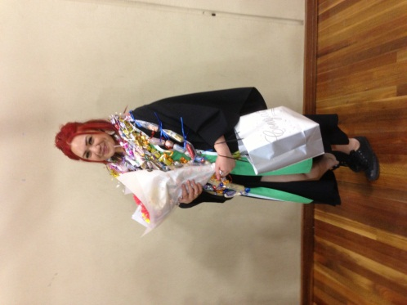

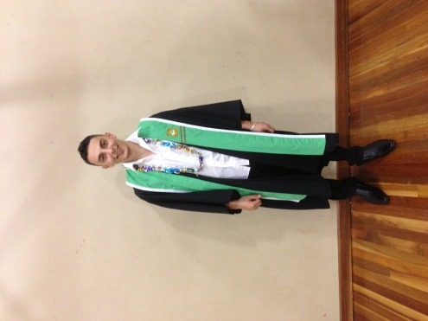

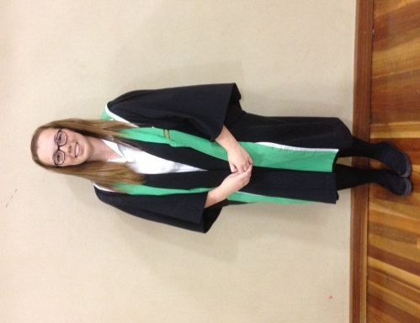

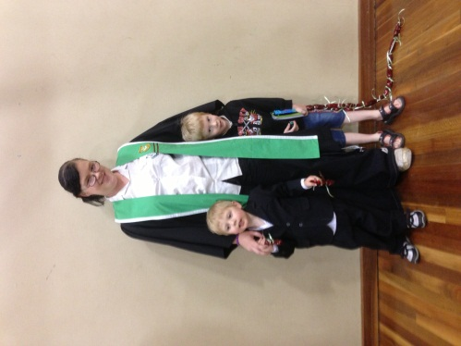

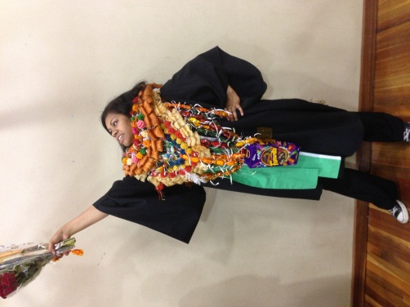

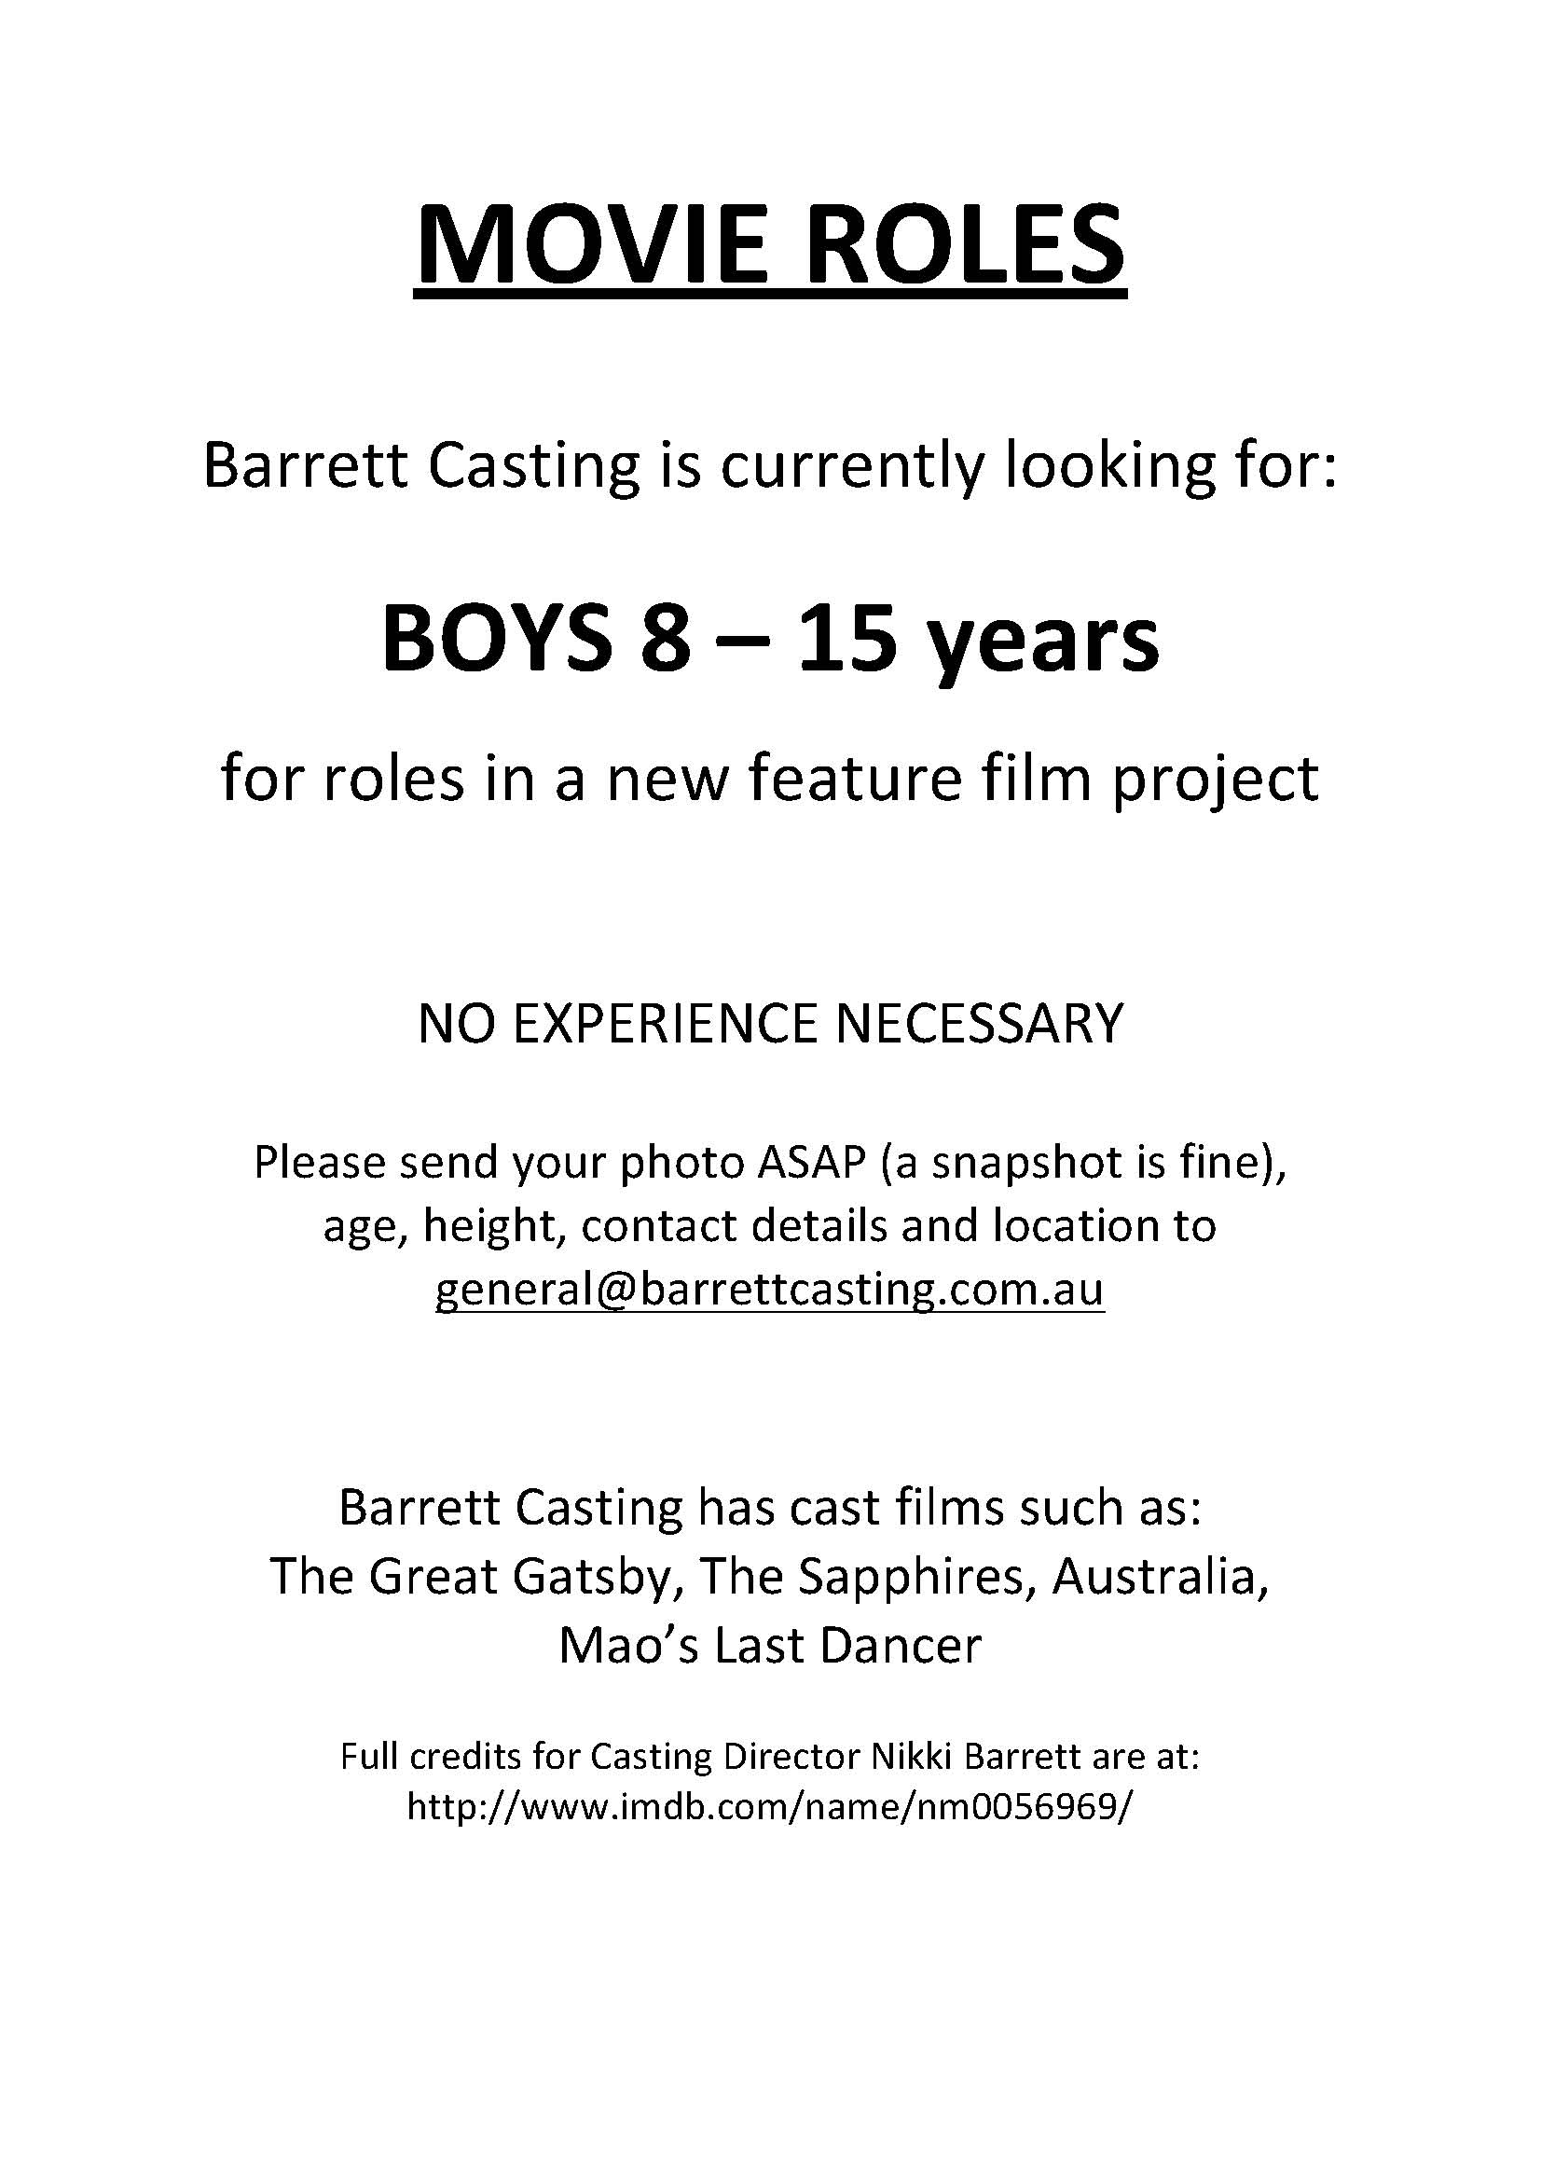
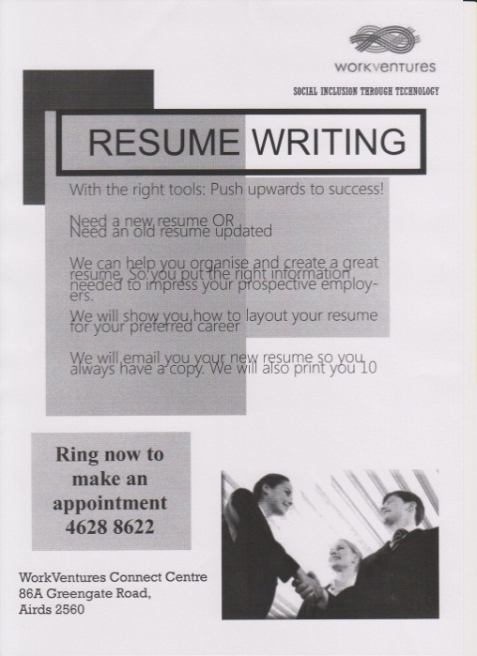
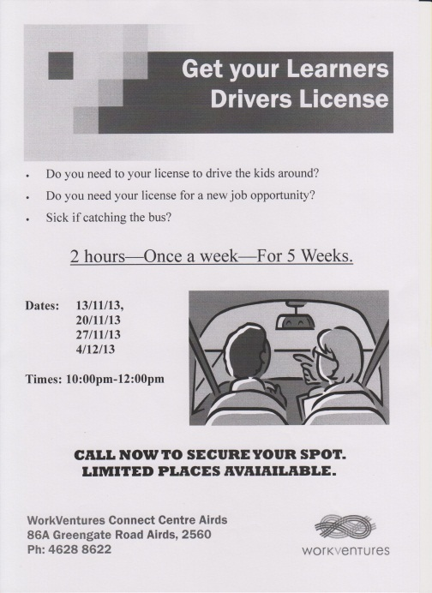
COMMUNITY NEWS

