Airds Announcer |  | 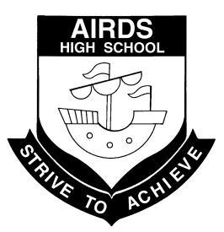
“A place to learn, lead and achieve your personal best”
Find us at: Airds High School, Briar Road, Airds NSW 2560
airds-h.school@det.nsw.edu.au
Issue 3– Term 2 | June 2012

DIARY DATES

Mon 16th July Staff Development Day
Tues 17th July Students return for Term 3
Tues 17th-18th July Fisher Zone Athletics Carnival
Wed 25th July Year 9 High Resolves
Mon 30th July Naidoc Assembly
Tues 31st July | Year 11 Biology Excursion
Wed 1st August | Aspirations Completion Ceremony
Thurs 2nd August | Australian Maths Competition  HSC practical exams begin
Fri 3rd August | Science & Maths Expo UWS-Parramatta
Mon 13th -17th August | Year 12 HSC trial exams
Mon 13th August | HSC Industrial Technology major projects due 9am
Mon 20th August | HSC Drama projects due  HSC Drama performances (all week)

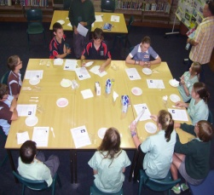
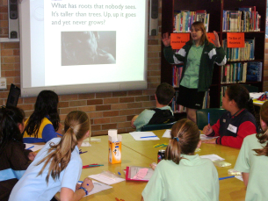
Airds HS Gifted & Talented Middle School Challenge Day

P&C REPORT
It’s hard to believe that we’re nearly half way through the year, but everyone has been so busy that the time has just flown by. Teachers and students have been involved in exciting and interesting learning activities every day and many extra-curricular activities have also been taking place throughout the term. Thank you to all the staff at Airds High School who work so tirelessly to ensure that our children’s time at school is both valuable and memorable.

I have had the privilege during the term to attend a number of sporting events that students from Airds HS have been participating in. At all of these events I was greatly impressed with the attitude and determination of all the students involved. It was great to see so many students having a go at a sport they had never played before and giving everything they had to the game and the team. The positive attitudes and great sportsmanship I witnessed at these events was very refreshing and made me proud to be a member of the Airds HS community. Congratulations to all the students who are involved in sporting teams and represent our school at zone and regional carnivals. You are all a credit to our school and should be very proud of yourselves.

It is with much sadness but a huge amount of thanks that Airds HS is farewelling Mrs Robyn Culbert at the end of this term. Robyn is retiring from her position as Community Liaison Officer and will no longer be regularly involved with the P&C. Robyn has been involved with Airds HS for well over 20 years, first as a parent and P&C member, and later as a member of staff. The work she has done with our teachers, students, parents and the wider community over many, many years has been invaluable and greatly appreciated by all those around her. It has been wonderful to experience Robyn’s happy, positive attitude and the calm and organised way in which she has approached everything over the years. The entire school community will miss Robyn greatly and it is difficult to express in words how much gratitude we feel for her commitment to Airds HS over so many years. Thank you very much Robyn, and we wish you all the very best in your retirement and everything you do in the future.

Finally, I would like to encourage everyone to think about attending a P&C meeting and finding out what we do. The more people we have involved with our P&C the more we can do for our school, and ultimately, our own children. Our next meeting will be held on Wednesday 1st August and it would be great to see some new faces there.

I hope you have an enjoyable and relaxing holiday and we’ll see everyone back at school for the start of an exciting Term 3

Ms Melanie Cutts
P&C President

FROM THE PASTORAL CARERS DESK
Term 2 is ending, and we are halfway through the year already. How quickly the time passes with such a busy school term, so much has happened. With so much activity and energy in the school at present, staff continue to amaze me as they work tirelessly to support our students in their learning and personal development. The students overall wellbeing is always a priority at AHS and this caring attitude goes beyond perceived teaching and learning.

In my last Airds Announcer item I asked the question. What shapes your identity? Well, developing your individual gifts and talents will help to shape your identity. You may have dozens of hidden abilities you didn’t know you’ve got because you’ve never tried them out. So try doing some things you’ve never done before, give it a determined try and if it doesn’t work out, call it an “experiment” not a failure. You will eventually learn what you are good at…

I encourage you to keep experimenting; I have met many people who discovered hidden talents in their seventies and eighties. I heard of a woman in her nineties who runs and wins 10 km races and didn’t discover that she enjoyed running until she was seventy-eight!

If we cultivate our gifts and talents; we will open our hearts and minds to grow our character and personality, and this will broaden our experiences, which will help to develop our personal identity.

I would like to take this opportunity to acknowledge Robyn Culbert (Community Liaison Officer). Robyn retires at the end of Term 2, and has given over 20 years of outstanding service to Airds High School and the community. She has been a wonderful asset to the school and will be sorely missed by students, staff and families.

Thanks Robyn for everything!! And our best wishes to you and John in your future retirement together.

In Term 3, I will be at AHS on Wednesday and Thursday.
If I can be of any assistance please do not hesitate to contact me.

Until next time
Cheers
Rob Hodgson JP
We are:
Safe
Respectful
Learners

CLO REPORT
Calling all gardeners! Our community garden plans are now underway and we are looking for volunteers for next term. Mr Peter Butler has generously given his time and expertise in establishing community gardens locally, to advise us and supervise this great project for our school. He has been working with our multi-cultural parents to plan vegetable and herb crops for planting next term. He would like to involve all parents so the garden can produce a sample of the food tastes of all our families. It is hoped to grow and harvest produce during the year, with the help of students and community, culminating in a celebration “feast” in Term 4. Peter has plans later for compost bins and possibly a worm farm. If you would like to help, or you have contacts for donations of soil, manure or mulch please contact the school. (Recycled wooden pallets are also useful for worm farms).

At time of writing the First Aid Course is about to begin. We had such a good response that we had to place some people on a reserve list. Thanks to the P&C for providing the opportunity for volunteers to gain valuable lifesaving skills and qualifications.

Thank you to Mrs Peagam and Mrs Ferderer who assisted at the Year 7 vaccinations recently. Your support and TLC for some nervous students was much appreciated.

Thanks also to those parents who helped distribute reports at Parent/Teacher interviews.

I have been advised of two valuable TAFE Outreach courses beginning next term (evenings) at Campbelltown - Introductory Computing and Micro-Computing. Outreach courses are for women who have experienced barriers to education. You will learn to make appropriate education and employment decisions. You will learn basic skills and get relevant experience and information so you can reach your goals. There are no formal educational entry requirements for these courses and there are NO TAFE fees.

For further information, please contact Annie on 46201866 or course information 4620 1703.
Please leave a message if unattended

A Date for your Diary
The 4th Macarthur Schools Parent Conference will be held on Friday 7th September at John Warby Public School. Our senior Hospitality students have been invited to do the catering once again and our Principal Mr Foord will also be a guest speaker again this year.

Sadly, this will be my last Announcer report, as I have decided it is time for me to retire after 22 years at Airds. My time at the school has been a wonderful and rewarding experience. I have met some amazing and hardworking students, staff, parents and community members and have enjoyed warm friendships with so many. In that time I have seen many changes, new initiatives and the continuing striving to do the absolute best for our kids. There have been great celebrations as well as some sad times, with encouragement and support always provided. I have been privileged to be a part of such a great team and will miss all of you.

Thank you for your friendship.

Mrs R Culbert
Community Liaison Officer

PICLO REPORT
Pacific greetings to all staff, students and parents,
Wow we are almost half way through the year already, how time flies when you’re having fun.
A busy month for Pacific people with the celebration of the Independence Day of Tonga on June 4th and the National day of Western Samoa on June 1st. Many people enjoyed the invitation by the Mayor of Campbelltown, Annoulak Chantivong, for a civic reception at the council chambers on June 7th to celebrate the Independence of Samoa it was a great night out following the successful day at the Pacific Forum at Airds HS.
The Pacific Forum was such a great event and it was possible because of the commitment and dedication of Pacific parents who shared a vision and a dream and made it happen. I would like to thank the following families the Lilomaiava family, the Fetui family, Siitia family, Tuagalu family and not forgetting my family the Varu’s (see I didn’t forget you) for all your time, commitment, and support not only for the forum but also for the school and especially for our children. This would not have happened if it wasn’t for you.
Opportunities to become part of the Pacific parents committee are always open, so come and be a part of a great team of parents who want to Promote, Provide and Pursue.
The Pacific Forum gave parents the opportunity to be informed of the diverse range of community services available in Campbelltown. There were fantastic speakers from all over including our guest speaker Dr Jioji Ravulo from UWS. Some services included Campbelltown Legal Centre(CLC), South West Sydney Regional Advisory Council (SWSRAC), NSW Council for Pacific Communities, Dept Human Services, Centrelink , Tenancy Advice, Benevolent Society, Powerhouse Arts Casula, Jfresh Productions , Australian Pacific and Maori Community Services (APMCS), and Court Advocacy to name a few. Parents left better informed of the services available to them and they now know where to go to seek help and support when they need to in their lives, they are now able to put a face to the name of the service which in turn makes the service more approachable.
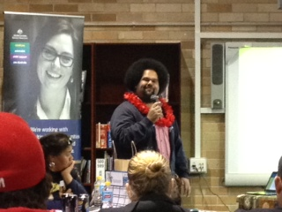
There were great performances from the Pacific students and the enthusiasm and attitude of all the Pacific students on the day is a credit to them. They were fantastic and so many assisted in whatever needed to be done there was no hesitation or complaints from any of them and I thank you for making my role that day a lot easier. I particularly would like to thank school captain Elijah Lilomaiava for his outstanding contribution to the day you gave so much you are a true leader and a great representative of the school and the Pacific community, well done also to Junior Puia and Andrew Tiatele who took the initiative and played their guitars during the lunch meal because we couldn’t find the music, to the girls who helped with the cleaning up and the boys who helped the caterers set up and pack up and re-setting of the library I say a BIG THANK YOU. Lunch was superb and we can thank ‘Taias Takeout’ for the beautiful and delicious Island buffet lunch.

The cultural displays by students and parents were amazing I learnt so much just by looking at the displays. Last but no means least thank you to Principal Mr Foord and Deputy Mr Meizio for your support during this venture and allowing us the opportunity to promote our culture and school.
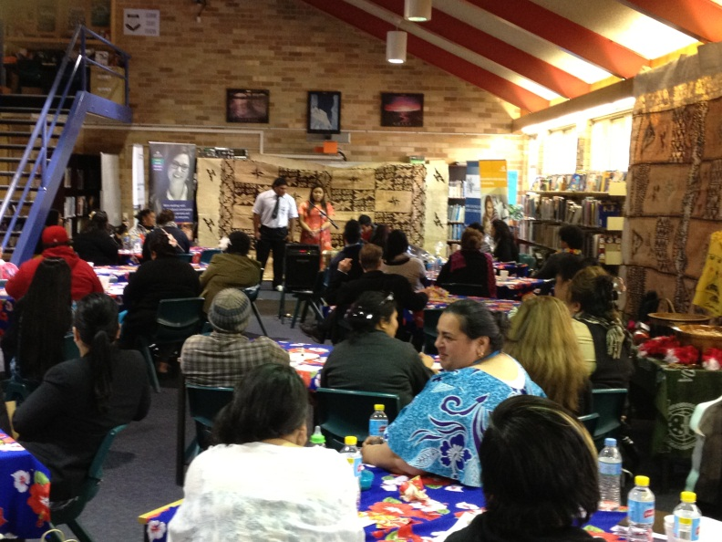

Good luck Jackie Faiaoga we raised $160.60 selling hot dogs at lunch to support Jackie who is currently in NZ competing in volleyball, we wish her well and know she will do us proud.
Multicultural garden is going full steam ahead and we are seeking ideas and plants, seeds, etc for the pacific section and willing hands to tend to the garden - no experience necessary.
Learning English this is a great site to look up on the internet to help with learning English and grammar it has lots of games quizzes and lessons for English language learners. I have had a look at it and I think it’s a great way to learn the English language. I encourage you to have a look and see how you go. This is the link http://www.roadtogrammar.com/
Pacific Achievement Awards are due in and they close 13th July. Airds HS will be nominating students again this year so good luck to those students who are up for nomination. Tickets to the event are obtainable from ‘The Cube’ Campbelltown Catholic Club.
Enjoy the holiday break and we will see you next term.
Kia manuia, All the best.
Mrs M Varu
PICLO

TEACHING AND LEARNING REPORT

We had a very successful NAPLAN this year. Students were fantastic and cooperated to the best of their ability during this rather difficult time. It is never easy to sit through hours of demanding testing and we were impressed with our students patience and resilience.
They really enjoyed the hot pies, chuppa chups and bottles of water that helped them through and we are very grateful to Helen in our canteen who did such a great job getting hot food out to so many people at once.
Thank you to all parents who ensured our students arrived on time and ready to work. Results do not come through until much later in the year.
ESL
Our ESL survey is currently underway. All families who have identified as LBOTE on enrolment forms are interviewed and their English language skills are assessed. We currently have ESL support for 5-10 students. If you speak another language other than English at home, please adjust your enrolment forms to recognise this as we are then able to apply to the government for more assistance.
Counting On
Our ‘Counting On’ teacher Mr Tyler has been working with a variety of classes giving extra support for Maths. We now have these fun and engaging activities in classes 7-10. Students love to do hands on activities and they often see Maths in a new light as they discover where in the world it is relevant and helpful.
Samoan Success
Our program during the last few weeks has focused on Visual Literacy. 21st century society is bombarded with so many images and so much advertising designed to persuade us to the opinions of others. We need the skills and knowledge to understand the power of symbols, pictures and other images. Our Samoan students are currently developing this understanding and applying it to the design and resourcing of our activity room. Samoan history and heritage are the focus for this engaging unit whereby students will design a refurbishment of our environment
STLAs
This term has been a busy term for us with the launch of the MULTILIT program. The programs acronym stands for Making up Lost Time in Literacy and aims to further develop student’s literacy skills. The program has been running with selected Year 7 Students this term with many students already showing great improvements in results. All students love attending their MULTILIT sessions each week and have become much more interested and excited about reading. The program will continue to run next term with additional students taking part.
SLSOs
Our SLSOs continue to support many students complete classwork, assessments and exams. At this time of year, people are sick and miss these activities. Our SLSOs are expert at supporting students who have fallen behind so please encourage your child to make contact with Ms Hopwood, Ms Addamo or Ms Rodriguez.
Ms Rodriguez will be leaving us in Term 3 as she has been successful in gaining permanent work at another school. We have been lucky enough to have had her for 5 years and many of our students will really miss her helpful and kind approach to things. We wish her all the best but we know she will really miss our school, the students and the staff.

Gifted and Talented
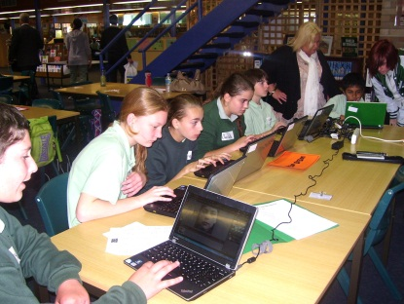
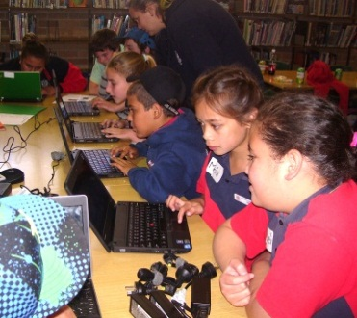
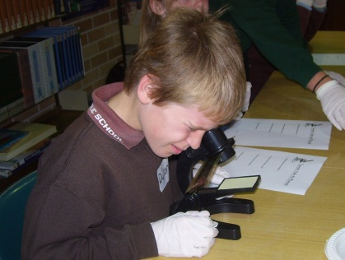
The Gifted and Talented Program has seen success this term with differentiated curriculum and withdrawal lessons continuing with the Year 9 G&T cluster group. The Year 9 students once again stepped up to the challenge when they hosted the Term 2 Airds High School ‘Gifted and Talented Middle School Challenge’ on Monday 18th June. The students showed great organisational and leadership skills and were excellent ambassadors for Airds High School. The Year 9 students received great feedback from all of the visiting schools and their teachers for the outstanding enthusiasm and knowledge shared with the Primary School students. We are really proud of the maturity, passion and willingness these Year 9 students have shown and they are to be congratulated for their efforts. Congratulations must go to Briar Road Primary School who won the challenge again this term. Looking forward to next term’s challenge!
Miss Zalewski & Ms Jones

An account of the challenge day by Victoria Peagam, a participating Year 9 student is printed below!
Gifted and Talented Middle School Challenge
On Monday 18th of June, Airds High School’s Yr 9 Gifted & Talented students hosted an event called Gifted and Talented Middle School Challenge. The students worked exceptionally hard to make sure the day was the best it could be. Children from surrounding primary schools (Briar Road, John Warby, Woodland Road and Bradbury) attended in the library of Airds High so that they could be challenged and educated by the selected students.
The day began with a game of Human Knots and Capture the Flag that the young students enjoyed, followed by lunch and a chat amongst themselves. Afterwards, the schools were rotated through four different stations: The Cup Game/ Project Play dough, Forensics, Matchstick Mayhem and Photoshop. All of the primary students were exceptionally satisfied with their educational accomplishments, as well as our own students. After rotating through the stations, all the students had recess and a little play time outside. Towards the end of the day, everyone enjoyed a game of Stu’s Quiz Boxes then a presentation of awards, followed by congratulations to Miss Zalewski, to celebrate her birthday.
The primary schools and their teachers were impressed with our students and can’t wait until their next visit.
Special thanks to:
Ms Jones
Miss Zalewski
Briar Road, Woodland Road, John Warby and Bradbury Public Schools
All the G&T students of Airds High
Dylan Crouch and Jazmyn Cooper-Martin
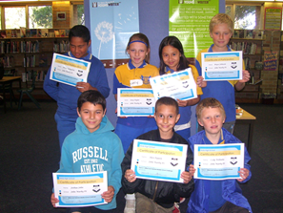
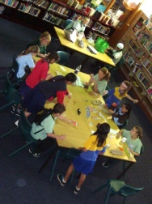

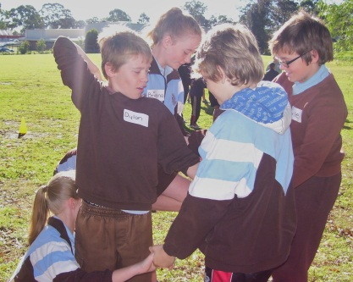

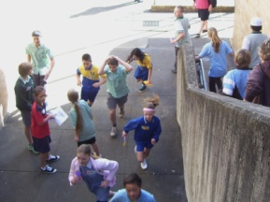

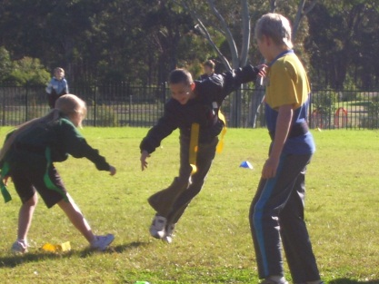

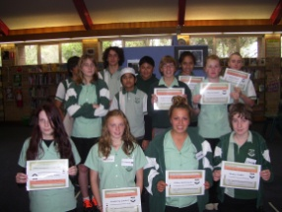

Library
The year is disappearing at a rapid pace. The national year of reading is half-way through. The Library has purchased many new resources to support leisure reading. It’s fantastic to see the number of students who now come in and check out the “new books” display before anything else and our borrowing statistics reflect an increase in reading.
ClickView is now up and running. For students to access videos shown or referred to in class, they need to get the URL address from their teacher so they can locate the video via the internet at home.
Our Library Monitors do a terrific job assisting at recess and lunch in many ways. They run the Circulation Desk and also the reshelving of books and keeping things tidy, as well as many other Library-related tasks that need doing. This frees us up so that we can work with students during break times, helping them find resources and reading material or providing technology assistance. We could not help your children in this manner without our wonderful monitors who give up their time.
Remember all the Library resources can be searched from home via the student DET portal. In the portal, click on the ‘My Library’ button to access our internal search engine. Remember also that we welcome parents as borrowers.
“The more you read; the more you will know. The more that you learn; the more places you’ll go.”
Dr. Seuss, “I can read with my eyes shut!”
Mrs Jones & Ms Burgess
Librarians

AM Program
The Awareness Motivation Program has seen a successful term with many new students joining the goal setting program. The program provides students with mentoring and goal setting opportunities and all students are provided with a healthy breakfast to start the day. Participating students have shown increased attendance rates and decreases in negative behaviours as well as improved engagement in classes.
Norta Norta
Mr Miranda is very keen for all the Year 12 Aboriginal students to contact him with any issues they are having with homework, assessments, exam preparation or even missed classwork. It is really important that students do not let things build up as then it becomes quite difficult to catch-up! It is never impossible though and if you notice that your child is anxious or avoiding school please get in touch with us and we will get busy organising time and resources to assist.
Macquarie University
The leaders of the educational research from the university visited us last week with a big bunch of flowers and a thankyou letter to all of those who assisted in the research. They have not completed their analysis of all the data but were very keen to emphasise that without our students and parents input, they would not have been able to gain the data they needed to advise government on community needs. Thank you to all parents and we hope you enjoyed your complimentary movie tickets.
Ms C Angel
HT Teaching & Learning

CAREERS REPORT
Ms Fitas the Careers Adviser can assist with career counselling, tax file numbers, work experience, resume writing and a variety of other options.
CAREERS NEWSLETTER CAN BE EMAILED TO BOTH PARENTS AND STUDENTS FOR IN DEPTH AND UP TO DATE INFORMATION.
In 2012, the National Careers & Employment Expo and WorldSkills Ultimate Skills Challenge will be held over 25,000 sqm at the Sydney Showground, Olympic Park from Thursday 30th August to Saturday 1st September 2012.

FREE ENTRY to the public and open every day from 9am to 4pm.
The student days are Thursday 30th and Friday 31st August 2012 and all activities are tailored for students.
MG My Gateway Current Traineeship & Apprenticeship
For information on apprenticeships or traineeships or to apply please visit their website: www.mygateway.org.au and click on Job Seekers

Ms A Fitas
Careers Adviser

SPORT REPORT
Athletics Carnival
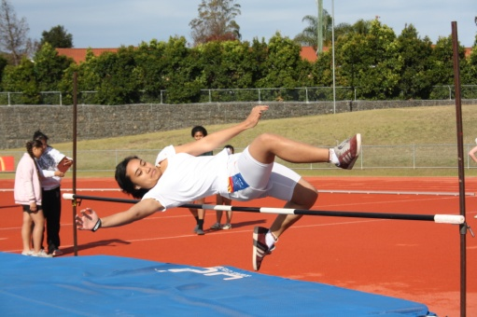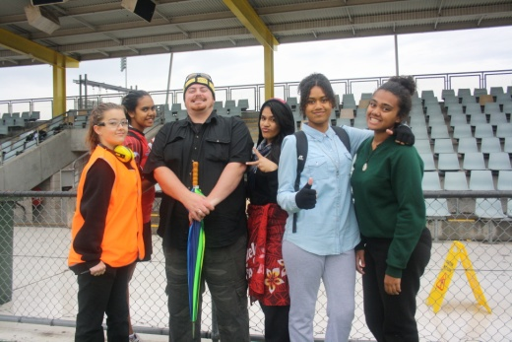
On the 25th of May we held our school Athletics Carnival at Campbelltown Sports Stadium. It ended up being a dry day and we actually saw some sun. This was exciting as the day before was grey, wet and miserable. Our students were lucky enough to use state of the art facilities which have seen many talented athletes compete at the same venue. It was great to see some parents at the ground supporting their children and we hope to see you again at the Fisher Zone carnival. I would like to thank all our staff for their hard work on the day, especially Mr Buckley for his humour and athletics facts on the PA system. A big thank-you to Miss Green and Ms Jones for their hard work with all our results on the computer. One last thank you to our transportation staff on the day; Mr Lightfoot, Mr Bromley and Miss Vongsouvanh. Congratulations to all those students who competed on the day and good luck to all those who made it to the next level.

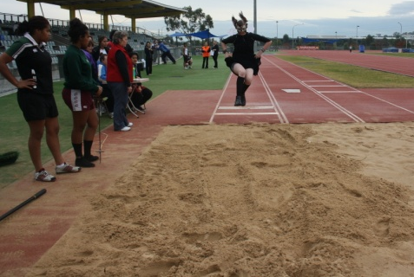

The following students now hold records in the following
events:

Age Group | Event | Name | Length or time
13 | Long Jump | Tristan Rowland | 4.38m
14 | 200m | Craig Sorovi | 27.25s
15 | Discus | Elijah Sa | 33m
16 | 200m | Leon Longbottom | 26.50s
12 | 200m | Vanessa Sitia | 36.28s
13 | Discus | Angela Franks | 16.65m
14 | High Jump | Loata Peter | 1.22m
14 | 200m | Loata Peter | 32.35s
16 | High Jump | Whitney McEvoy | 1.25m
16 | Long Jump | Evelyn Lardner | 4.44m
16 | 100m | Evelyn Lardner | 13.74s
16 | 200m | Evelyn Lardner | 30.47s

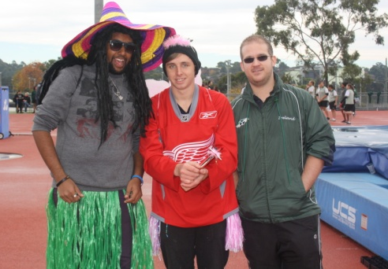

Congratulations to all our Age Champions

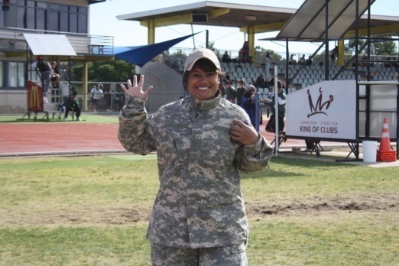
Age Champions 2012 |  | Gender | Age | Points
Michelle Naicori | Female |  | 12 | 36
Angela Franks | Female |  | 13 | 46
Loata Peter | Female |  | 14 | 32
Melita Trappel | Female |  | 15 | 48
Evelyn Lardner | Female |  | 16 | 40
Adi Turaganivolo | Female |  | 17 | 30
Sam El-Abd | Male |  | 12 | 32
Tristan Rowland | Male |  | 13 | 44
Craig Sorovi | Male |  | 14 | 34
Elijah Sa | Male |  | 15 | 48
Hayden Harison | Male |  | 16 | 32
Filo Aiga |  | Male | 17 | 36

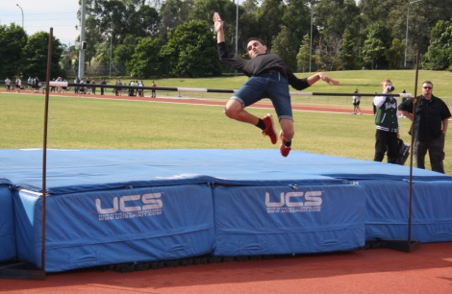

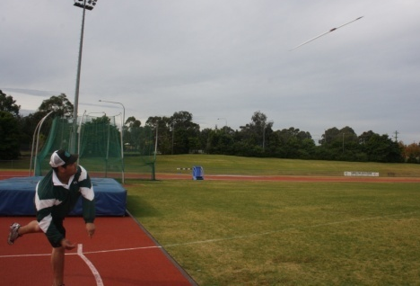

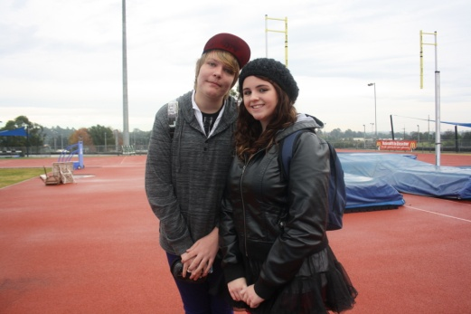

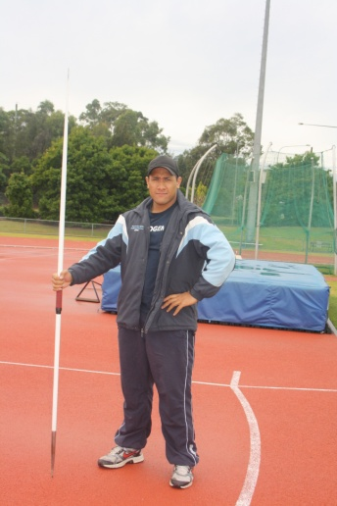

Our Fisher Zone Athletics carnival will be held on the 17th and 18th of July at Campbelltown Sports Stadium. Students have received permission notes and these need to be handed back to me (Miss Tate) before the end of Term 2, as the carnival is on the 1st and 2nd day back of Term 3.
Open Boys Hockey
I believe this is the best team we have taken away to represent our school in the knockout competition. We had a mix of abilities from all year groups but all seem to blend well and work together as a unit on the day. The boys played at Narellan hockey fields on the 13th June against one of the best school teams in NSW, Camden High School. Airds unfortunately went down 12 nil in the game; however, our boys continually fought hard and almost scored a few times in the second half.
Our stand out player on the day was William Philipsen our goal keeper. He was diving and putting his body on the line the whole game. We had James Peagam and Ryen Edmond- Hughes working tirelessly in the backs. Our midfielders consisted of Matthew Chard, Chris Williams and Robert Clark-Hirka. The hard working inners were Jayden McCormick and Jake Taylor and our strikers were Austin Harris and Jonathan Bauluck. Well done boys it was an absolute pleasure coaching all of you. All the Year 12 boys will be greatly missed next year.
A big thank you to Mr Lightfoot and Miss Fansa for their contributions on the day. Thank you to Mitchell Alley who was our photographer.
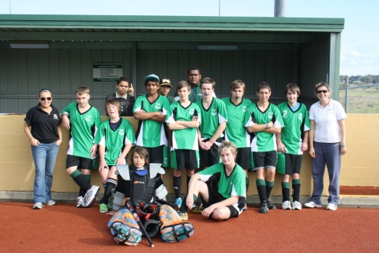
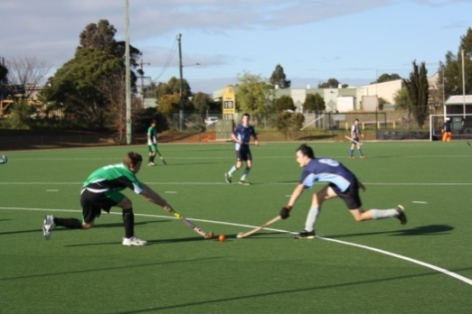

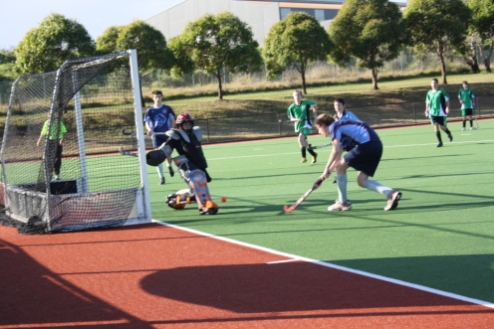

Girls Knockout Hockey Central Venue
On the 28th of May our girls went up against Westfield High School in their 3rd round match into the knockout series. The Airds girls put up a great fight but, unfortunately went down to the sports school in a close game. Our 2012 Knockout hockey team are a beautiful bunch of girls. Each and every game all the girls gave it their all. I would like to thank all the girls for a terrific day. It has been an absolute honour and pleasure to spend a whole day with you out at Moorebank Hockey Complex. To all the Year 12 students who have been part of the team for 4 years now, you will be greatly missed next year.
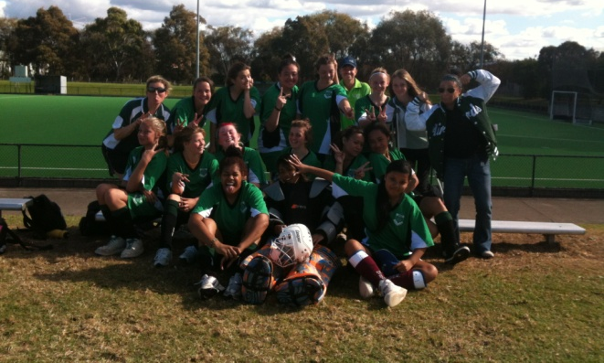

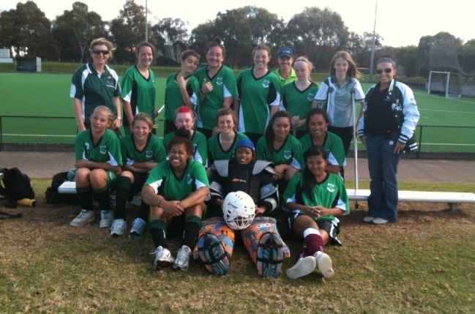
The day could not have been possible without the following people. A BIG THANK YOU to Miss Fansa, Judith Ferderer and Melanie Cutts.
Open Girls League Tag and Year 7 – 9s
I took a group of Year 7-9 and Year 10-12 girls out on a League tag day to Ingleburn where they competed against various schools from around the local area. The Year 7-9 girls had a very successful day, they just missed out on the grand final on for and against; however, this group performed admirably and in the spirit of the game. There were some standout performances from Ciara Loli, Naya El-Abd, Leavea Sauvao and Loata Peter. In the Year 10-12 group the girls played well all day and progressed to the grand final where they were narrowly defeated. The stand-outs included Whitney McEvoy, Evelyn Lardner, Adi Turaginovolo and Siteri Peter. Well done girls on a great day!
Mr Bromley
Fisher Zone Cross Country
Our Fisher Zone Cross Country Carnival bought out a beautiful day for running. We had 19 students representing Airds HS. Our school received 5th place which is 1 place higher than we received last year. Aidan Ferderer received Age Champion in the 14 boys 4km run and a close second was Jake Taylor.

Congratulations to the following students who made it to regional Cross Country carnival.
Name | Age group
Joel Reid | 12 years
Aidan Ferderer | 14 years
Jake Taylor | 14 years
Wizz Foster | 14 years
Dylan Mahon | 16 years
Matthew Chard | 18 years
Chris Williams | 18 years
James Peagam | 18 years
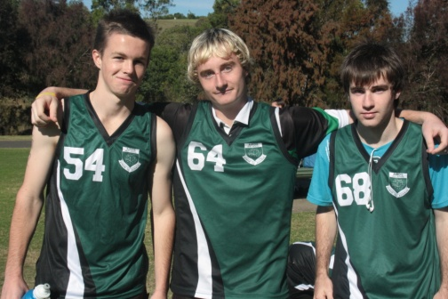

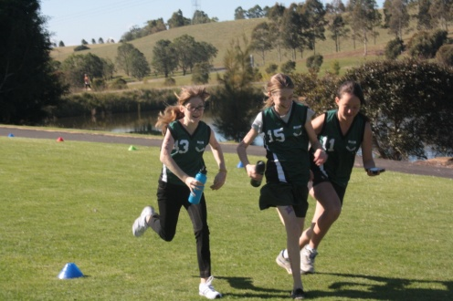

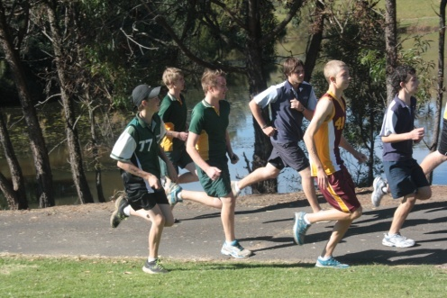

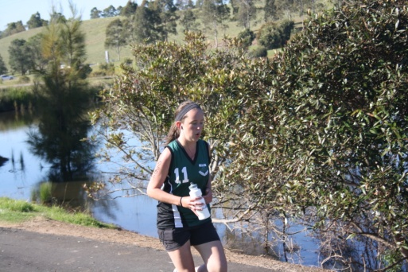
Regional Cross Country
The Regional Cross Country Carnival was held on the 14th of June. The weather wasn’t kind all week which meant reports back from our runner’s suggested very muddy conditions where some have finished the race covered from head to toe in mud. Matthew Chard was one of those runners. Sorry Matt! Great run though. We need to congratulate one of our runners Aidan Ferderer in year 9. He received 6th place in the 14 boy’s age group. He is now off to the State Championship on the 20th of July at Eastern Creek. All the best and congratulations Aidan!
Ms N Tate
Sport Organiser

Open Boys and Girls Futsal
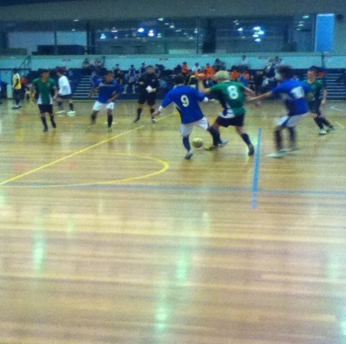
On the 27th April, selected girls and boys travelled to Minto Sports Stadium to compete in the Open Boys and Girls Regional Futsal Championships. Both teams knew they were up against tough opposition and the girls opening game was against the reigning Australasian Champions. The girls had many of their team members playing Futsal for their first time but they all tried exceptionally hard and displayed good enthusiasm and sportsmanship throughout the day.
The boys group was just as difficult, coming up against some well known sports schools, but again they showed some great skill and teamwork, but were unlucky not to come away with more goals to help them to the finals.
Both teams behaved extremely well and both Mr Lightfoot and I were very pleased with the way they participated in all of the games. They should be very proud of themselves, well done both teams!!!
Mr Miranda and Mr Lightfoot

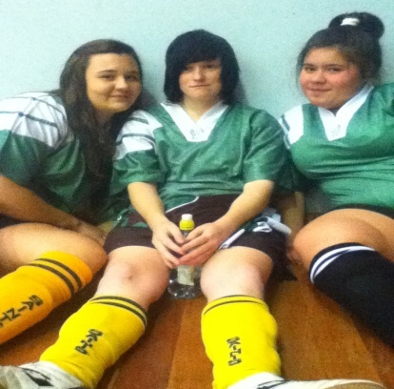

SRC REPORT
It has been yet another busy term for the SRC. We have welcomed our newest members, Year 7 representatives Kimberley Anderson, Mackauley Jones, Pelagia Dmitrieff and Mahmoud El-Tahach. They have settled in well and are embracing the opportunity to be student leaders.

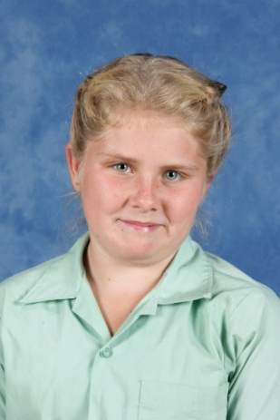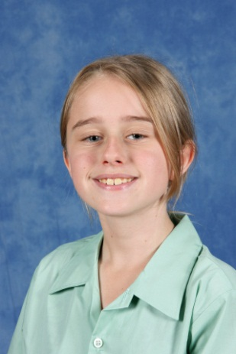
Kimberley Anderson Pelagia Dmitrief

Mahmoud El-Tahach Mackauley Jones
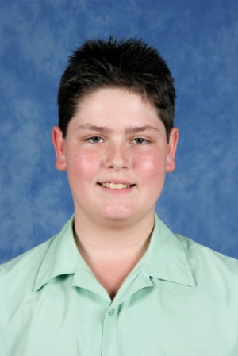
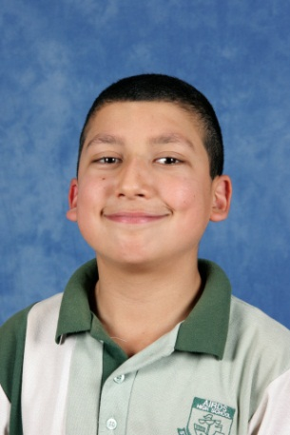

We hosted our 1st Inter-School Group (ISG) SRC Meeting on Monday 2nd April. Many students from the local primary and high schools met and were inspired by a guest speaker, participated in team building activities and listened to reports from each of the schools as to initiatives they have undertaken. Thank you to the following students who helped out on the day and also attended the meeting; Adi Turaganivolo (11), Anna Mati-Leifi (11), Aidan Ferderer (9), Rhiannon Cuthbert (8), Angela Franks (8), Emily Moore (8) and Justin Peachey(8). On the day they also voted for the ISG Executive and Anna Mati-Leifi was successful in the position of secretary. Paul Vaai and Emily Moore attending this term’s ISG Meeting which was held on Tuesday 19th June at Ambarvale High School.
School Ambassador Day was held on Friday 15th June at Belgenny Farm. I am pleased to announce that our 2012 School Ambassador for Public Education is Meaghan Noom from Year 10. She attended this day with ambassadors from other schools and had a very busy day completing a variety of activities. Meaghan will need to undertake a selection of duties in this role and we will keep you updated on them in upcoming Airds Announcer articles. Matthew Chard also attended on the day as he was our School/Regional Ambassador in 2011. He gave an enlightening speech to the group about what it involved and how much the opportunity helped him grow as a person.

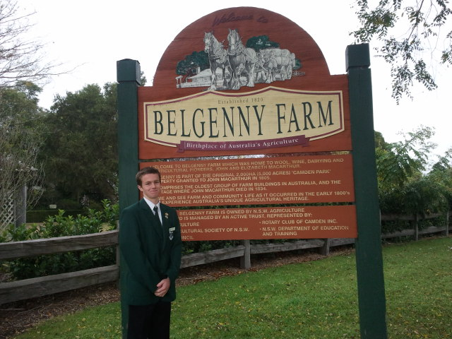

Miss Simms – SRC Co-ordinator
Mr Wallace – Assistant SRC Co-ordinator

Charity of the Term – Sids and Kids
The charity of the term for Term 2 is Sids and Kids. Sids and Kids is dedicated to saving the lives of babies and children during pregnancy, birth, infancy and childhood and supporting bereaved families. On Thursday 28th June 2012 we are having a mufti day for a gold coin donation and wearing red. On that day we are also selling red noses for $2.00.

Education Week
For Education Week, Airds High School SRC are planning that every year group’s SRC organise a different activity. Some of these activities may have prizes for the winners or just for participating.

Year 7-Capture the Flag
Year 8-Dodgeball
Year 9-Literacy and Numeracy Challenge
Year 10-Scavenger Hunt
Year 11-Volleyball
Year 12 will be helping each year group organise their chosen activity

Written by Angela Franks and Emily Moore

TAS/CAPA REPORT
Our Parent Teacher night was a wonderful opportunity to be able to speak with all the parents. This gave our faculty the chance to inform parents about their child’s progress in our subjects and we appreciated your time.

As most parents would have already been aware, there has been a change in the Year 7 and 8 Technology Mandatory and Visual Arts classes. This means students in Year 7 Technology Mandatory and Visual Arts classes will not be rotating and will be with their same teacher for the rest of the year. Year 8 Technology Mandatory students however will be rotating to their new Technology Mandatory classes next term. This brings about the changes for Term 3. Term 2 Year 8 Technology Mandatory students who had Ms Vongsouvanh will now have Mr Lightfoot in Term 3. Mr Lightfoot’s Term 2 group will now be with Ms Coogan and Ms Coogan’s old group will now be moving to Ms Vongsouvanh’s class for Term 3.

All TAS and CAPA subjects contain fees. Your child’s fee includes all the resources and materials required to complete projects which they will use in their practical lessons. If your child’s fees have already been paid in full then it has been greatly valued. If fees have not been paid then it would be appreciated if it could be paid to the front office within the first three weeks of the term. If you have any difficulty in paying the fees, could you please inform the Head Teacher so that other arrangements can be made. Fees letters can be obtained from your child’s teacher outlining costs and equipment involved for each subject.

As Term 3 fast approaches this means time to knuckle down for our Year 12 students. Once again we would like to remind parents of important Higher School Certificate dates for Industrial Technology, Music and Visual Arts students. Industrial Technology Major Works are to be completed and submitted to their classroom teacher no later than 9.00am on 13th August 2012 (Week 5). Visual Arts Body of Work must be completed and submitted by 3.00pm on 27th August 2012 (Week 7). Music performances will be conducted between 3rd September, 2012 to 14th September 2012 (Weeks 8 and 9). No work will be accepted after these times and dates given.

If you attended the Community Out Loud event on Saturday 16th June at AB Central you would have had the opportunity to see some of our talented Year 11 and Year 12 students perform. They consisted of Mahdi Saleh of Year 12 who performed a magnificent solo act. Tyson Ryan (Year 12), Kasilea Cherry (Year 12) and Charmaine Edwards (Year 11) were an astonishing band show. Our Year 11 students Anna Mati-Leifi, Paul Vaai and Andrew Tiatele produced a breathtaking performance. Organisers thoroughly enjoyed our students’ performances and have already asked them to perform again at an event at the end of this year. Big congratulations should go to our fantastic performers for being such wonderful ambassadors and displaying some of the amazing talent we have here at Airds High School. A thank you goes out to Ms Adair and Ms Green for organising the students.

During the term Mr John conducted a two day Construction Induction Training course with selected students from Year 9 through to Year 11. This allows students to learn about essential Workplace Health and Safety practices within the Construction industry. The successful completion of this program means that students will now be qualified with a White Card, enabling them to work outside on a construction worksite. This program is highly beneficial for our students who not only will be going out on work placement throughout the year but would also like to work in the construction industry. Students will be issued their qualification certificate when they arrive next term and only when they have paid the $50 fee. If your child has not paid this fee then please pay at the front office. Well done to our students and thank you to Mr John for this valuable day and giving this opportunity to the selected students.
Students completing the Construction Induction Program
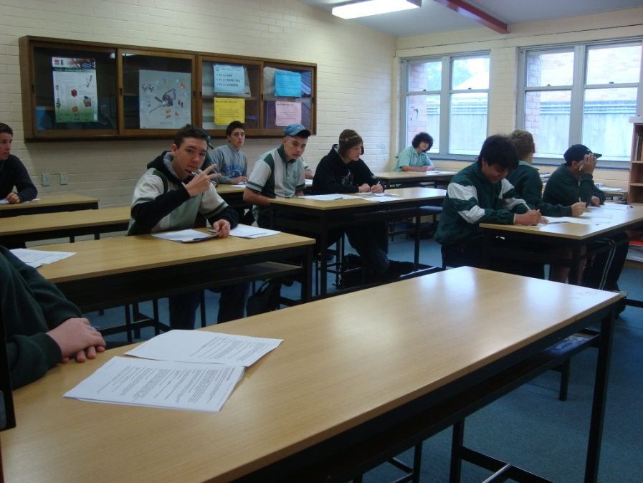
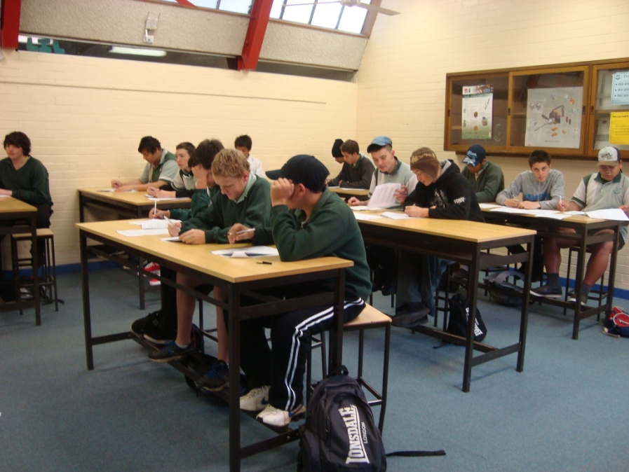
There are many activities happening within TAS and CAPA in Term 3. Until then, have a safe holiday.

Ms N Vongsouvanh
Rel HT TAS/CAPA

SCIENCE REPORT
May and June have been very busy months for the Science faculty as we work towards Science Week. We have been organising extra-curricular activities including Clean-Up Australia, Mobile Muster and National Tree Day.

Year 9 Argon and Year 8 Brannigan and Turanga will be enjoying a visit to the Australian Museum on the 21st June courtesy of the Australian Museum. Students will experience a day looking at the outstanding natural history displays and creating posters with Ipads.

On Friday 22nd June Year 12 Chemistry will be travelling to the University of Western Sydney, Parramatta campus for a hands-on day of Chemistry with Ms Dunn. This will be a fantastic opportunity for students to revise the experimental work they have completed in class.

Ms Holmes is regularly visiting Airds Pond as part of the Local Environment for Year 11 Biology. They have been observing and testing the area to monitor the biological factors at work in our school backyard.

Science is currently collecting used mobile phones to be recycled as part of the Mobile Muster Challenge. This means that old phones will not end up in landfill sites contaminating the soil but will be broken down into their basic metals and recycled into new phones and electronic equipment. As a reward for the first five students with the most phones collected by December there are 5 Shuffle type MP3 players up for grabs courtesy of the Mobile Muster Organisation.

Ms Temple
Rel HT Science

YEAR 10 REPORT
Wow I can’t believe it’s almost half way through the year. Time has just raced by as we now look forward to our much deserved break from all the exams, assignments and assessment for semester one. Hopefully our student’s accessed the dedicated staff here at Airds High School to aid in their exam preparation and have all achieved their desired outcome. Students need to remember that the time to talk and communicate to our dedicated staff here at Airds High School is not over just because exams are over, they must continue to utilise staff for their day-to-day educational needs throughout the rest of the year.

It is great to see one of our own troopers back in action. Ben Ling has been deeply missed recently with an extended stint in hospital. I had the pleasure of going with five Year 10 students to see Ben in Randwick Hospital. The students were Tyson Riordan, Mark Common, Jason Zeballos, Jesse Edwards and Mitchell Regan. Both staff and students passed the hat around for Ben and we were able to raise over $200 which went towards a signed Roosters football jersey. It was moving to see in person the true camaraderie and admiration the boys had for their mate and I am happy to report that he is back, fighting fit and engaging in all activities just like the good old days; welcome back Ben.

In other news this has been an action packed term for Year 10 as we have had many events on our calender and will continue to have in the weeks ahead. We have just successfully completed our Year 10 Welfare Day where we had a huge focus on teamwork, communication
and leadership skills and let’s not forget fun. We enjoyed a
fun packed day which started with team building activities and then was accompanied by a travelling entertainment group called Games to You. Games to You brought three activities to the school which consisted of Laser Tag, a Giant Hamster Ball and a Multiplayer Gaming Trailer.

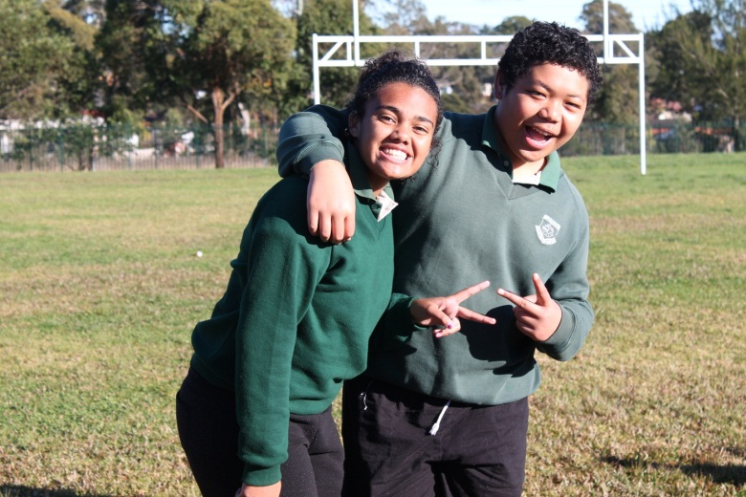

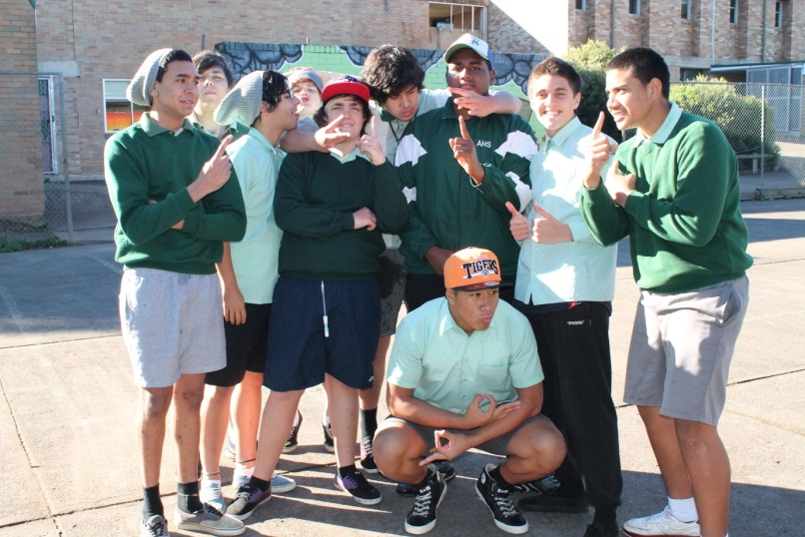

Ben Ling making sure that every drop counts

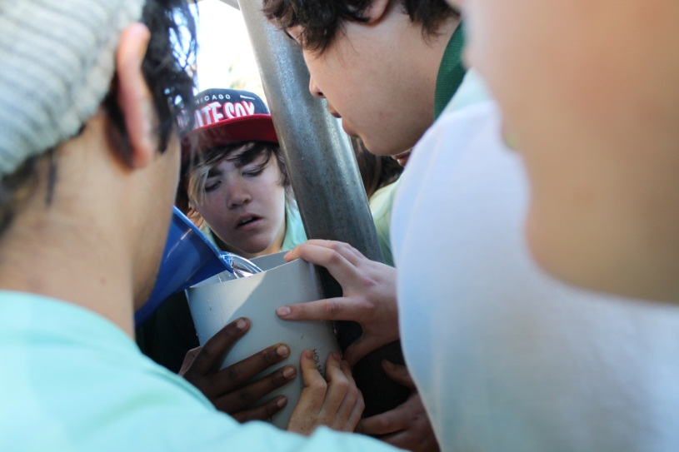

Whoops here comes the water fall

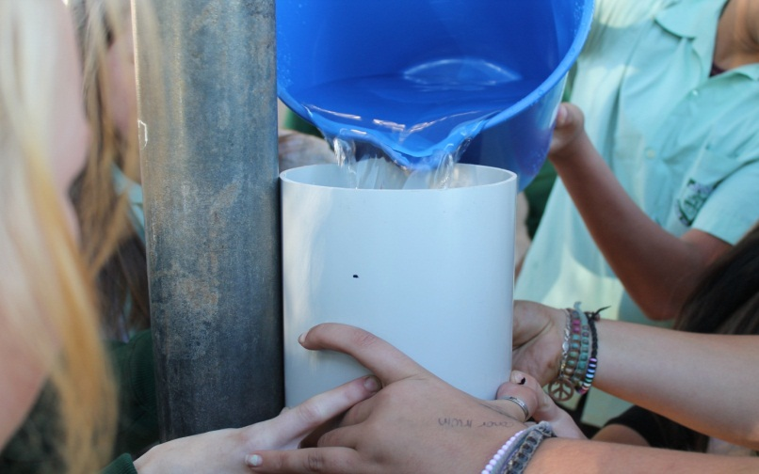

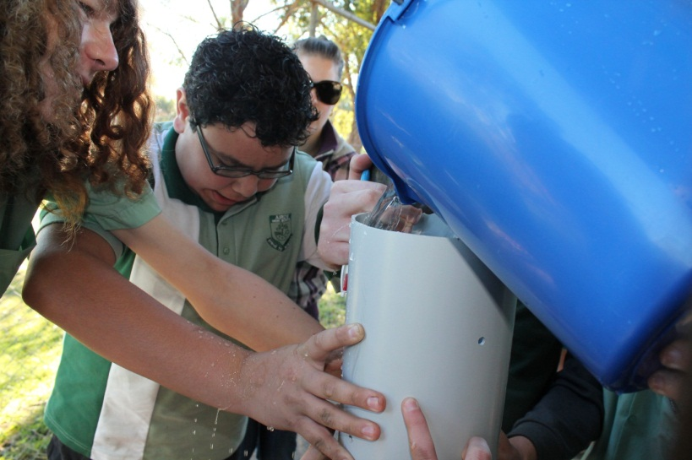
Quintin hoping that is just water and nothing else…..

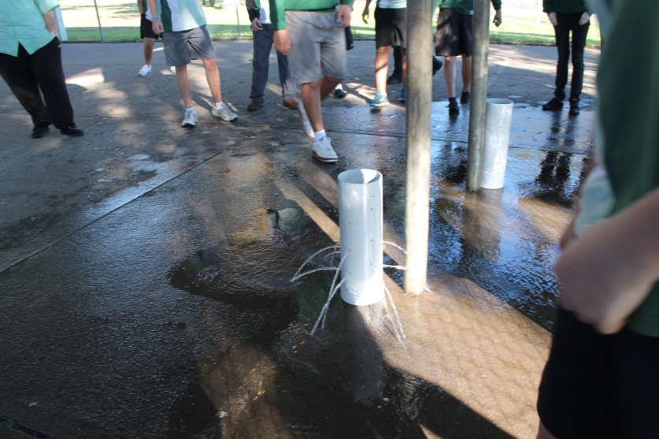
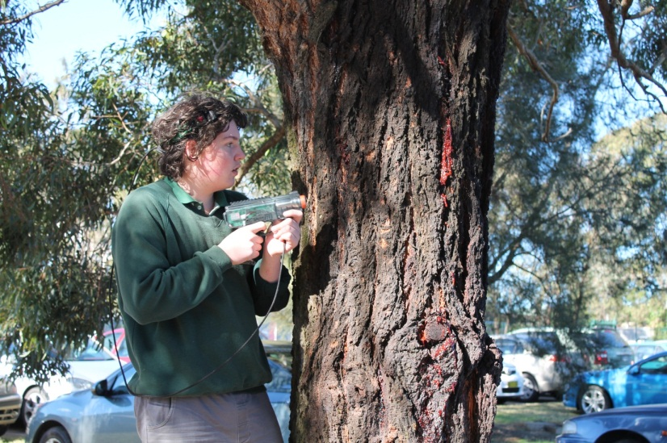
Kyle searching for Stephanie

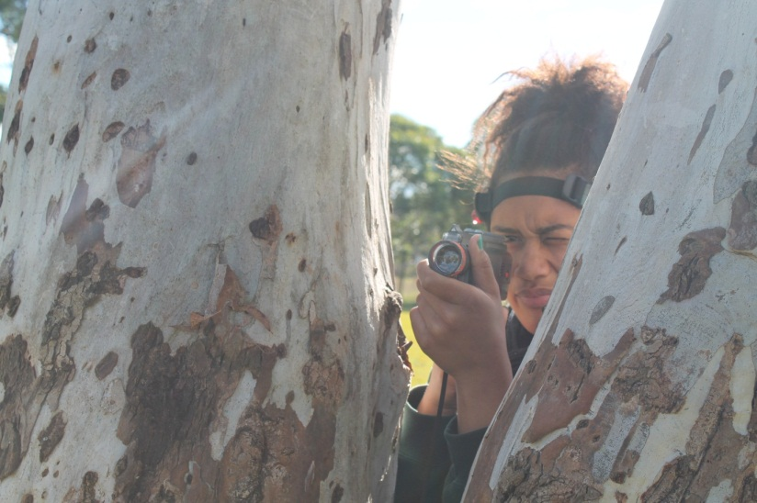
Stephanie getting Kyle from his right flank

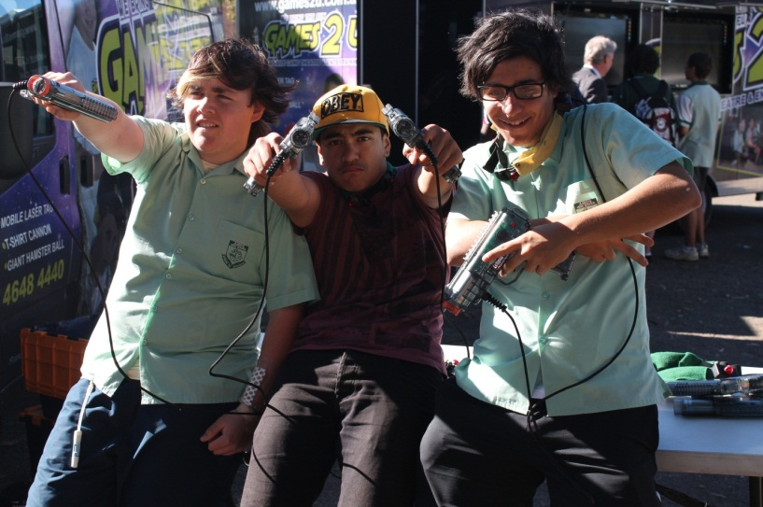

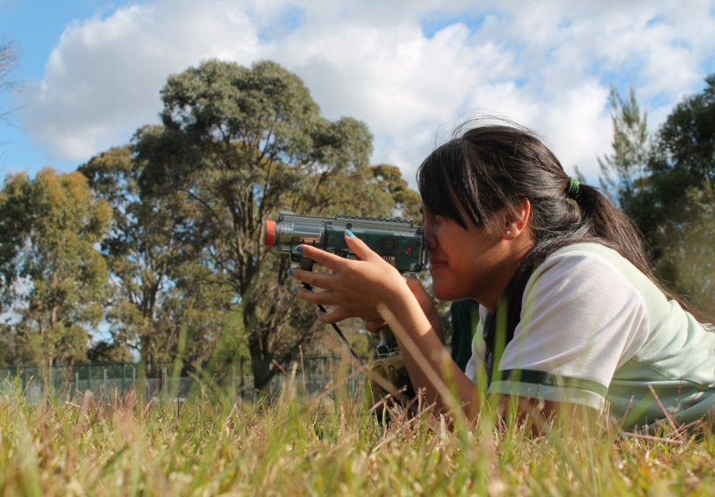

Rosa deep in the jungles of Airds

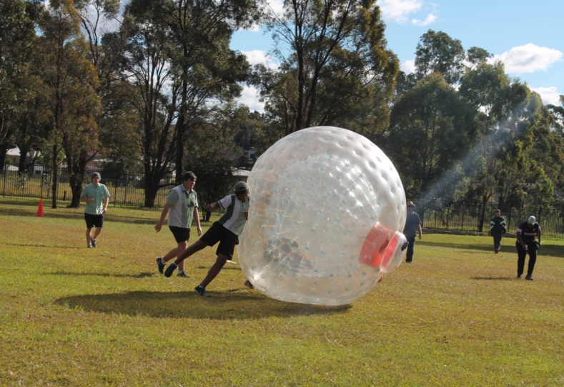

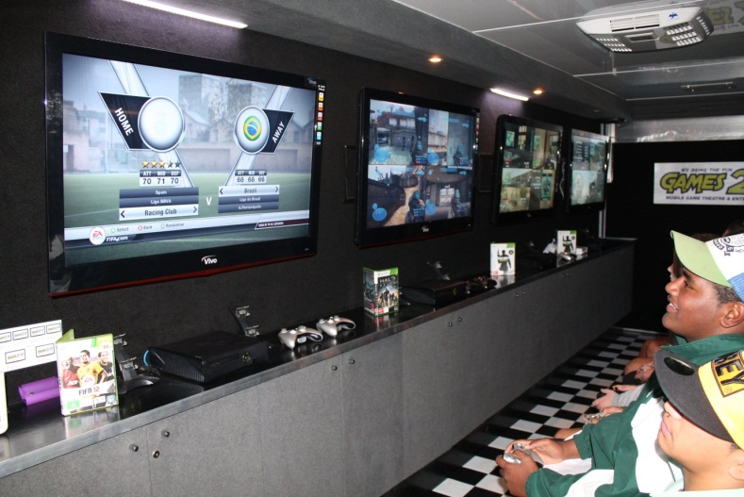

As you can see we had quite an enjoyable day and I have to say that this is arguably the most fun that I have had with our year since my time as their Year Adviser. This was predominantly due to the incredibly safe and respectful behaviour displayed by our students; which just allowed myself and the two supervising teachers Ms Simms and Mr Bromley to focus on all the positives of the day and really enjoy our time with the kids.

Fundraising will be big on our agenda next term and a solid commitment is needed by all so that we can provide greater options for our Year group.

In closing, I wish our year group a safe and joyful holiday and hope that we are all ready to strive to achieve our personal best when we come back for Term 3.

Cheers
Mr D. Lightfoot

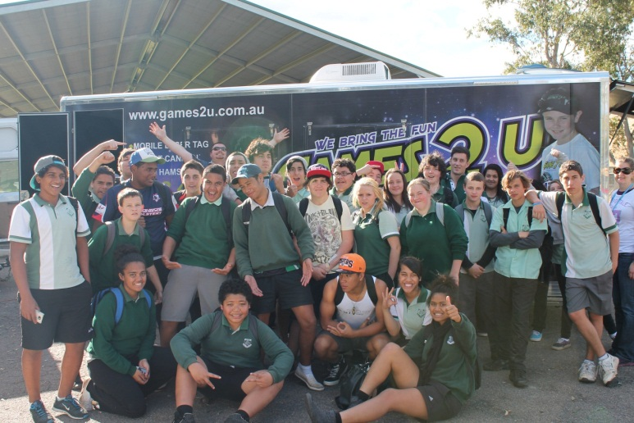

PDHPE REPORT
Well done to all students who have completed their assignments and half yearly exams to the best of their ability this term for PDHPE. It is very pleasing to see students achieve such high results. The following students have produced excellent results for assignments, exams and performances in Health and PE this semester. The students have come in the top 3 places in their class for Year 7 and 8, and in their year groups for Year 9, 10, 11 and 12:

Year 7
Rome – 1st Aurin Jones, 2nd Wendy Phan, 3rd Alex Bustescu
Persia – 1st Nora Al-Katify, 2nd Fereshta Rezaie, 3rd Tanisha Kassem
Eqypt – 1st Vanessa Siitia, 2nd Jasmine Thomas, 3rd Joel Etherington
Greece – 1st Cheyenne Smith, 2nd Hayley Greatley, 3rd Oscar Charlesworth-Budge

Year 8
Brannigan – 1st Angela Franks, 2nd Rhiannon Cuthbert, 3rd Askari Zehour
Conrad – 1st Shantel Eteaki, 2nd Leavea Sauvao, 3rd Justin Peachey
Turanga – 1st Sharna Hillhouse, =2nd Cem Or and Samuel Vyizigiro

Year 9
PDHPE – =1st Aidan Ferderer and Elizabeth Lilomaiava, 3rd Amy McDonald

PASS – 1st Aidan Ferderer, 2nd Thomas Simpson, =3rd Jason Phoumivong, Toby Parsons and Kasey Wasson
Coaching – 1st Elizabeth Lilomaiava, =2nd Aidan Ferderer and Kimberley Gimbert

Year 10
PDHPE – 1st Kira-Leigh Moore, 2nd Christopher Dent, 3rd Brittany Rose

PASS – 1st Jason Zeballos, 2nd Riggot Varu, 3rd Stephanie Naicori

Year 11
PDHPE – 1st Katelyn Ferderer, =2nd Yasmine Daye and Kane Walsh

SLR – 1st Adi Turaganivolo, 2nd Ali Khalil, 3rd Lucas McDonald

Sport Coaching (consistent effort) – Holly Reed, Stephanie Wasson and Alex Thornton

Year 12
PDHPE – 1st Kelekelio Lilomaiava, 2nd Ryen Edmond-Hughes, 3rd James Peagam

SLR – 1st Chloe Horne, 2nd Matthew Chard, 3rd James Peagam

Support PDHPE – most consistent
Gucci – Mohamed Hanash
Prada – Bryan Rendell-Sneddon
Blunstone – Jerome Tautalafua
Manolo – Jackson Baxter
Cooper – Joshua McDonald

Well done to all those students! Keep up the superb effort!

Hope you all have a safe and happy mid-year holiday.

Mr S Wagner
Head Teacher PDHPE

POSITIVE ATTENDANCE
The following students had excellent attendance during Term 1. They had 2 or less days absent for the term (96% attendance) and no truancies from class. They were rewarded with a free lunch, catered for by the canteen on behalf of the school. Keep up the excellent attendance!

Well done to the following students:

Year 7
Kimberley ANDERSON
Jackson BAXTER
Jacob CUMBERLAND
Aurin JONES
Samara LYNCH
Luke MCDONALD
Michelle NAICORI
Vanessa SIITIA
Ethan RUTLEDGE-DRAPER
Melissa SIMPSON
Cheyenne SMITH
Mandy TALAOLOA
Jasmine THOMAS

Year 8
Nikita AH-LAM
Rhiannon CUTHBERT
Joshua DENT
Angela FRANKS
Nadine HAKES
Cougar SMITH
Jake TAYLOR
Christian WOODIN

Year 9
Brock BAKER
Jaiden CLARKE
Stefan CZARNOWSKI
Zac DUNN
Khaled EL-TAHACH
Liam STARK
Aidan FERDERER
Anthony LE
Elizabeth LILOMAIAVA
Amy MCDONALD
Victoria PEAGAM
Sammantha DICKINSON
Jason PHOUMIVONG
Thomas SIMPSON
Marrenars SREY
Michael STARK
Nick SUTHERLAND
Thomas WALKER
Kasey WASSON
Jacob WOODIN
Joshua WOODIN

Year 10
Teuila FETUI
Damien MANU
Meaghan NOOM
Stephanie NAICORI

Year 11
Aimee BURKE
Yasmine DAYE
Katelyn FERDERER
Alexander THORNTON
Stephanie WASSON

Year 12
Lisa AH-LAM
Shannon BAXTER
Elizabeth BUSHE
Matthew CHARD
Carly-Jade CHESTERFIELD
Ryen EDMOND-HUGHES
Chloe HORNE
Chantalle KING
Melissa LE
Kelekolio LILOMAIAVA
Walid MOUSALLI
Rebekah NOOM
Mahdi SALEH
Maggie TA'UO-MAILEI
Derya UZAL
Joshua YASSINE

If your child’s name is not on this list, then you must try ensuring they attend school every day, be on time and not truant classes.

The Education Act (1990) requires parents to ensure that children of compulsory school age attend school on each day that the school is open for instruction. If children are absent from school, parents are required to provide the school with an acceptable explanation within seven days of the absence.

Poor attendance may lead to the failure of a student to attain a Record of School Achievement, a Higher School Certificate and/or reduced Family Assistance payments.

Mrs Williams
Positive Attendance Coordinator

Supervisor of Girls Report
My name is Gemma Simms and I am a PDHPE Teacher here at Airds High School. At the beginning of the term I was successful in gaining the position of Supervisor of Girls. My main roles are:
- Conducting research into effective girls’ education and gender equity strategies
- Leading and managing the Girl Zone Team
- Working co-operatively with members of the Welfare Team
- Working co-operatively with outside agencies

Halfway through this term, I held meetings with all the female students in the school; 7-10 and 11-12. The following points were discussed at these meetings and need to be encouraged by you at home:
- Uniform: no short skirts/shorts, no jeans. Head Teachers of each year group will be following up if your child is out of uniform. There are student assistance funds available for uniforms if you are experiencing financial difficulties. Please ask your child to come and see me if they need a jumper, another shirt etc.
- Appropriate use of school facilities: students are not to be loitering around areas of the school especially the toilets. Property needs to be respected so that it can be used by everyone.
- Bullying: inappropriate use of social media, bystander behaviour and conflict resolution skills

The Girls Zone program will begin at the start of Term 3 and continue until the end of Term 4. I am currently finalising the student list and will have held a meeting with the parents of the students involved. I encourage you to support your child and motivate them to attend all of the sessions that have been organised for them.

If you have any questions/concerns about your female daughter/child please do not hesitate to contact the school on 4625 5811 and speak to me.

Gemma Simms
PDHPE Teacher
Supervisor of Girls
Woolworths Earn & Learn is back again for 2012. For every $10 you spend you will receive a sticker. You can either place the stickers on a sticker card and when it is full hand it into the office or just hand in the loose stickers and the office will place them on a card.

For every $10 you spend at Coles you will receive a voucher. These vouchers can be handed in at the school office. Thank you for your support.

COMMUNITY NOTICES

LIVE ONLINE HELP WITH HOMEWORK

A FREE online service live with a qualified tutor

visit www.campbelltown.nsw.gov.au/library
Click on yourtutor.com
Key in your library card number

- Monday to Friday 4pm to 8pm
- Access your tutor from home or your local library
- The service is available for students in years 4-12
- FREE access to your tutor is now available at your
local library

PARENT LINE – Helpline 1300 1300 52
This state government funded helpline (managed by Catholic Care) provides a unique free support service to parents. Highly skilled professional counsellors are available 24 Hrs, 7 days, taking calls from parents & carers about any parenting issues, from tips on how to manage the morning routine to concerns about distant adolescents to complex challenges of living in blended families.

Youth Off the Streets
Every Monday transport will be provided for young people from Airds to travel to the Koch Centre for Youth in Macquarie Fields. The Koch Centre is a place where young people can be safe and have lots of fun playing sports and other activities.
The bus picks up at AB Central at 4:00pm and drops off around Riverside Dr at 8:00pm, there is no cost but a permission note must be signed each term for each person. Bookings can be made 1 week in advance by calling 87966700 or SMS 0430 326 343

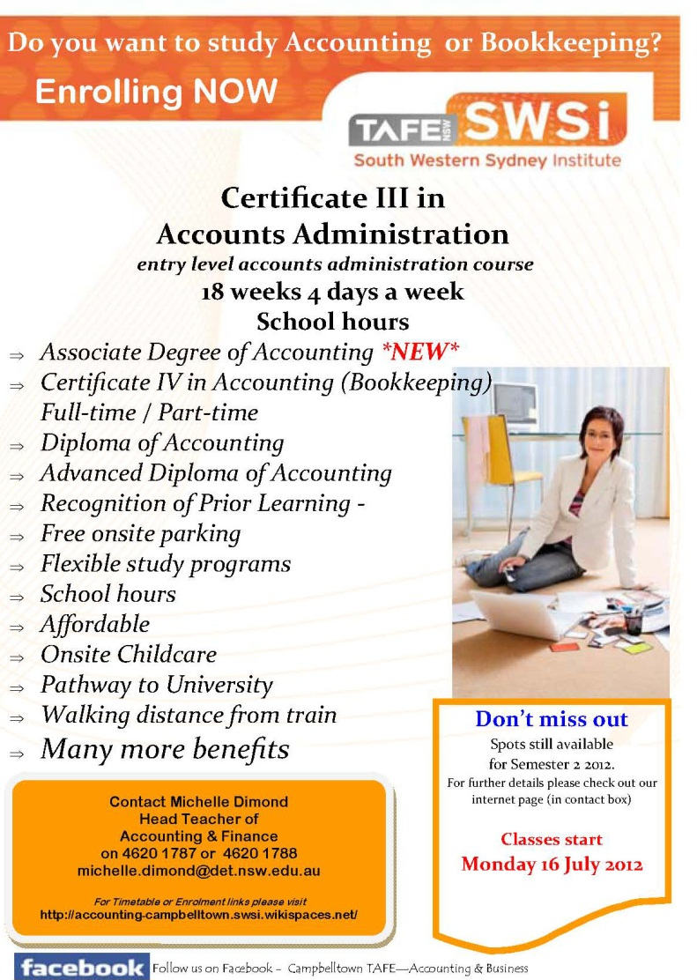

Be fire safe this winter

Winter’s chill has arrived and with it our scramble for heaters, electric blankets and open fires. Entertaining is now year round thanks to portable outdoor gas heaters. But with all these conveniences come fire dangers. Statistics reveal that almost half of all home fires are started in the kitchen and 43 per cent of all fire fatalities occur in winter. NSW Fire and Rescue reminds us to do a fire safety audit of our homes this winter, check smoke detectors are working and ensure appliances such as clothes dryers and dishwashers are running efficiently and safely. For more household fact sheets and useful videos on how to protect your home and family from fire go to www.fire.nsw.gov.au/

School holidays sorted

The school holidays are fast approaching. For great activities to keep the kids gainfully occupied check out the informative Go Play website which is full of ideas for kids aged up to 18 years. You can search by age, activity, region, date, time and by government organisation. Go to: www.goplay.nsw.gov.au

Volunteer Host Family
World Education Program (WEP) is inviting you to experience another culture in your own home by becoming a volunteer host family to an international student arriving in July 2012. Students from Italy, Belgium and The Netherlands are looking forward to experiencing life in Australia, making new friends and becoming a member of an Australian family.

Find out more!
Don’t miss out on this wonderful opportunity, contact WEP
today to receive a full information pack for your family.

Chantel Woods
Inbound Exchange Administrator

Phone: 1300 884 733
Email: wep@wep.org.au
Online: www.wep.org.au

DEPUTY PRINCIPAL’S REPORT YR 8, 10 & 12
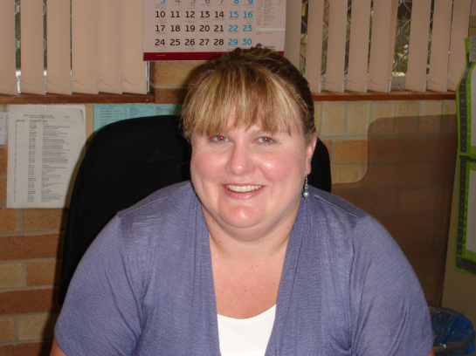

Term 2 has certainly been a busy term on the Welfare front. Whilst each of the Year Advisers have read each child’s report and made a final comment, they have also been busy planning School Values Days. These days are valuable in terms of building cohesion within the year group and for reinforcing what it means to be a safe, respectful learner at Airds High School. I thank each of the Year Advisers for their hard work throughout this hectic term.
At the end of this term, we farewell Mrs Dunn, our Year 12 Year Adviser as she leaves us for Maternity Leave. We hope that she enjoys this time with her family and we await the news of her newest arrival. Ms Radford has been acting in an assistant role since the start of the year and we welcome her to the full time position of Year 12 Year Adviser for the remainder of the year. We know that she will do an awesome job in what is a very important time for Year 12.
Ms Simms has taken on the role of Supervisor of Girls for 2012. She has been working very hard, researching important elements in girls’ education and developing a program to support some of our female students. This program is in its infancy stage and we hope to expand it in 2013. If your child has the opportunity to participate, please seriously consider their participation as I am sure that they would find the experience valuable. Mr Wallace has also taken on the role of Assistant SRC Co-ordinator to allow Ms Simms to work as both the SRC Co-ordinator and the Superviser of Girls.
On a negative note, mobile phones continue to cause issues in our school. Please discuss appropriate mobile phone usage with your child – they are not to be used at all during the school day, and certainly not in a classroom where it interferes with learning. If there is an emergency, and you need to contact your child, please go through the School Office who will be only too happy to get an urgent message to your child. We thank you for your support on this issue.
I hope that you all have a safe, relaxing holiday with your children and look forward to working with you in Term 3.
Mrs J Fuller
Deputy Principal

DEPUTY PRINCIPAL’S REPORT YR 7, 9 & 11

Welcome to all the parents and friends of Airds High School. I hope you all have a restful, relaxing and enjoyable holiday with family and friends.This term has been extremely busy with Half Yearly Examinations and assessment tasks for most of our year groups, Athletics Carnival, Cross Country Carnival and of course our famous Flag Ceremony all happening in the first six weeks. No wonder I’m exhausted and looking forward to the holidays!
Our Year Advisers have been extremely busy organising and delivering welfare days for all of our students. These days provide invaluable opportunities for our students to work on their social skills within their year/stage group and to take ownership of their learning, as well as celebrating their success within a safe, secure and fun environment.
We are again teaming up with the good people at “Aussie” to run a mentoring program “Aspirations” for some of our brightest stars in Year 11. Over the course of the next two terms our students will be travelling into the city to complete various challenges with their mentors. The purpose of this program is to open the eyes of our students in regards to different career paths and opportunities in our fair city. I am enjoying the opportunity to work with Year 11, the Aussie mentors and of course the lovely Ms Green. On the outings so far our students have been a credit to their families and our school; they have looked absolutely brilliant in their full school uniforms, especially the black shoes, blazers and ties!
Mr Foord and I have been busily studying the working drawings for our new Trade Training Centre (TTC). This million dollar project will see our old hall (Gym) converted into two learning areas, one for PDHPE and the other for Construction. The plans will be approved before the holidays and the renovation will be completed before school starts in 2013. This fabulous resource will be available for use both during and after school and will indeed become a major asset for our community.
Of course without regular attendance your child will not have access to any of these wonderful resources and programs. When your child misses school or arrives late it causes them to lose value learning time and therefore opportunities. This also has a negative impact upon their classmates and staff. It also teaches them bad habits in regards to punctuality, which will be hard to break once they enter the workforce. Please support us in encouraging your child to attend school promptly everyday!
That’s all I have at the moment, except to say that we can only achieve the best possible outcomes for your child by working together. I look forward to seeing or hearing from you soon. Hopefully at Parent/Teacher night on Tuesday 26th June if not before! If I do not see you have a happy, safe and enjoyable two weeks with your children.
Mr S McGuire
Deputy Principal

DEPUTY PRINCIPAL’S REPORT
TEACHING & LEARNING

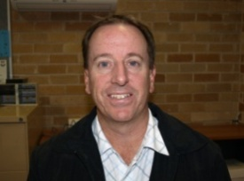
The 2nd Gifted & Talented challenge was held on Monday 18th June. This was once again a very successful day with the students from Briar Rd, John Warby, Bradbury & Woodland Rd public schools participating in set challenges and rotating their way through KLA based quiz questions, problem solving activities & team building experiences such as Photoshop, Matchstick, Forensics, play dough and the rthymic cup activities. The Year 9 students ran the activities and they were very mature and well prepared and did a fantastic job under the supervision of Ms Zalewski and Mrs Jones. The challenge will take place again on Wednesday 12th September.

Another exciting Middle Schooling program that ran this term was Exploring Science this is where our science faculty conducted a range of forensics activities with students in Years 5 & 6 from Briar Rd, John Warby & Bradbury Public schools. The activities included fingerprinting, invisible ink and imprint evidence. The program will conclude early next term with the students visiting the high school to do a DNA extraction from strawberries. I would like to thank Melanie Holmes for coordinating this project and Kate Kennedy, Erin Radford and Kris Temple for their assistance.

We are currently in the process of stocktaking all of the Red, Blue & Green (Year 12, 11 & 10) DER laptops. This involves all students using their laptop at school for a minimum of 30min before the end of term 2. The stocktake will occur electronically while the laptop is in use. Any student that does not participate in this process before the end of the term will be required to hand in their laptop to our TSO (Michael Peppernell) next term where it will have to be recorded for the stocktake manually.

As part of the 2012 School to Work Plan the school is establishing a School Café, which will involve Barista training for our students. In doing this we aim to achieve the following targets:

- Promote and facilitate effective strategies to improve student retention and attendance.
- Implement high quality programs to support students and their families throughout school at recognised transition points.
- Support KLA’s in the delivery of a curriculum relevant to the needs of every learner.
- Engage with communities, interagency, business and tertiary sectors to maximise learning opportunities and student life choice.

The school is currently in the planning stages which include:
- The design and setup of the café area within the canteen
- Design of café logo for signage and uniforms
- Flyers to be distributed
- The design of a website to promote the café
- Barista training for staff and students

We look forward to giving you all the final details of the café and its operation early in Term 3. Watch this space.

The very successful Pacific Forum was held on Thursday 7th June, it gave parents the opportunity to be informed of the diverse range of community services available in Campbelltown. This event would not have been possible without the hard work of Maryanne Varu and the Pacific Parents Committee in particular I would like to thank the following families the Lilomaiava family, the Fetui family, Siitia family, Tuagalu family and the Varu’s.

Finally I would like to acknowledge the work and contribution to the school & community of Robyn Culbert who is retiring after 22 Years as Community Liaison Officer. Robyn’s first contact with the school was with her children attending the school with Stacey starting in 1987 & Adrian in 1994. She became involved in school activities as a member of the P & C and in 1990 was successful in attaining the role of Community Liaison Officer. She has been involved in so many activities that it would be impossible to list, but when asked of what has stood out in her time here she mentioned the flag ceremonies and seeing parents progress from just participating in events to actually contributing ideas and becoming more involved in the decision making of the school. She will miss the staff and parents who she has worked very closely with over her 22 years. Robyn is now looking forward to travelling around Australia and looking after her grandchildren. We might be able to replace the position that Robyn has filled but we can’t replace the person.

Mr J Miezio
Deputy Principal Teaching & Learning

PRINCIPAL’S REPORT

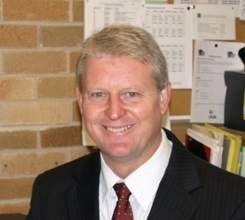

Semester 1, 2012 has almost come to an end and it has been an extremely busy one. Firstly I would like to thank all staff for their commitment to ensure all our students have experienced quality lessons, extra-curricular activities and many excursions that have supplemented their learning.

On Friday 22nd June we said farewell to a number of staff who have contributed greatly to Airds High and it’s community.

Mrs Robyn Culbert has been connected with the school for over 22 years. Initially as a parent and then as the school’s Community Liaison Office; Mrs Culbert has served the school well, ensuring that the community has had an equal role in contributing to and determining school direction. Her service, professionalism, passion and commitment to the school should be commended and on behalf of the school and it’s community I would like to wish her well in her retirement.

Due to declining numbers our General Assistant allocation was reduced from a fulltime GA to .5 GA, as a result Mr William Sutherland was transferred to Robert Townson HS. Bill as he was affectionately called by staff and students has left the legacy of our wonderful grounds and acquitted many of our students with landscaping skills and an appreciation of gardening. We wish him well and I know that Robert Townson will benefit from his passion and skills.

Mrs Louise Rodriquez one of our SLSO (student learning support officers) has supported students in their learning for over 5 years in the high school and many more years as SLSO at Briar Rd primary school. Many students have benefited from her support that enabled them to access the curriculum. Mrs Rodriquez has gained a permanent position at Auburn Girls HS and we wish her every success.

Mrs Jocelyn Keller: STLA (support teacher learning assistant) was a member of a dynamic Teaching and Learning team that supported students and teachers in their learning and understanding of student learning. Mrs Keller had a vast array of skills that were of great benefit to our school, she will be sorely missed and we wish her every success at Picton High School.

Parent Teacher Night
Thank you to all parents who were able to attend our recent P/T night and who spent time with staff to find out valuable information about their child’s progress. It is extremely important to support your children in the process of learning. I extend an invitation to all parents to attend many of the school functions and Parent and Citizen meetings (held the first Wednesday of each month at 10:00am), as the greater your involvement in the school the greater the learning outcomes of your children.

School Canteen
The refurbished school canteen was officially handed over to the school on Friday 8th June. Photos have been included in this issue for your interest. It is a fabulous resource and it will contribute greatly to ensure that we can continue to deliver a varied canteen menu at more than affordable prices. I would also like to commend the work of Mrs Helen Ingram our new canteen manager who has made a significant contribution to the health and wellbeing of our students and staff with the quality and quantity of her daily menu. I would also like to thank AB Central for the donation of a commercial coffee machine which will enable the establishment of a café and an opportunity for students in the school to achieve their barista credentials, affording them opportunities of employment in the hospitality industry.
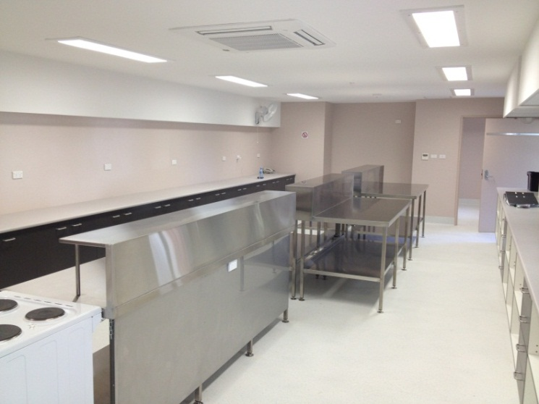
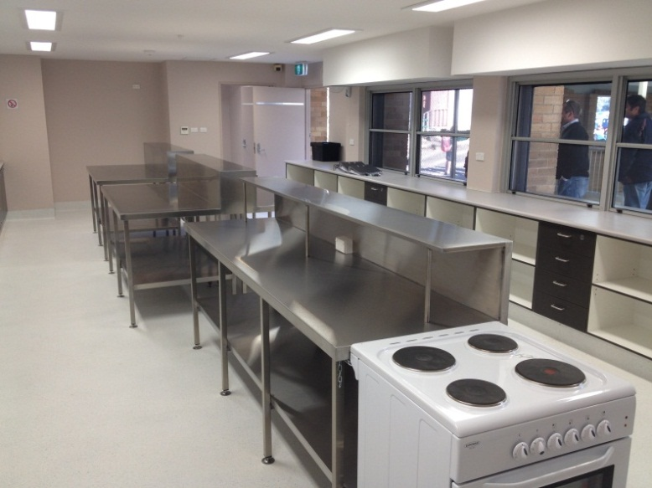

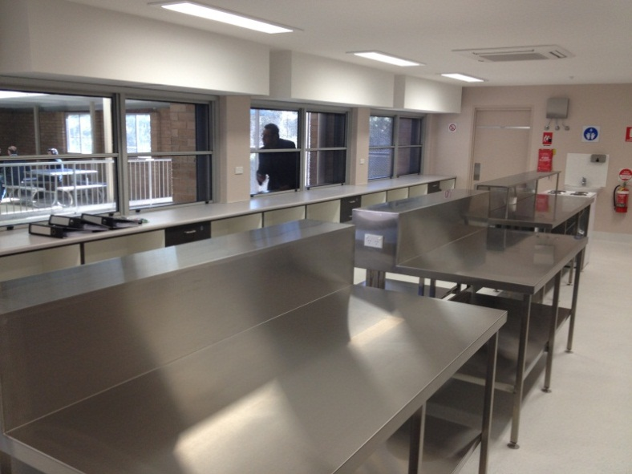
The refurbished canteen

Pacific Forum
Congratulations to Maryanne Varu and Ha Nguyen on a wonderful Pacific Islander forum. It was great to see so many parents and community organisations coming together to support and enhance the learning outcomes of their children. We look forward to your increased involvement in our school.

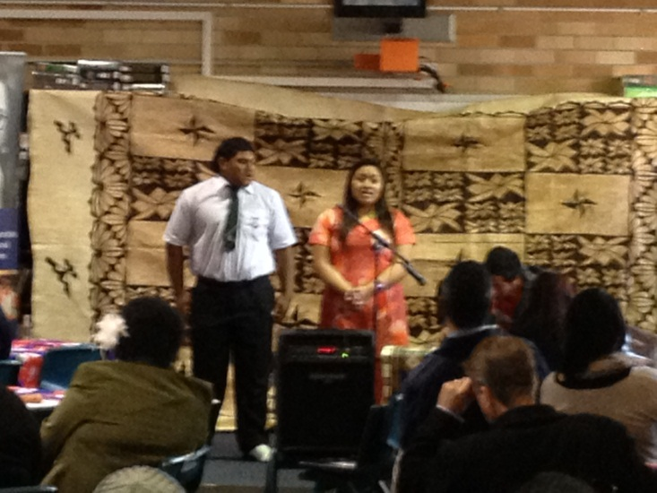
Paul Vaai and Anna Mati-Leifi perform at the Pacific Forum

Trade Training Centre
Airds High school resources continue to improve. Not only have we installed six more interactive white boards into the school, ensuring that all teaching spaces are now utilising the latest technology , but the final drawings of our TRADE TRAINING CENTRE have been signed off. Construction of the facility will commence in Term 3 and will be available as a teaching space at the commencement of 2013. Studenst will be able to gain a Certificate II or III in Construction and thus increase their chances of securing a job in the construction industry. We look forward to this fabulous resource, the association with building companies with the Airds Bradbury renewal project and the future vocational opportunities for our students.

Plans for the Trade Training Centre
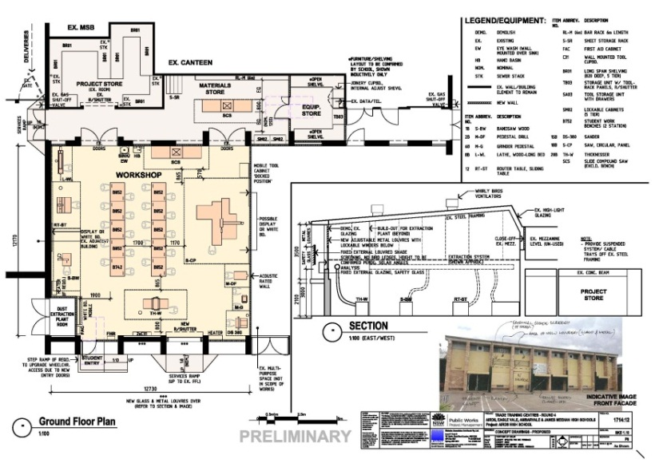

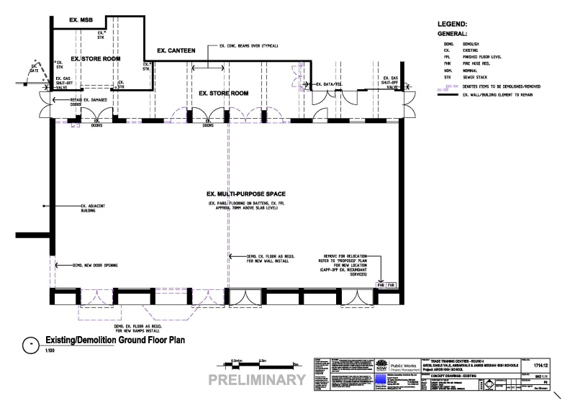

Community Garden
Airds High secured a grant at the end of 2011 for the establishment of a community vegetable garden in 2012. This is in its initial stages of development and once the structure has been completed we will invite community members in, to plant culturally specific vegetables and be part of our gardening group.

Aspirations
Airds High Year 11 students continue their association with Aussie with their involvement in the Aspirations program. Last Wednesday in at Aussies head office in George St, Sydney, the students enjoyed being involved in a self-reflection activity on the personal skills that are required to be successful in the work place. This was followed by a tour of Parliament House and time in the gallery during question time. Premier O’Farrell mentioned Airds High many times during his responses to questions from the opposition. Treasurer: Mike Baird; Minister: Graham Annesley and State Member for Campbelltown: Bryan Doyle addressed the students during lunch. Many powerful words of wisdom were bestowed upon the students and the staff present.

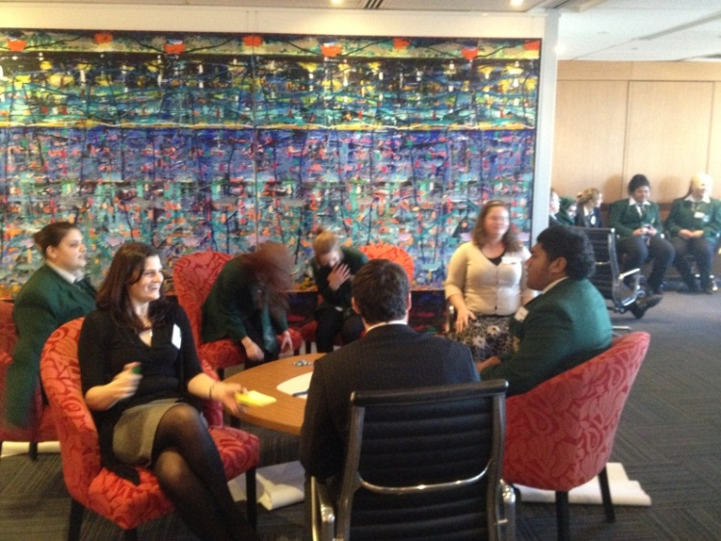
Aspirations group at Aussie

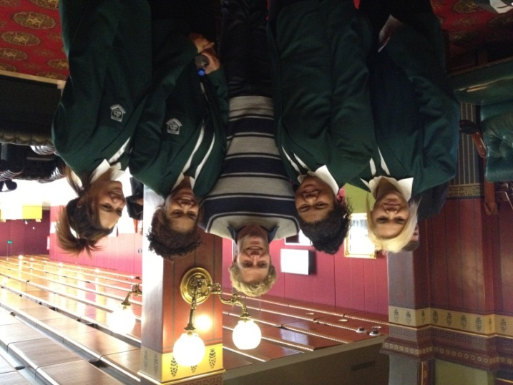
At Parliament House with Chris Brown from Bondi Vet

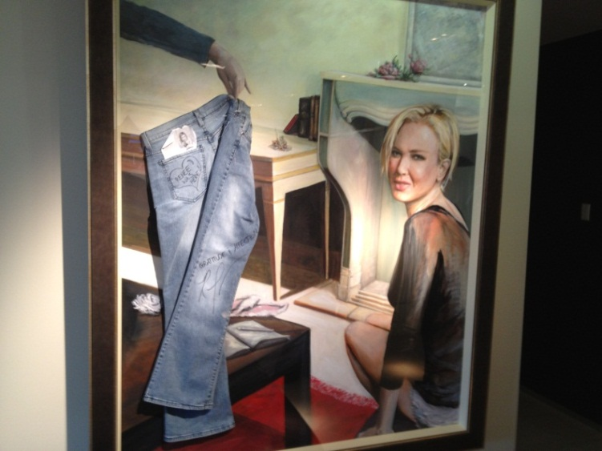
Genes for Jeans artwork at the Aussie office

School Uniform
Thank you to all students and parents who have readily supported our school value of “taking pride in yourself, school and community”. Wearing correct school uniform is one way of meeting and reflecting this value. If parents are having difficulty purchasing our uniform there are a number of options available to assist you. Firstly we sell the majority of uniform items from our front office and these are sold to you, below cost price. Secondly we are happy to invoice parents, organise payment plans or provide student assistance.

Winter is a time when many varied jumpers are worn by students and this undermines our school uniform and causes conflict. It is important that junior students wear bottle green jumpers and seniors plain black as no other jumpers are acceptable. Wearing layers is also a good way of beating the cold. The uniform continues to improve at school and I thank students and parents for their support in this matter.

Finally I would like to wish all students, parents and staff an enjoyable and safe holiday break and look forward to a great Semester 2 at Airds High.

Mr M Foord
Principal

